9.04 Estimation and units of area
Year 8 Maths · Worksheet · Level 1 · Warm-up
Name: ____________________ Date: ______________
Area is the amount of flat space a shape covers, measured in square units: mm², cm², m², hectares (ha) and km². A hectare is the area of a square 100 m by 100 m. Tip: to estimate the area of a curvy shape on a grid, count the full squares, then add about half of the part squares.

 Understanding
- Choose the best unit to measure the area of each thing: mm², cm², m², ha or km².
  - a phone screen ______________
  - a basketball court ______________
  - a farm ______________
  - Tasmania ______________
- This square is 1 cm by 1 cm. It is divided into squares that are 1 mm by 1 mm.
- 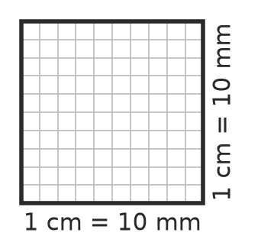
  - How many mm² are in 1 cm²? ______________
  - 1 m = 100 cm. How many cm² are in 1 m²? ______________

 Fluency
- Find the area of each shape by counting squares. In b), two triangles together make one whole square.
- 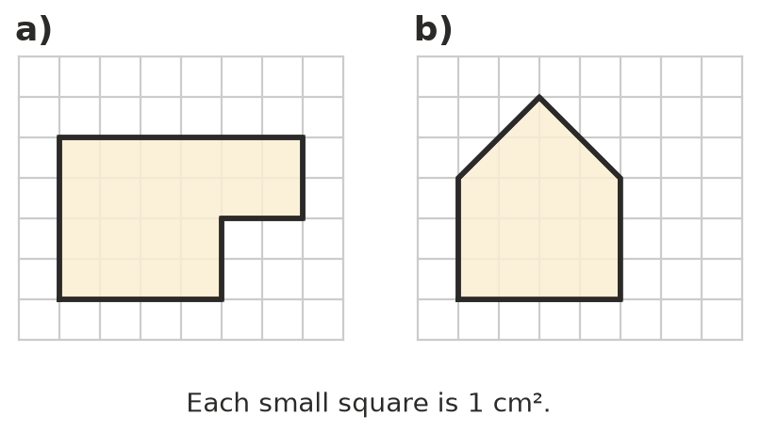
  - ______________
  - ______________
- Convert each area.
  - 3 cm² = ______________ mm²
  - 500 mm² = ______________ cm²
  - 2 m² = ______________ cm²
  - 4 ha = ______________ m²
- Estimate the area of this shape.
- 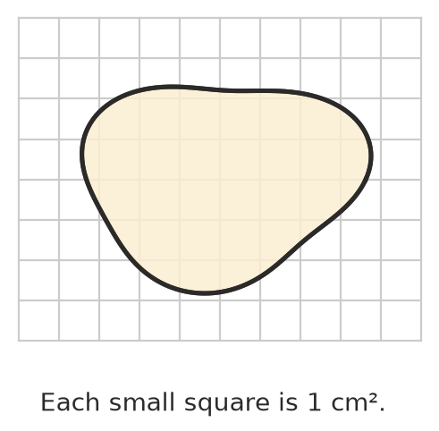
  - Number of full squares: ______________
  - Number of part squares: ______________
  - Estimated area (full squares + half of the part squares): ______________

 Reasoning
- Explain why 1 hectare is the same as 10 000 m².

- Tom says 1 cm² = 10 mm², because 1 cm = 10 mm. Explain his mistake.

 Problem solving
- A rectangular paddock is 200 m long and 150 m wide. Find its area in m² and in hectares.

- A floor 3 m by 2 m is covered with square tiles that are 50 cm by 50 cm. How many tiles are needed?

- Estimate the area of a classroom door in m². Explain how you made your estimate.

