9.04 Estimation and units of area
Year 8 Maths · A5 question sheet · Level 2 · Core
This worksheet practises choosing and converting units of area, and estimating the area of irregular shapes. Tip: a length conversion factor gets squared for area. Because 1 m = 100 cm, 1 m² = 100 × 100 = 10 000 cm².

 Understanding
- Choose the most sensible unit for the area of each thing: mm², cm², m², ha or km².
  - a SIM card
  - the cover of a book
  - a house block
  - a vineyard
  - a national park
- Complete the facts.
  - 1 cm² = ______________ mm²
  - 1 m² = ______________ cm²
  - 1 ha = ______________ m²
  - 1 km² = ______________ ha = ______________ m²

 Fluency
- Convert each area.
  - 7.5 cm² = ______________ mm²
  - 4200 mm² = ______________ cm²
  - 0.6 m² = ______________ cm²
  - 35 000 cm² = ______________ m²
  - 2.4 ha = ______________ m²
  - 3.2 km² = ______________ ha
- Estimate the area of this lake. Each grid square is 100 m by 100 m.
- 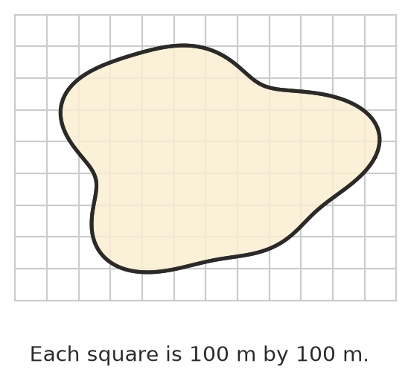
  - What area does one grid square stand for, in hectares?
  - Estimate the area of the lake in hectares.
  - Write your estimate in m².
- Find the exact area of each shape by counting whole and half squares.
  - 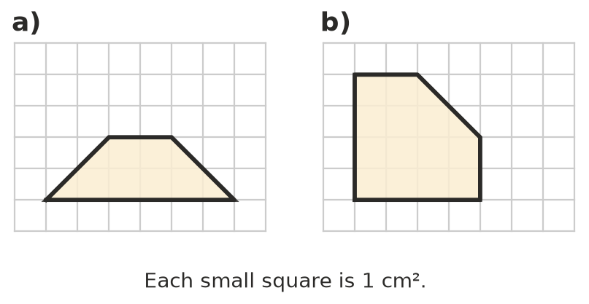

 Reasoning
- Explain why you multiply by 10 000, not 100, to change m² into cm².
- Jess says 0.5 km² is a smaller area than 60 ha. Is she right? Show your working.

 Problem solving
- A house block is 45 m long and 28 m wide. Find its area in m² and in hectares.
- A farm has an area of 3.6 km². Wheat is planted on 40% of it. How many hectares of wheat are there?
- A kitchen floor is 4.2 m by 3 m. It is tiled with square tiles that are 30 cm by 30 cm. How many tiles are needed?
- A sheet of A4 paper measures 21.0 cm by 29.7 cm.
  - Find its area in cm², then in m².
  - About how many A4 sheets would cover 1 m²?

