9.03 Perimeter of composite shapes
Year 8 Maths · Worksheet · Level 3 · Challenge
Name: ____________________ Date: ______________
This worksheet stretches your skills with harder composite shapes, sectors with any angle, exact answers and working backwards. Calculators are allowed; round to 1 decimal place unless a question says otherwise. Tip: the arc of a sector with angle θ is $\frac{θ}{360}$ × 2$π$r.

 Understanding
- All the corners of this shape are right angles.
- 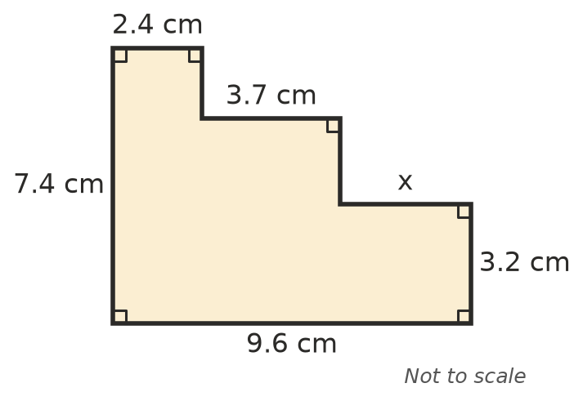
  - Find x. ______________
  - Find the perimeter of the shape. ______________
  - You can’t work out the two unlabelled vertical sides on their own. Explain why you can still find the perimeter.

- Find the exact length of each arc, in terms of $π$.
  - radius 10 cm, angle 72° ______________
  - radius 8 m, angle 135° ______________

 Fluency
- Find the perimeter of each shape. In b), the angle at the centre is 270°. In c), semicircles are drawn on two opposite sides of a square.
- 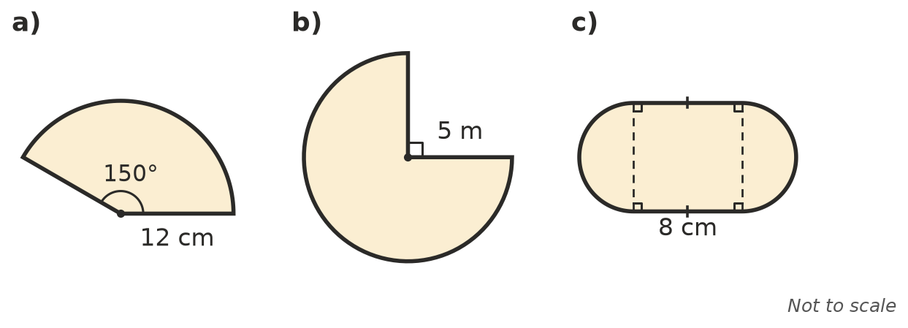
  - ______________
  - ______________
  - ______________
- Write the exact perimeter of each shape in the form a + b$π$.
  - a quadrant with a radius of 6 cm ______________
  - a semicircle with a diameter of 2x cm ______________
- A rectangular lawn is 20 m by 12 m, with each corner rounded off by a quarter circle of radius 3 m. Find its perimeter.
- 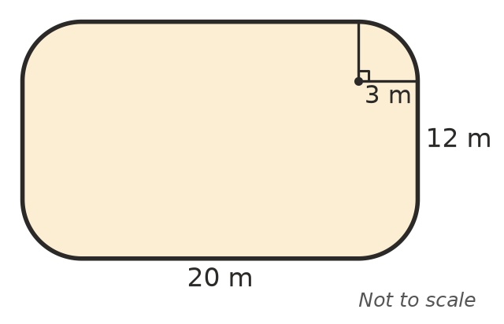

- This arch is made from two semicircles with the same centre. Find its perimeter.
- 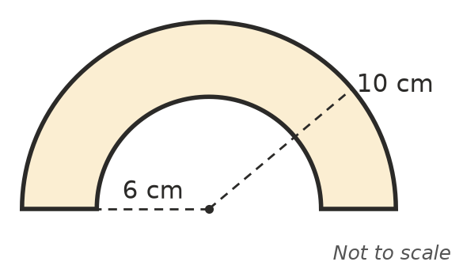

 Reasoning
- Show that the perimeter of a semicircle with radius r is r($π$ + 2).

- Point B is 20 m from point A. Path 1 is one semicircle with diameter AB. Path 2 is two semicircles in a row, with diameters 8 m and 12 m along AB. Show that both paths are the same length.

- A semicircle with diameter d is cut out of one edge of a rectangle, so the curve bites into the rectangle. Does the perimeter go up or down, and by how much? Explain.

 Problem solving
- The inside lane of a running track has two straights of 84.39 m and two semicircular ends with a radius of 36.5 m.
  - Find the length of one lap of the inside lane, to 1 decimal place. ______________
  - Lane 2 is 1.22 m further out all the way around. How much further is one lap of lane 2? Round to 2 decimal places. ______________

- A quadrant has a perimeter of 50 cm. Find its radius.

- A sector has a radius of 9 cm and a perimeter of 30 cm. Find the angle at its centre, to 1 decimal place.

