9.03 Perimeter of composite shapes
Year 8 Maths · Worksheet · Level 2 · Core
Name: ____________________ Date: ______________
This worksheet practises the perimeter of composite shapes, including shapes with semicircles, quadrants and other sectors. Calculators are allowed; round to 1 decimal place unless a question says otherwise. Tip: trace around the outside of the shape with your pencil and tick each edge as you add it, and don’t count edges that are inside the shape.

 Understanding
- All the corners of this shape are right angles.
- 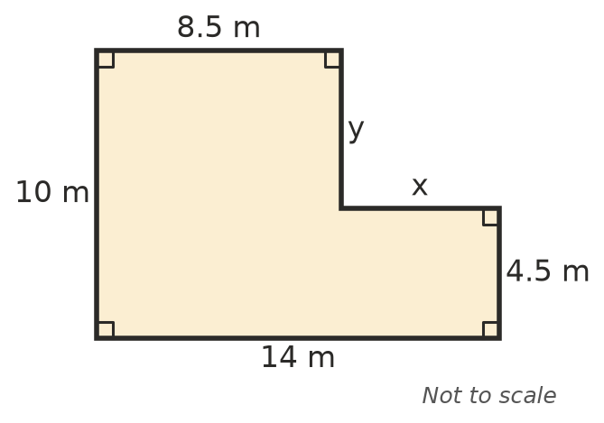
  - Find x and y. ______________
  - Find the perimeter. ______________
- Complete each statement.
  - A sector with an angle of 60° is ______________ of a full circle.
  - The curved edge (arc) of a sector with radius r and angle θ has length $\frac{θ}{360}$ × ______________

 Fluency
- Find the perimeter of each shape: a) a semicircle, b) a quadrant, c) a sector.
- 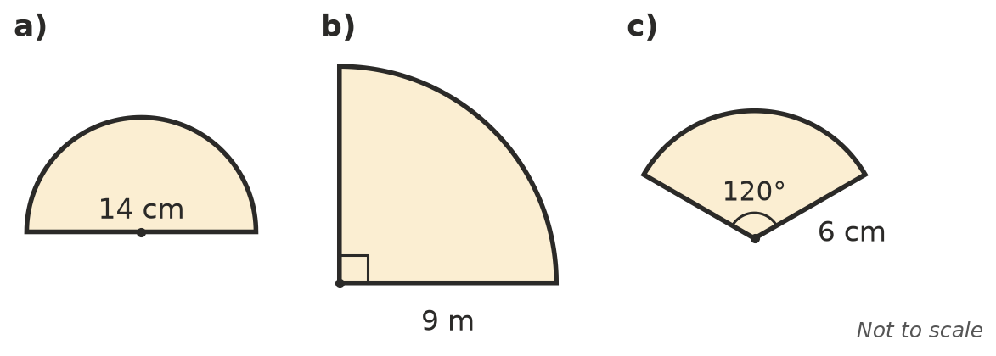
  - ______________
  - ______________
  - ______________
- Find the perimeter of each shape. In a), the shape is symmetrical. In b), a semicircle has been cut out of a rectangle.
- 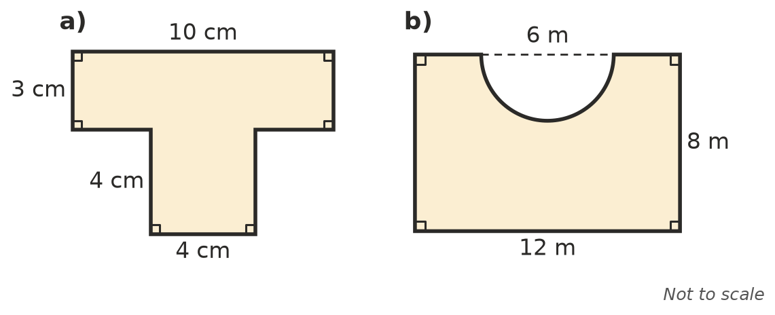
  - ______________
  - ______________
- A school running track has straight sides of 80 m and a semicircle at each end. Find the distance around it.
- 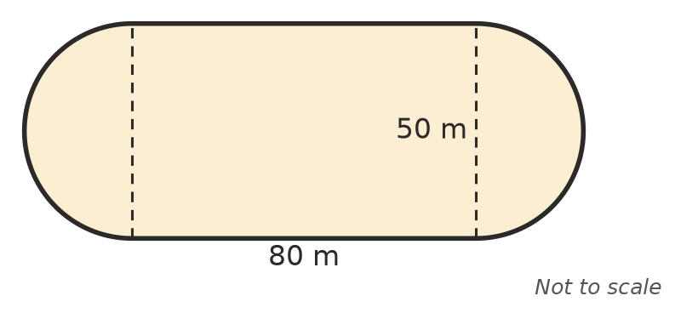

- A window is a rectangle 1.2 m wide and 1.5 m high, with a semicircle on top. Find the total length of the frame around the outside.

 Reasoning
- Explain why the shape in Question 1 has the same perimeter as a 14 m by 10 m rectangle.

- Write the exact perimeter of a semicircle with a diameter of 10 cm, in the form a + b$π$.

- Which has the bigger perimeter: a circle with a radius of 5 cm, or a quadrant with a radius of 10 cm? Show your working.

 Problem solving
- A garden bed is a quadrant with a radius of 3.5 m. Edging goes all the way around it and is sold by the whole metre at $8.50 per metre. How much will the edging cost?

- A round pizza with a diameter of 36 cm is cut into 8 equal slices. Find the perimeter of one slice.

- A semicircle has a perimeter of 36 cm. Find its diameter. (Hint: the perimeter is d + $\frac{πd}{2}$.)

