9.03 Perimeter of composite shapes
Year 8 Maths · Worksheet · Level 1 · Warm-up
Name: ____________________ Date: ______________
A composite shape is made from simpler shapes joined together. To find its perimeter, add up only the edges on the outside. For a curved edge, work out what fraction of a circle it is: a semicircle’s curve is half the circumference, and a quadrant’s curve is a quarter. Calculators are allowed; round to 1 decimal place.

 Understanding
- All the corners of this shape are right angles.
- 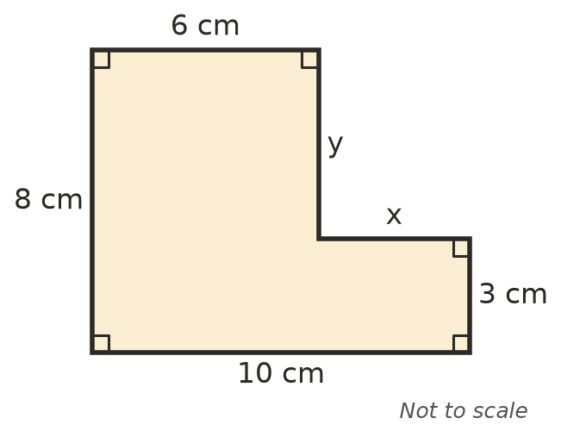
  - Find the missing lengths: x = ______________ and y = ______________
  - Find the perimeter of the shape. ______________
- This semicircle has a diameter of 10 cm.
- 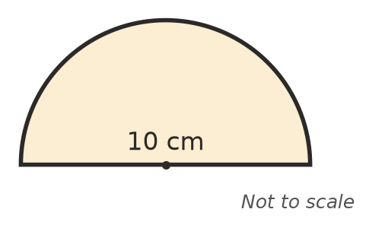
  - Find the length of the curved edge (half of $π$ × 10). ______________
  - How long is the straight edge? ______________
  - Find the perimeter of the semicircle. ______________

 Fluency
- Find the perimeter of each shape. All corners are right angles. In a), all the steps are the same size.
- 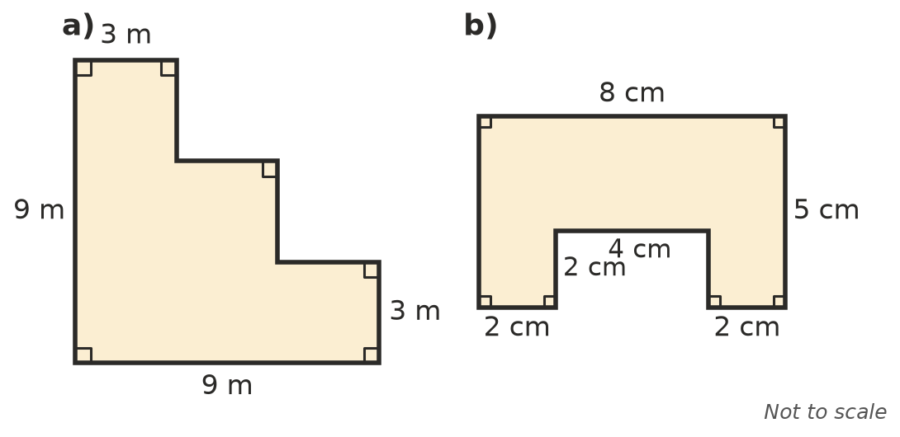
  - ______________
  - ______________
- Find the perimeter of each shape: a) is a quadrant (a quarter of a circle) and b) is a semicircle.
- 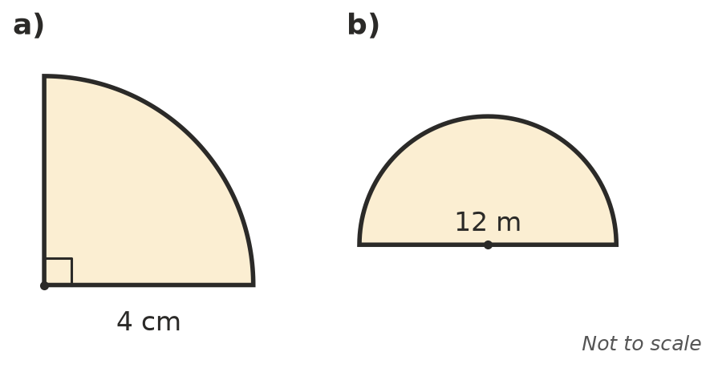
  - ______________
  - ______________
- A garden bed is a rectangle with a semicircle on one end. Find its perimeter.
- 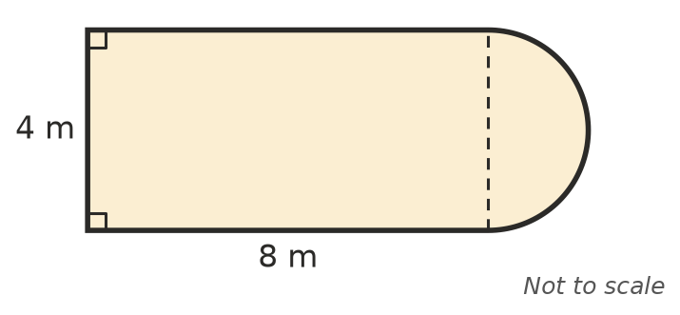

 Reasoning
- Sam says the perimeter of the semicircle in Question 2 is 15.7 cm. What has he forgotten?

- A 1 cm by 1 cm square is cut out of one corner of a 6 cm by 4 cm rectangle. Does the perimeter change? Draw a sketch and explain.

 Problem solving
- A running track has two straight sides of 100 m and a semicircle at each end. Find the distance around the track.
- 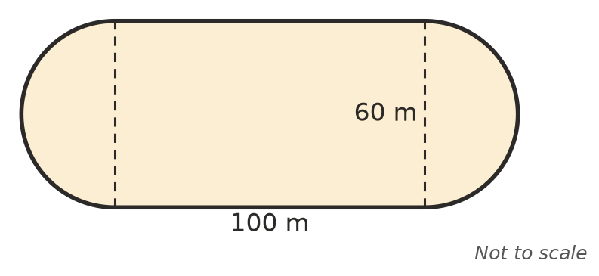

- A garden bed in the corner of a yard is a quadrant with a radius of 3 m. Edging is needed only along the curved edge. How much edging is needed?

- A shape is made from a square with sides of 6 cm and a semicircle sitting on top of one side, like an arch. Sketch the shape and find its perimeter.

