9.02 Circumference of a circle
Year 8 Maths · Worksheet · Level 3 · Challenge
Name: ____________________ Date: ______________
This worksheet stretches your skills with circumference: exact answers, working backwards, and problems where $π$ being irrational matters. Calculators are allowed. Tip: keep $π$ exact for as long as you can and round only at the end.

 Understanding
- Explain why C = $π$d and C = 2$π$r always give the same answer for the same circle.

- Write rational or irrational for each number.
  - 3.14 ______________
  - $\frac{22}{7}$ ______________
  - 2$π$ ______________
  - the circumference ÷ the diameter of a dinner plate ______________

 Fluency
- Give the exact circumference of each circle, in terms of $π$.
  - radius 3.5 cm ______________
  - diameter 2a cm ______________
  - radius $\frac{1}{2}$ m ______________
- Find the circumference of each circle. Round to 2 decimal places.
- 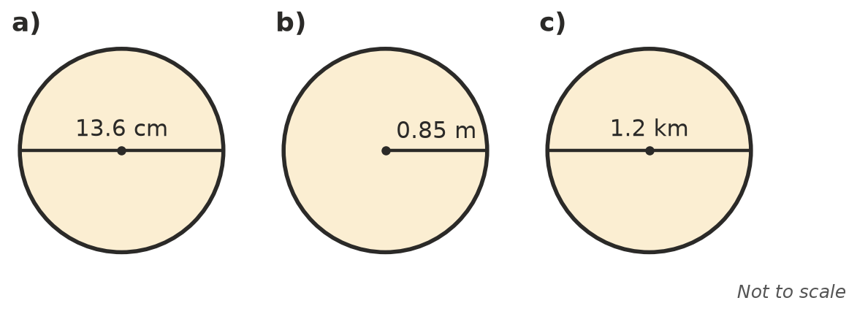
  - ______________
  - ______________
  - ______________
- Work backwards. Round to 1 decimal place where needed.
  - C = 75.4 cm, radius = ______________
  - C = 30$π$ m, radius = ______________
  - C = 1 m, diameter in cm = ______________

 Reasoning
- A round table has a diameter of 70 cm.
  - Find its circumference using $π$ ≈ $\frac{22}{7}$. ______________
  - Find its circumference using the $π$ key, to 2 decimal places. ______________
  - Explain why the answer in a) is a little bigger. ______________

- Imagine a rope pulled tight around the Earth’s equator (radius about 6378 km). The rope is made 10 m longer and lifted evenly all the way around.
  - How high above the ground is the rope now? Round to 2 decimal places. (Hint: compare 2$π$r with 2$π$(r + h).) ______________
  - Would the answer be different for a rope around a basketball? Explain.

- Lucas measured a plate: circumference 78 cm, diameter 25 cm. He says this proves $π$ = 3.12. Give two reasons why he is wrong.

 Problem solving
- A bike wheel has a diameter of 70 cm. About how many times does it turn on a 5.5 km ride? Round to the nearest whole number.

- Two runners each run one lap of a circular track. The inside runner’s lane has a radius of 36.5 m. The outside runner is 1.2 m further from the centre. How much further does the outside runner run? Round to 2 decimal places.

- A trundle wheel turns 400 times while measuring a distance of 1.1 km. Find the diameter of the wheel, to the nearest centimetre.

- The circumference of a circle is 15 cm longer than its diameter. Find the diameter, to 1 decimal place.

