9.02 Circumference of a circle
Year 8 Maths · Worksheet · Level 2 · Core
Name: ____________________ Date: ______________
This worksheet practises C = $π$d and C = 2$π$r, exact answers in terms of $π$, and working backwards from the circumference. Calculators are allowed: use the $π$ key and round as each question says. Tip: an exact answer keeps $π$ in it (like 14$π$ cm); a rounded answer uses the $π$ key.

 Understanding
- Complete each statement.
  - C = $π$ × ______________ = 2 × $π$ × ______________
  - $π$ is irrational. This means it can’t be written as a ______________, and its decimals never end or repeat.
- Which statement is true? Answer: ______________
  - $π$ = $\frac{22}{7}$ exactly
  - $π$ = 3.14 exactly
  - $π$ is between 3.14 and 3.15
  - $π$ is a whole number
- Find the missing length.
  - radius 4.5 cm, diameter = ______________
  - diameter 1.3 m, radius = ______________
  - diameter 36 mm, radius in cm = ______________

 Fluency
- Find the circumference of each circle. Round to 1 decimal place.
- 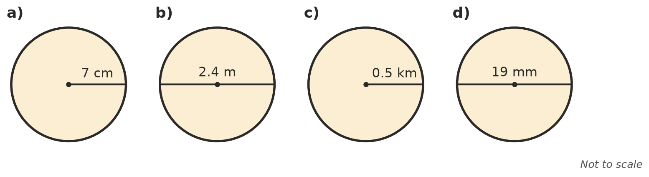
  - ______________
  - ______________
  - ______________
  - ______________
- Give the exact circumference of each circle, in terms of $π$.
  - diameter 11 cm ______________
  - radius 9 m ______________
  - radius 2.5 cm ______________
- Work backwards to find the missing length. Round to 1 decimal place where needed.
  - C = 40 cm, diameter = ______________
  - C = 100 m, radius = ______________
  - C = 18$π$ cm, diameter = ______________

 Reasoning
- Nina says $π$ = $\frac{22}{7}$. Use your calculator to write both as decimals, and explain why Nina is not quite right.

- The radius of a circle is tripled. What happens to its circumference? Explain using the formula.

- Without a calculator, choose the best estimate for the circumference of a circle with a radius of 10 cm: 30 cm, 63 cm, 100 cm or 314 cm. Explain.

 Problem solving
- A wheelchair wheel has a diameter of 66 cm. How many times does it turn when the wheelchair travels 1 km? Round to the nearest whole number.

- A gum tree trunk has a circumference of 2.5 m. Find its diameter to the nearest centimetre.

- On a merry-go-round, Ava sits 3.2 m from the centre. The ride goes around 15 times. How far does Ava travel, to the nearest metre?

