9.02 Circumference of a circle
Year 8 Maths · Worksheet · Level 1 · Warm-up
Name: ____________________ Date: ______________
The circumference is the distance around a circle. For every circle, circumference = $π$ × diameter, or C = $π$d. Because the diameter is 2 radii, you can also write C = 2$π$r. Calculators are allowed. Tip: check whether you have been given the radius or the diameter before you start.

 Understanding
- Name each labelled part of the circle.
- 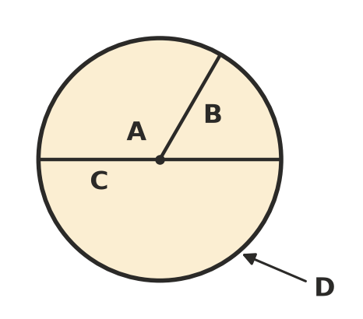
- A: ______________ B: ______________ C: ______________ D: ______________
- Find the missing length.
  - radius 6 cm, diameter = ______________
  - diameter 18 m, radius = ______________
  - radius 2.5 mm, diameter = ______________
- Complete each sentence about $π$ (pi).
  - For any circle, circumference ÷ diameter = ______________
  - Rounded to 2 decimal places, $π$ ≈ ______________
  - $π$ is an irrational number. Its decimals go on forever and never ______________ in a pattern.

 Fluency
- Use $π$ ≈ 3.14 to find the circumference of each circle.
  - diameter 10 cm ______________
  - diameter 20 m ______________
  - radius 5 cm ______________
- Use the $π$ key on your calculator to find the circumference of each circle. Round to 1 decimal place.
- 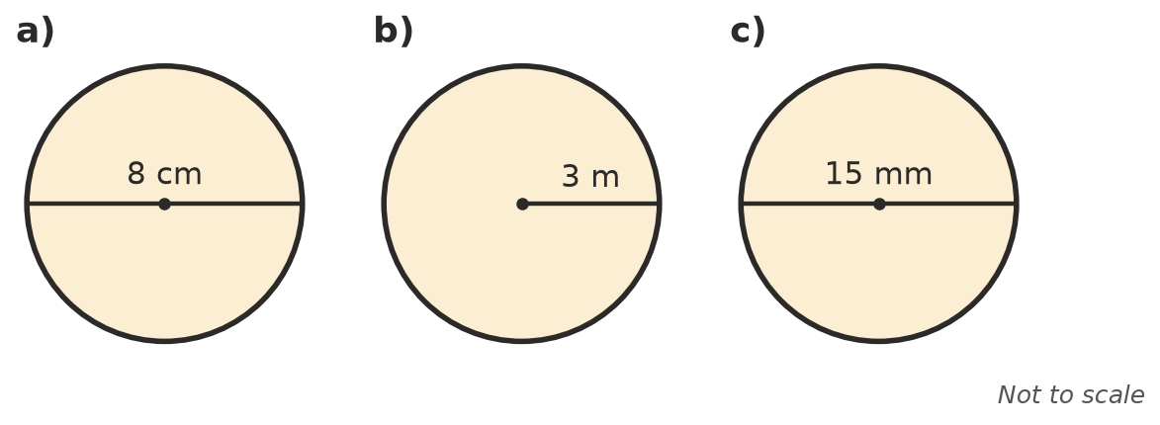
  - ______________
  - ______________
  - ______________
- An exact answer leaves $π$ in it, like 10$π$ cm. Give the exact circumference of each circle.
  - diameter 7 cm ______________
  - radius 4 m ______________

 Reasoning
- A circle has a diameter of 10 cm. Without a calculator, choose the best estimate of its circumference: 13 cm, 31 cm or 100 cm. Explain your choice.

- Mia found the circumference of a circle with a radius of 6 cm by working out $π$ × 6. Explain her mistake and find the correct circumference, rounded to 1 decimal place.

 Problem solving
- A bike wheel has a diameter of 60 cm.
  - How far does the bike move when the wheel turns once? Round to 1 decimal place. ______________
  - How far does it move, in metres, when the wheel turns 100 times? ______________

- A round garden bed has a radius of 2 m. How much plastic edging is needed to go once around it? Round to 1 decimal place.

