9.02 Circumference of a circle
Year 8 Maths · A5 question sheet · Level 3 · Challenge
This worksheet stretches your skills with circumference: exact answers, working backwards, and problems where $π$ being irrational matters. Calculators are allowed. Tip: keep $π$ exact for as long as you can and round only at the end.

 Understanding
- Explain why C = $π$d and C = 2$π$r always give the same answer for the same circle.
- Write rational or irrational for each number.
  - 3.14
  - $\frac{22}{7}$
  - 2$π$
  - the circumference ÷ the diameter of a dinner plate

 Fluency
- Give the exact circumference of each circle, in terms of $π$.
  - radius 3.5 cm
  - diameter 2a cm
  - radius $\frac{1}{2}$ m
- Find the circumference of each circle. Round to 2 decimal places.
  - 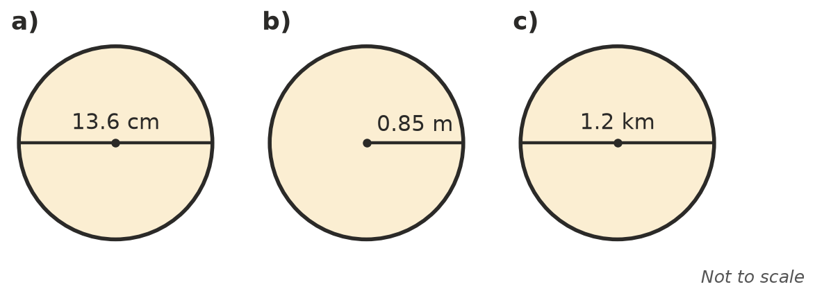

- Work backwards. Round to 1 decimal place where needed.
  - C = 75.4 cm, radius =
  - C = 30$π$ m, radius =
  - C = 1 m, diameter in cm =

 Reasoning
- A round table has a diameter of 70 cm.
  - Find its circumference using $π$ ≈ $\frac{22}{7}$.
  - Find its circumference using the $π$ key, to 2 decimal places.
  - Explain why the answer in a) is a little bigger.
- Imagine a rope pulled tight around the Earth’s equator (radius about 6378 km). The rope is made 10 m longer and lifted evenly all the way around.
  - How high above the ground is the rope now? Round to 2 decimal places. (Hint: compare 2$π$r with 2$π$(r + h).)
  - Would the answer be different for a rope around a basketball? Explain.
- Lucas measured a plate: circumference 78 cm, diameter 25 cm. He says this proves $π$ = 3.12. Give two reasons why he is wrong.

 Problem solving
- A bike wheel has a diameter of 70 cm. About how many times does it turn on a 5.5 km ride? Round to the nearest whole number.
- Two runners each run one lap of a circular track. The inside runner’s lane has a radius of 36.5 m. The outside runner is 1.2 m further from the centre. How much further does the outside runner run? Round to 2 decimal places.
- A trundle wheel turns 400 times while measuring a distance of 1.1 km. Find the diameter of the wheel, to the nearest centimetre.
- The circumference of a circle is 15 cm longer than its diameter. Find the diameter, to 1 decimal place.

