9.01 Perimeter
Year 8 Maths · A5 question sheet · Level 3 · Challenge
This worksheet stretches your perimeter skills with mixed units, algebra and multi-step problems. Tip: when a side length is unknown, call it a letter, write the perimeter as an expression, and solve an equation.

 Understanding
- Write a simplified expression for the perimeter of each shape.
  - a rectangle with length 2a cm and width (a + 5) cm
  - a triangle with sides x cm, (x + 2) cm and (2x − 1) cm
- Convert and calculate.
  - 0.065 km = ______________ cm
  - Find 4.8 m + 36 cm + 120 mm, in metres.

 Fluency
- Find the perimeter of each shape. Sides with the same marks are equal; c) is a regular heptagon.
  - 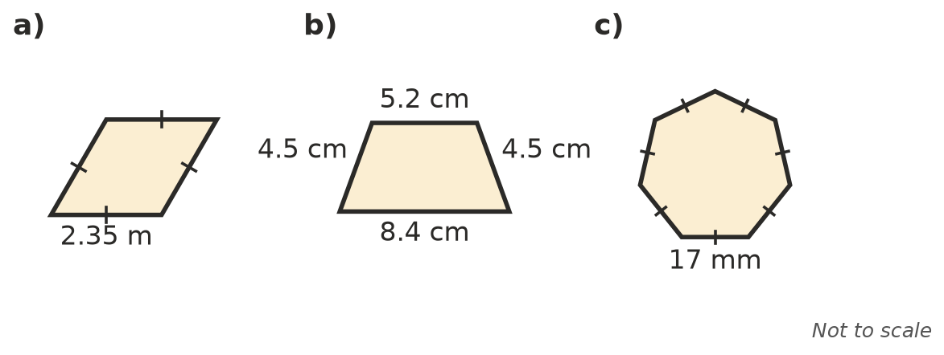

- A regular polygon has a perimeter of 1.08 m and sides of 12 cm. How many sides does it have, and what is it called?
- A triangle has sides of x cm, 2x cm and (x + 6) cm. Its perimeter is 50 cm. Find the length of each side.

 Reasoning
- A rectangle has a perimeter of 24 cm, and its sides are whole numbers of centimetres.
  - List all the possible rectangles (length and width).
  - Which one has the biggest area?
- Show, using algebra, what happens to the perimeter of a square when its side length is doubled.
- Jack says a triangle could have sides of 4 cm, 7 cm and 12 cm, giving a perimeter of 23 cm. Explain why no triangle has these side lengths.

 Problem solving
- A rectangular paddock is 120 m long and 85 m wide.
  - Fence posts go every 2.5 m around the edge, including one at each corner. How many posts are needed?
  - The fence has 3 strands of wire all the way around. Wire costs $0.85 per metre. Find the cost of the wire.
- The length of a rectangle is 7 cm more than its width. Its perimeter is 58 cm. Find its length and width.
- A regular hexagon with sides of 10 cm has the same perimeter as a square. Find the side length of the square.
- A piece of string 1.5 m long is cut into two pieces. The first piece makes an equilateral triangle with sides of 18 cm. The second piece makes a square. How long is each side of the square?

