9.01 Perimeter
Year 8 Maths · A5 question sheet · Level 2 · Core
This worksheet revises perimeter: the total distance around the outside of a shape. Tip: before you add, change every length to the same unit, and use any equal-side marks to copy and fill in sides that aren’t labelled.

 Understanding
- Write a rule for the perimeter P of each shape.
  - a rectangle with length l and width w: P =
  - a square with side length s: P =
  - a regular octagon with side length s: P =
- Convert each length.
  - 3.75 m = ______________ cm
  - 860 mm = ______________ m
  - 0.4 km = ______________ m
  - 52 cm = ______________ m

 Fluency
- Find the perimeter of each shape. Sides with the same marks are equal.
  - 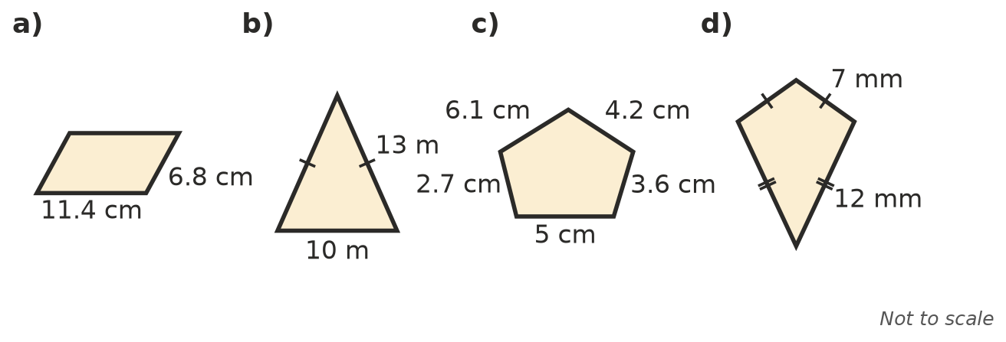

- Find the perimeter of each regular polygon.
  - a regular octagon with sides of 2.5 m
  - a regular decagon (10 sides) with sides of 14 mm
  - a regular hexagon with sides of 3.8 cm
- A triangle has sides of 1.2 m, 85 cm and 950 mm. Find its perimeter in centimetres.

 Reasoning
- A triangle has a perimeter of 42 cm. Two of its sides are 15 cm and 11 cm. How long is the third side?
- A square and an equilateral triangle have the same perimeter. The square has sides of 9 cm. How long is each side of the triangle? Explain.
- Leila says the perimeter of a 10 cm by 6 cm rectangle is 60 cm. Explain her mistake and find the correct perimeter.

 Problem solving
- A rectangular vegetable garden is 6.5 m long and 4.2 m wide. Garden edging is sold in 2.4 m lengths. How many lengths are needed to go all the way around? Show your working.
- The length of a rectangle is 3 times its width. Its perimeter is 64 cm. Find its length and width.
- Ella jogs 5 laps around a rectangular city block that is 450 m long and 280 m wide. How far does she jog, in kilometres?
- Sam has 6 m of timber to make square photo frames with sides of 35 cm. How many whole frames can he make, and how much timber is left over?

