9.01 Perimeter
Year 8 Maths · A5 question sheet · Level 1 · Warm-up
The perimeter of a shape is the total distance around its outside. Add up the lengths of all the sides, and make sure they are all in the same unit first. Tip: tick off each side as you add it, so you don’t miss one.

 Understanding
- Complete each unit fact.
  - 1 cm = ______________ mm
  - 1 m = ______________ cm
  - 1 km = ______________ m
- Find the perimeter of each shape by counting the edges of the squares.
  - 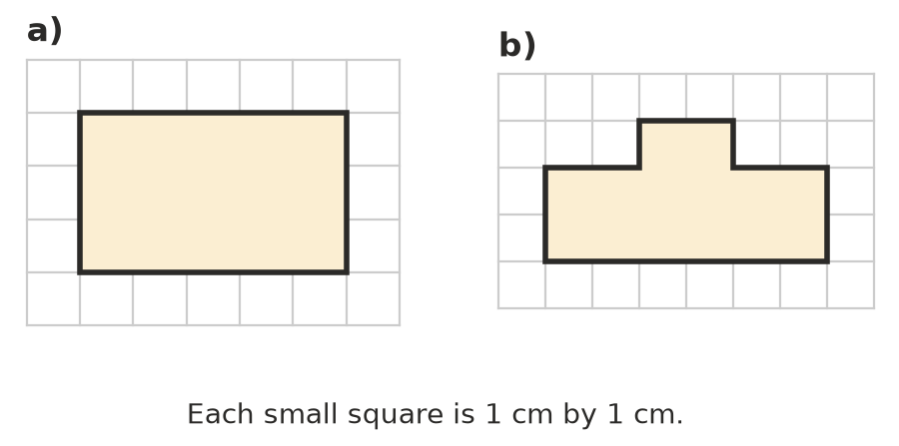

 Fluency
- Find the perimeter of each shape. Sides with the same marks are equal.
  - 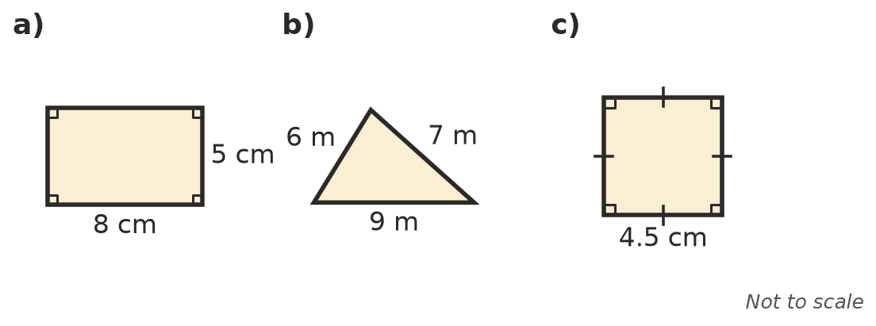

- A regular shape has all its sides the same length. Find the perimeter of each regular shape.
  - a regular pentagon (5 sides) with sides of 6 cm
  - a regular hexagon (6 sides) with sides of 9 mm
  - an equilateral triangle with sides of 12 m
- Convert each length.
  - 45 mm = ______________ cm
  - 3.2 m = ______________ cm
  - 2500 m = ______________ km
- A rectangular table top is 2 m long and 85 cm wide. Find its perimeter in centimetres.

 Reasoning
- Rectangle A is 6 cm by 4 cm. Rectangle B is 7 cm by 3 cm. Do they have the same perimeter? Show how you know.
- A square has a perimeter of 36 cm. How long is each side? Explain how you worked it out.

 Problem solving
- A farmer fences a rectangular paddock that is 50 m long and 30 m wide. Fencing costs $12 per metre. How much does the fence cost? Show your working.
- A rectangle has a perimeter of 30 cm. Its length is 9 cm. How wide is it? Show your working.

