Linear relationships: Practice test 3
Year 8 Maths · Test · Test 3
Name: ____________________ Date: ______________
Time: 45 minutes
Total: 40 marks
Show your working in the boxes. Then write each final answer on the answer sheet on the last page.

 Section A: No calculator
- Solve each equation.
  - y − 12 = −20 (1 mark)

  - −4c = −36 (1 mark)

  - $\frac{2w}{5}$ = 6 (1 mark)

  - 13 = 3 − 5g (1 mark)

- The rule for a line is y = 5 − 3x.
x | −2 | −1 | 0 | 1 | 2
y

  - Complete the table of values. (2 marks)

  - Is the relationship between x and y linear? Give a reason from your table. (1 mark)

- Use this table of values to answer each part.
x | 1 | 2 | 3 | 4 | 5
y | 2 | 6 | 10 | 14 | 18

  - Write the rule that connects x and y. (1 mark)

  - Use your rule to find y when x = 20. (1 mark)

- Use the straight line on the number plane to answer each part.
- 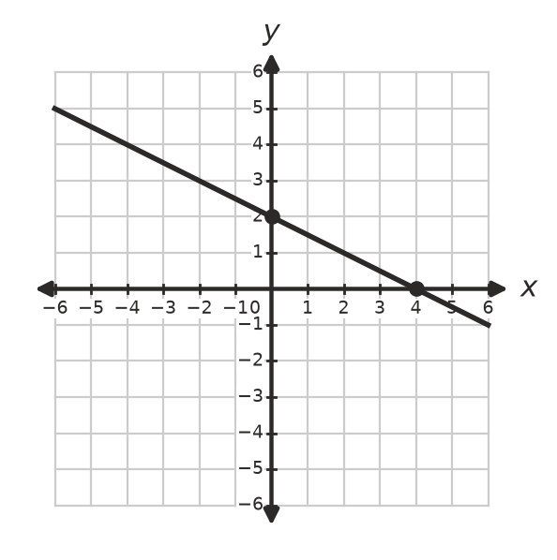
  - What is the y-intercept of the line? (1 mark)

  - What is the gradient of the line? (1 mark)

  - Write the equation of the line. (1 mark)

- Make a table of values for y = 2x + 1 and for y = 4 − x, using x-values from −1 to 2. Draw both lines on the same number plane.
- 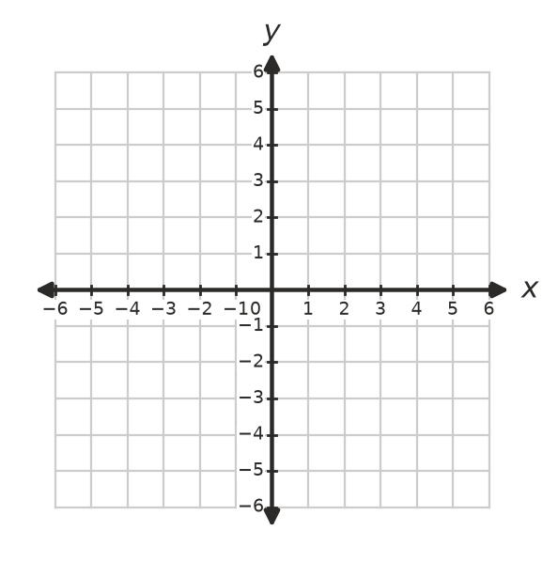
  - Write the coordinates of the point where the two lines meet. (1 mark)

  - Use your graph to write the solution of the equation 2x + 1 = 4 − x. (1 mark)

- Answer each part.
  - Which point lies on the line y = 3x − 7? Answer: ______________ (1 mark)
  - (2, 1)
  - (−1, −10)
  - (0, 7)
  - (4, 3)

  - A straight line passes through the origin and the point (3, 12). Write its equation. (1 mark)

- Solve each equation. Show your working.
  - 3(2k − 5) = 21 (2 marks)

  - 9 − 2(x − 3) = 5 (2 marks)

  - $\frac{3x−1}{4}$ = $\frac{x+3}{2}$ (2 marks)

- Do the lines y = 2x + 5 and y = 2x − 1 intersect? Explain how you know without drawing them. (2 marks)

- Answer each part about inequalities.
  - Solve 3x − 4 ≥ 8. (1 mark)

  - Solve 7 − $\frac{x}{3}$ > 5, and show your answer on the number line. (2 marks)
- 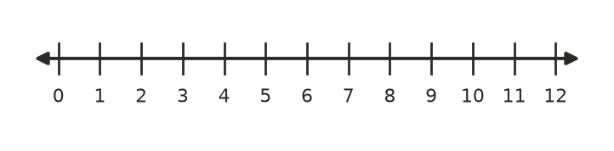

- Write the inequality shown on this number line. (1 mark)
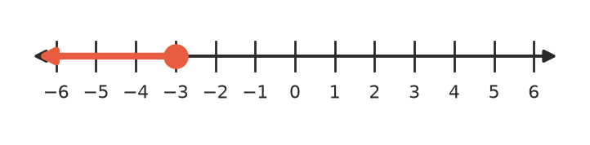

 Section B: Calculator allowed
- A car hire company charges $65 for one day plus $0.28 for each kilometre driven.
  - Write a rule for the cost, C dollars, of hiring a car for one day and driving k kilometres. (1 mark)

  - Find the cost of driving 240 km in one day. (1 mark)

  - Josh’s bill for one day was $118.20. Write and solve an equation to find how far he drove. (2 marks)

- Two candles are lit at the same time. Candle A is 30 cm tall and burns down 2.5 cm each hour. Candle B is 22 cm tall and burns down 1.5 cm each hour.
  - Write and solve an equation to find after how many hours, t, the candles are the same height. (2 marks)

  - How tall are the candles at that time? (1 mark)

- Zac has $120 saved, and he saves $35 each week. Write and solve an inequality to find the smallest whole number of weeks after which he will have more than $500. (2 marks)

- I think of a whole number. If I multiply it by 5 and subtract 7, I get the same answer as when I add 13 to it and then double the result. Write and solve an equation to find my number. (3 marks)

 Answer sheet
Name: ____________________
Write your final answer for each question in the table.
Question | Answer | Marks | Question | Answer | Marks
1a |  | /1 | 7a |  | /2
1b |  | /1 | 7b |  | /2
1c |  | /1 | 7c |  | /2
1d |  | /1 | 8 |  | /2
2a |  | /2 | 9a |  | /1
2b |  | /1 | 9b |  | /2
3a |  | /1 | 10 |  | /1
3b |  | /1 | 11a |  | /1
4a |  | /1 | 11b |  | /1
4b |  | /1 | 11c |  | /2
4c |  | /1 | 12a |  | /2
5a |  | /1 | 12b |  | /1
5b |  | /1 | 13 |  | /2
6a |  | /1 | 14 |  | /3
6b |  | /1
 |  |  |  | Total | /40

