Linear relationships: Practice test 2
Year 8 Maths · Test · Test 2
Name: ____________________ Date: ______________
Time: 45 minutes
Total: 40 marks
Show your working in the boxes. Then write each final answer on the answer sheet on the last page.

 Section A: No calculator
- Solve each equation.
  - a + 15 = 6 (1 mark)

  - $\frac{n}{−3}$ = 7 (1 mark)

  - 9 − 2b = 1 (1 mark)

  - 3h − 7 = −22 (1 mark)

- The rule for a line is y = −3x + 4.
x | −1 | 0 | 1 | 2 | 3
y

  - Complete the table of values. (2 marks)

  - Find the value of x when y = −11. (1 mark)

- For a youth group dinner, long tables are pushed together end to end. Each table has 2 chairs along each long side, and there is 1 chair at each end of the row. The table shows how many chairs, c, fit around t tables.
Tables (t) | 1 | 2 | 3 | 4
Chairs (c) | 6 | 10 | 14 | 18

  - Write a rule for c in terms of t. (1 mark)

  - How many chairs fit around 15 tables in a row? (1 mark)

- Use the straight line on the number plane to answer each part.
- 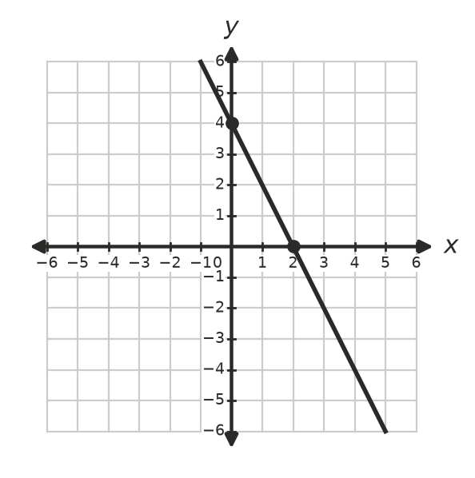
  - What is the gradient of the line? (1 mark)

  - Write the equation of the line. (1 mark)

  - Does the point (5, −6) lie on this line? Show how you know. (1 mark)

- Make a table of values for y = $\frac{1}{2}$x − 1, using x = −2, 0, 2 and 4. Then draw the line on the number plane.
- 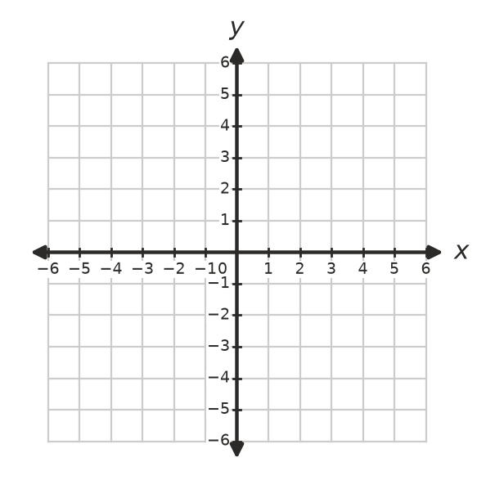
  - What is the y-intercept of the line? (1 mark)

  - Write the coordinates of the point where the line crosses the x-axis. (1 mark)

- Answer each part.
  - Which line is parallel to y = 3x − 4? Answer: ______________ (1 mark)
  - y = 4x − 3
  - y = 3x + 2
  - y = −3x − 4
  - y = x + 3

  - Write the equation of the vertical line that passes through (4, −1). (1 mark)

- Solve each equation. Show your working.
  - 5(x + 3) − 2x = 27 (2 marks)

  - 2(3m − 1) = 4(m + 5) (2 marks)

  - $\frac{x}{3}$ + $\frac{x}{4}$ = 14 (2 marks)

- The graphs of y = 2x − 3 and y = −x + 3 are drawn below.
- 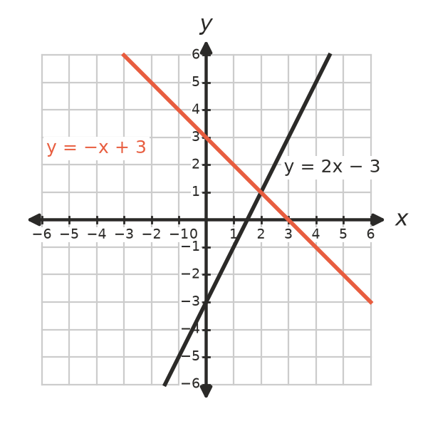
  - Write the coordinates of the point of intersection. (1 mark)

  - Use the graph to write the solution of the equation 2x − 3 = −x + 3. (1 mark)

- Answer each part about inequalities.
  - Solve $\frac{x}{2}$ − 1 < 3, and show your answer on the number line. (1 mark)
- 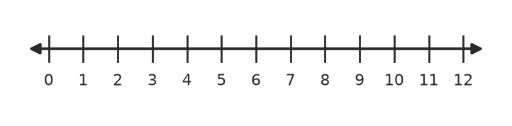

  - Is x = −3 a solution of 5 − 2x ≥ 11? Explain your answer. (2 marks)

- Write the inequality shown on this number line. (1 mark)
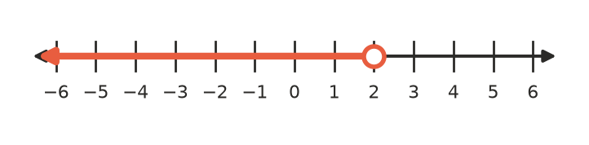

 Section B: Calculator allowed
- A water tank on a farm holds 1850 L. A pipe drains it at a steady 65 L per minute.
  - Write a rule for the volume of water left, V litres, after t minutes. (1 mark)

  - How much water is left after 12 minutes? (1 mark)

  - Write and solve an equation to find when there will be 550 L left. (2 marks)

- Taxi A charges $4.20 plus $2.30 per kilometre. Taxi B charges $7.80 plus $1.85 per kilometre.
  - Write and solve an equation to find the distance, d km, for which both taxis cost the same. (2 marks)

  - How much does each taxi cost for that distance? (1 mark)

- A goods lift can carry at most 1000 kg. The operator weighs 85 kg, and each box weighs 36 kg. Write and solve an inequality to find the greatest number of boxes the operator can take in the lift. (2 marks)

- Ana is three times as old as her brother Leo. In 8 years’ time, Ana will be twice as old as Leo. Write and solve an equation to find their ages now. (3 marks)

 Answer sheet
Name: ____________________
Write your final answer for each question in the table.
Question | Answer | Marks | Question | Answer | Marks
1a |  | /1 | 7a |  | /2
1b |  | /1 | 7b |  | /2
1c |  | /1 | 7c |  | /2
1d |  | /1 | 8a |  | /1
2a |  | /2 | 8b |  | /1
2b |  | /1 | 9a |  | /1
3a |  | /1 | 9b |  | /2
3b |  | /1 | 10 |  | /1
4a |  | /1 | 11a |  | /1
4b |  | /1 | 11b |  | /1
4c |  | /1 | 11c |  | /2
5a |  | /1 | 12a |  | /2
5b |  | /1 | 12b |  | /1
6a |  | /1 | 13 |  | /2
6b |  | /1 | 14 |  | /3
 |  |  |  | Total | /40

