Linear relationships: Practice test 1
Year 8 Maths · Test · Test 1
Name: ____________________ Date: ______________
Time: 45 minutes
Total: 40 marks
Show your working in the boxes. Then write each final answer on the answer sheet on the last page.

 Section A: No calculator
- Solve each equation.
  - x − 9 = −4 (1 mark)

  - −6m = 42 (1 mark)

  - $\frac{k}{4}$ + 3 = −2 (1 mark)

  - 5p + 8 = −17 (1 mark)

- The rule for a line is y = 3x − 2.
x | −2 | −1 | 0 | 1 | 2
y

  - Complete the table of values. (2 marks)

  - Does the point (5, 13) lie on the line? Show how you know. (1 mark)

- Write the rule that connects x and y in this table. (2 marks)
x | 0 | 1 | 2 | 3 | 4
y | 7 | 5 | 3 | 1 | −1

- Use the straight line on the number plane to answer each part.
- 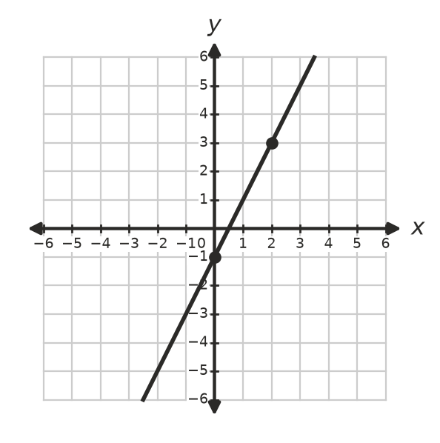
  - What is the y-intercept of the line? (1 mark)

  - What is the gradient of the line? (1 mark)

  - Write the equation of the line. (1 mark)

- Make a table of values for y = 4 − x, using x-values from −2 to 5. Then draw the line on the number plane.
- 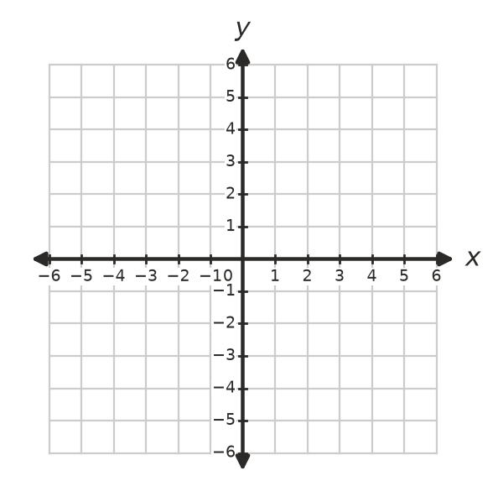
  - Write the coordinates of the point where the line crosses the x-axis. (1 mark)

  - Write the coordinates of the point where the line crosses the y-axis. (1 mark)

- Write the equation of each line.
  - The horizontal line that passes through (3, −5) (1 mark)

  - The vertical line that passes through (−2, 6) (1 mark)

- Solve each equation. Show your working.
  - 4(2a + 1) = 36 (2 marks)

  - 7n − 5 = 3n + 19 (2 marks)

  - $\frac{2y+4}{3}$ = 6 (2 marks)

- The graphs of y = x + 1 and y = −2x + 7 are drawn below.
- 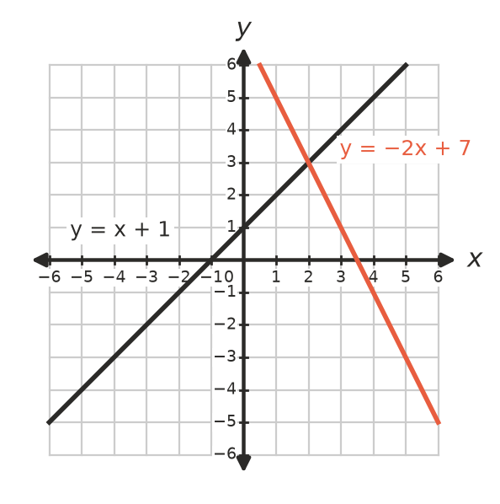
  - Write the coordinates of the point of intersection. (1 mark)

  - Substitute your point into both equations to show that it lies on both lines. (1 mark)

- Answer each part about inequalities.
  - Solve 2x + 5 > 11, and show your answer on the number line. (1 mark)
- 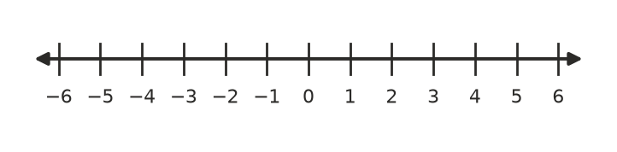

  - Jack solved −2x < 8 and wrote x < −4. Explain the mistake he made, and write the correct answer. (2 marks)

- Write the inequality shown on this number line. (1 mark)
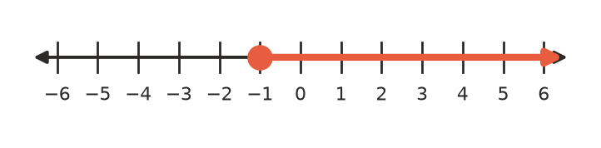

 Section B: Calculator allowed
- An electrician charges a $75 call-out fee plus $90 for each hour of work.
  - Write a rule for the total cost, C dollars, for a job that takes h hours. (1 mark)

  - Find the cost of a job that takes 3.5 hours. (1 mark)

  - Another job cost $435. Write and solve an equation to find how many hours it took. (2 marks)

- Gym A charges a $40 joining fee plus $12 per week. Gym B has no joining fee and charges $17 per week.
  - Write and solve an equation to find the number of weeks, w, after which the two gyms cost the same. (2 marks)

  - Which gym is cheaper for a whole year (52 weeks)? Show your working. (1 mark)

- Mia has $50. She buys one popcorn for $6.50 and some movie tickets at $13.50 each. Write and solve an inequality to find the greatest number of tickets she can buy. (2 marks)

- A rectangular garden bed is 3 m longer than twice its width. Its perimeter is 51 m. Write and solve an equation to find the width and the length of the garden bed. (3 marks)

 Answer sheet
Name: ____________________
Write your final answer for each question in the table.
Question | Answer | Marks | Question | Answer | Marks
1a |  | /1 | 7b |  | /2
1b |  | /1 | 7c |  | /2
1c |  | /1 | 8a |  | /1
1d |  | /1 | 8b |  | /1
2a |  | /2 | 9a |  | /1
2b |  | /1 | 9b |  | /2
3 |  | /2 | 10 |  | /1
4a |  | /1 | 11a |  | /1
4b |  | /1 | 11b |  | /1
4c |  | /1 | 11c |  | /2
5a |  | /1 | 12a |  | /2
5b |  | /1 | 12b |  | /1
6a |  | /1 | 13 |  | /2
6b |  | /1 | 14 |  | /3
7a |  | /2
 |  |  |  | Total | /40

