6.06 Inequalities
Year 8 Maths · Worksheet · Level 3 · Challenge
Name: ____________________ Date: ______________
This worksheet extends inequalities to negative coefficients, fractions, pronumerals on both sides, double inequalities and harder problems. Tip: reverse the sign whenever you multiply or divide by a negative number. To check, test one number that should work and one that shouldn’t in the original inequality.

 Understanding
- Write the inequality shown on each number line.
- 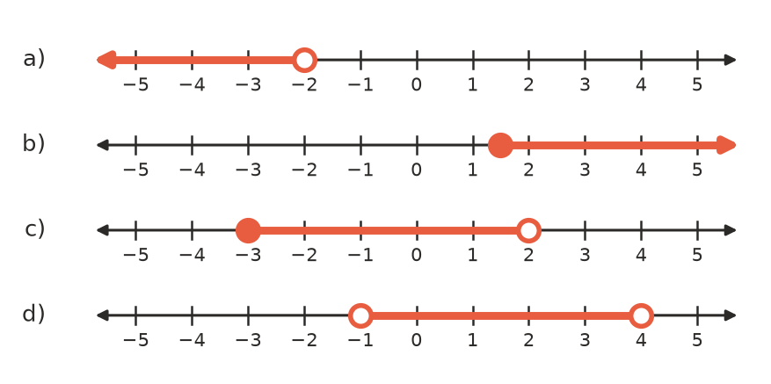
  - ______________
  - ______________
  - ______________
  - ______________
- Without doing any working, Tia says that the solution of $−x>3$ is $x<−3$. Explain why she is right, using an example of a number that works and one that doesn’t. ______________

 Fluency
- Solve each inequality.
  - $−5x+7≤22$ ______________
  - $−\frac{x}{4}>2$ ______________
  - $3(2−x)<18$ ______________
  - $\frac{2x−3}{5}≥−1$ ______________
  - $4x−7>2x+5$ ______________
  - $2(x+1)≤5x−13$ ______________
  - $\frac{x}{3}+\frac{x}{6}<5$ ______________
  - $9−2x≥3x−11$ ______________
- Solve each inequality, then show the solution on the number line with the same letter: a) $\frac{5−x}{2}≥4$, b) $−3(x+1)<6$, c) $−1<2x+3≤9$.
- 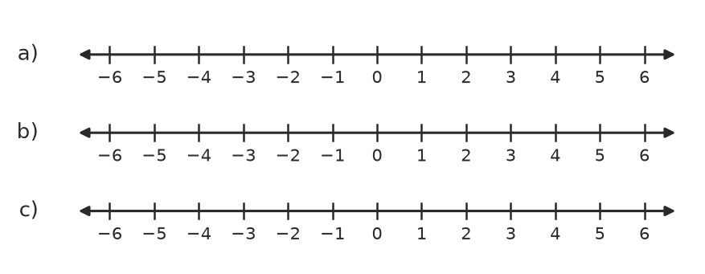
  - ______________
  - ______________
  - ______________
- Answer each question.
  - What is the largest integer that satisfies $7−3x>20$? ______________
  - How many integers satisfy $−7≤2x+1<9$? ______________

 Reasoning
- Kai solved $−\frac{x}{2}+3≤7$ and got $x≤−8$. Use a test value to show that his answer is wrong, then find the correct solution. ______________

- Find a whole-number value of $a$ so that $x=4$ is a solution of $3x−a>5$ but $x=3$ is not. Explain how you found it. ______________

- Write two different inequalities that both have the solution $x>−2$. One must have a negative number multiplying $x$. ______________

 Problem solving
For each question, write an inequality, solve it and answer the question.
- Plan A costs $40 a month with unlimited data. Plan B costs $18 a month plus $0.50 per GB of data. For what amounts of data is Plan A cheaper?

- A rectangle is 6 cm longer than it is wide. Its perimeter must be no more than 60 cm. What is the greatest possible width?

- A water park ride closes when the temperature is 95 °F or more. Use $F=1.8C+32$ to find the temperatures in °C for which the ride stays open.

- A school camp costs $480 for the bus plus $35 per student. The budget is $1500. Each student pays $55.
  - What is the greatest number of students that can go without going over the budget? ______________
  - What is the least number of students needed for the money paid by students to cover the total cost? ______________
  - Between what numbers of students does the camp work? ______________

- The sum of three consecutive integers is less than 50. What is the largest possible value of the smallest integer?

- To get an A, Noah’s average over five tests must be at least 85. His first four marks are 82, 91, 78 and 86. What mark does he need on the fifth test? Is it possible if the test is out of 100?

