6.06 Inequalities
Year 8 Maths · Worksheet · Level 2 · Core
Name: ____________________ Date: ______________
This worksheet practises reading and drawing inequalities on number lines and solving inequalities, including ones with negative numbers. Tip: solve an inequality like an equation, with one exception. When you multiply or divide both sides by a negative number, reverse the inequality sign.

 Understanding
- Write the inequality shown on each number line.
- 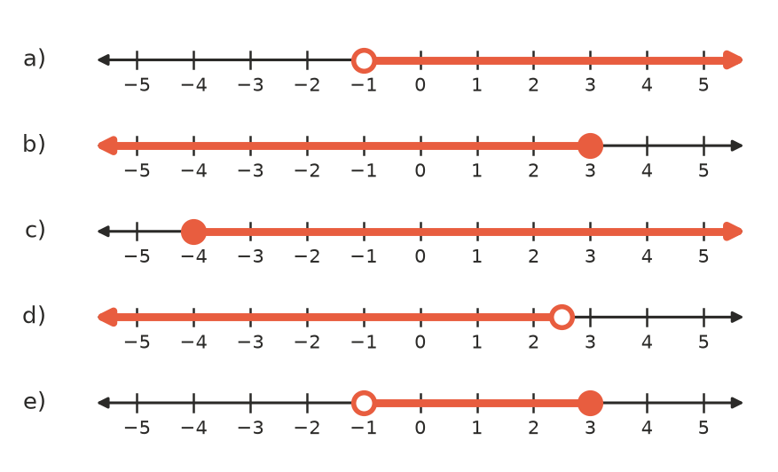
  - ______________
  - ______________
  - ______________
  - ______________
  - ______________
- Start with a true statement. Do the same thing to both sides, then write the correct sign, < or >, in the box.
  - 6 > 2. Multiply both sides by −3: −18 □ −6 ______________
  - −2 < 5. Divide both sides by −1: 2 □ −5 ______________
  - What do you notice about the sign when you multiply or divide by a negative number? ______________

 Fluency
- Solve each inequality.
  - $x+7≥3$ ______________
  - $5x>−15$ ______________
  - $\frac{x}{3}−2<1$ ______________
  - $3x−5≥10$ ______________
  - $−2x<8$ ______________
  - $7−x≤3$ ______________
  - $−4x+1>13$ ______________
  - $2(x+3)≤14$ ______________
- Solve each inequality, then show the solution on the number line with the same letter: a) $3x+2>8$, b) $5−2x≥11$, c) $\frac{x+1}{2}<3$.
- 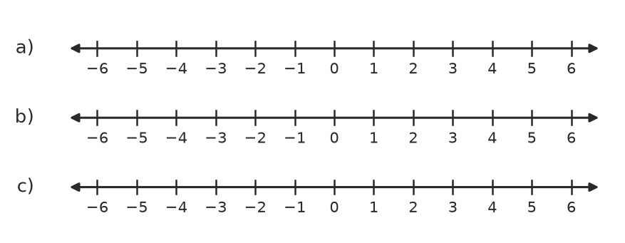
  - ______________
  - ______________
  - ______________
- Answer each question.
  - List the integers that satisfy $−3<x≤2$. ______________
  - What is the smallest integer that satisfies $4x−3>10$? ______________

 Reasoning
- Josh solved $6−3x>12$ and got $x>−2$.
  - Test $x=0$ in the original inequality. Does it work? What does this tell you about Josh’s answer? ______________
  - Find the correct solution, and test a value to check it. ______________

- Explain the difference between the solutions of $x=3$, $x>3$ and $x≥3$. ______________

- Write an inequality that needs two steps to solve and has the solution $x≤−1$. ______________

 Problem solving
For each question, write an inequality, solve it and answer the question.
- A taxi charges $4 flagfall plus $2.50 per kilometre. Eli has $30. How far can he travel?

- To earn a badge, the average of Grace’s three tests must be at least 75. Her first two marks are 68 and 79. What mark does she need on the third test?

- A sausage sizzle costs $60 to set up. Sausages sell for $3 each. How many sausages must be sold to raise at least $150 after paying the set-up cost?

- Lucas has a 15 GB data plan. He has already used 3.6 GB, and he uses 0.8 GB each day. For how many more whole days can he use data before he goes over?

- A goods lift can carry at most 1000 kg. The lift operator has a mass of 85 kg, and each box has a mass of 24 kg. What is the greatest number of boxes the operator can take in one trip?

