6.06 Inequalities
Year 8 Maths · Worksheet · Level 1 · Warm-up
Name: ____________________ Date: ______________
This worksheet practises the inequality symbols, showing inequalities on a number line, and solving simple inequalities. Tip: an open circle means the number is not included (< or >). A closed circle means the number is included (≤ or ≥). Solve an inequality just like an equation, but keep the inequality sign.

 Understanding
- Write True or False.
  - 7 > 4 ______________
  - −3 > −1 ______________
  - 5 ≤ 5 ______________
  - −6 < 2 ______________
  - 8 ≥ 9 ______________
- Look at the two number lines.
- 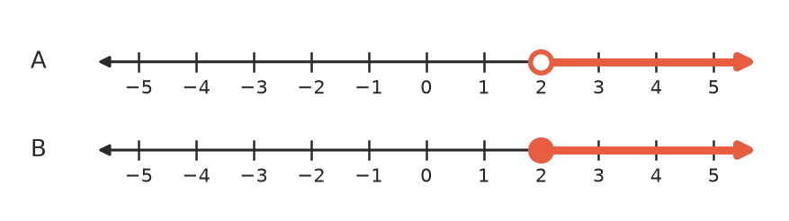
  - Which number line shows $x≥2$? ______________
  - Is 2 a solution of $x>2$? Explain how number line A shows this. ______________

 Fluency
- Write the inequality shown on each number line.
- 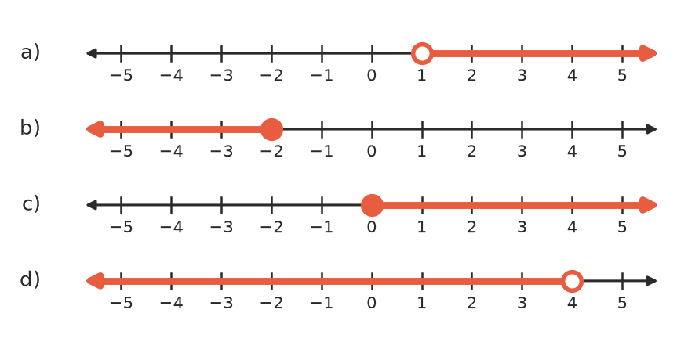
  - ______________
  - ______________
  - ______________
  - ______________
- Show each inequality on the number line with the same letter: a) $x>3$, b) $x≤1$, c) $x≥−2$, d) $x<0$.
- 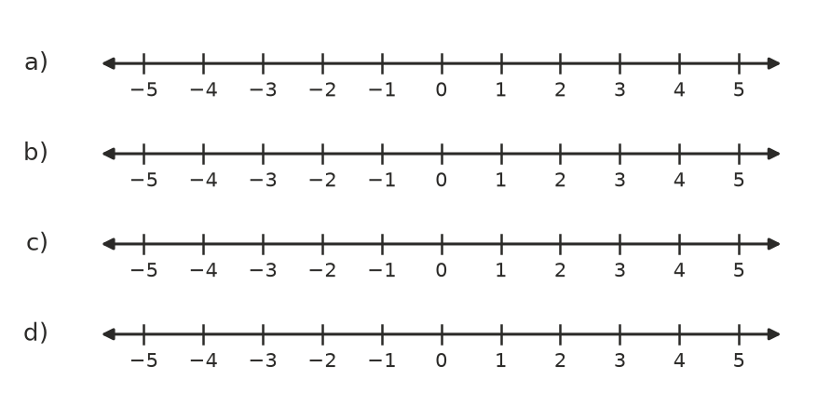
- Solve each inequality.
  - $x+4>9$ ______________
  - $x−3≤4$ ______________
  - $3x<12$ ______________
  - $\frac{x}{2}≥3$ ______________
  - $2x+1>7$ ______________
  - $4x−3≤13$ ______________

 Reasoning
- Use substitution to decide whether each value is a solution of $2x+3>12$. Write Yes or No.
Value | Working | Yes or No
$x=5$
$x=4$
$x=4.5$
$x=10$

- List the whole numbers that make each inequality true.
  - $x<4$ (whole numbers start at 0) ______________
  - $−2≤x<3$ (list the integers) ______________

 Problem solving
- Write an inequality for each sentence.
  - A lift can carry at most 800 kg. Use $m$ for the mass. ______________
  - You must be at least 16 years old to get a learner’s permit. Use $a$ for age. ______________
  - Riders must be taller than 120 cm. Use $h$ for height. ______________
- Sam has $10 to spend at the canteen. Pies cost $3 each.
  - Write an inequality for the number of pies, $p$, he can buy. ______________
  - Solve it. What is the greatest number of pies he can buy? ______________
- Mia’s phone plan has 20 GB of data. She has used 8 GB, and she uses 1.5 GB each day.
  - Write an inequality for the number of days, $d$, before she runs out. ______________
  - Solve it. For how many more days can she use data? ______________

