6.06 Inequalities
Year 8 Maths · A5 question sheet · Level 1 · Warm-up
This worksheet practises the inequality symbols, showing inequalities on a number line, and solving simple inequalities. Tip: an open circle means the number is not included (< or >). A closed circle means the number is included (≤ or ≥). Solve an inequality just like an equation, but keep the inequality sign.

 Understanding
- Write True or False.
  - 7 > 4
  - −3 > −1
  - 5 ≤ 5
  - −6 < 2
  - 8 ≥ 9
- Look at the two number lines.
- 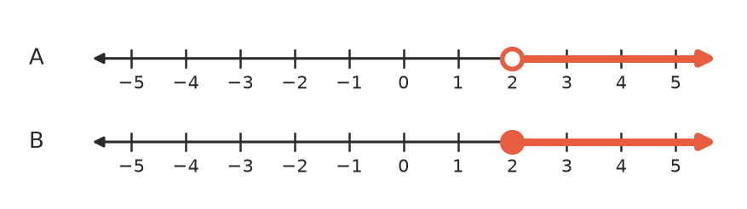
  - Which number line shows $x≥2$?
  - Is 2 a solution of $x>2$? Explain how number line A shows this.

 Fluency
- Write the inequality shown on each number line.
  - 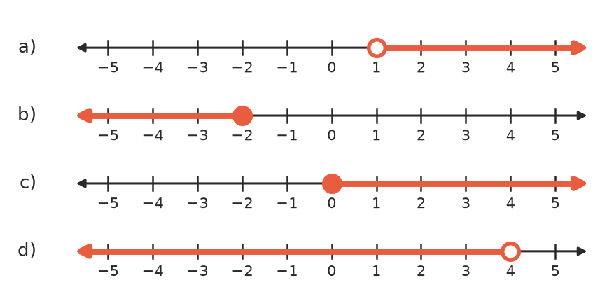

- Show each inequality on a grid in your book with the same letter: a) $x>3$, b) $x≤1$, c) $x≥−2$, d) $x<0$.
- Solve each inequality.
  - $x+4>9$
  - $x−3≤4$
  - $3x<12$
  - $\frac{x}{2}≥3$
  - $2x+1>7$
  - $4x−3≤13$

 Reasoning
- Use substitution to decide whether each value is a solution of $2x+3>12$. Write Yes or No.
Value | Working
$x=5$
$x=4$
$x=4.5$
$x=10$

- List the whole numbers that make each inequality true.
  - $x<4$ (whole numbers start at 0)
  - $−2≤x<3$ (list the integers)

 Problem solving
- Write an inequality for each sentence.
  - A lift can carry at most 800 kg. Use $m$ for the mass.
  - You must be at least 16 years old to get a learner’s permit. Use $a$ for age.
  - Riders must be taller than 120 cm. Use $h$ for height.
- Sam has $10 to spend at the canteen. Pies cost $3 each.
  - Write an inequality for the number of pies, $p$, he can buy.
  - Solve it. What is the greatest number of pies he can buy?
- Mia’s phone plan has 20 GB of data. She has used 8 GB, and she uses 1.5 GB each day.
  - Write an inequality for the number of days, $d$, before she runs out.
  - Solve it. For how many more days can she use data?

