6.05 Intersecting lines
Year 8 Maths · Worksheet · Level 3 · Challenge
Name: ____________________ Date: ______________
This worksheet extends intersecting lines to fractions and decimals, equations not written as $y=…$, lines that never meet or always meet, and real problems that compare two options. Tip: if one equation is written like $x+y=10$, substitute the other rule for $y$ into it. Always find both coordinates of the point.

 Understanding
- Two different straight lines can meet once, never, or be the same line. Write a pair of equations for each case.
  - They meet at exactly one point. ______________
  - They never meet. ______________
  - They are the same line, so they meet at every point. ______________
- Without solving, decide how many times each pair of lines meets. Explain.
  - $y=4x−1$ and $y=4x+3$ ______________
  - $y=2x+5$ and $2y=4x+10$ ______________
  - $y=−x+2$ and $y=x−2$ ______________

 Fluency
- Use algebra to find the point of intersection of each pair of lines.
  - $y=5x−7$ and $y=2x+8$ ______________
  - $y=−3x+1$ and $y=2x−14$ ______________
  - $y=0.5x+4$ and $y=−x−2$ ______________
  - $y=\frac{2}{3}x+1$ and $y=6−x$ ______________
  - $x+y=10$ and $y=3x−2$ ______________
  - $2x+y=1$ and $y=x+7$ ______________
- Draw $y=−\frac{1}{2}x+3$ and $y=2x−2$ on the grid. Write the point of intersection and check it by substitution. ______________
- 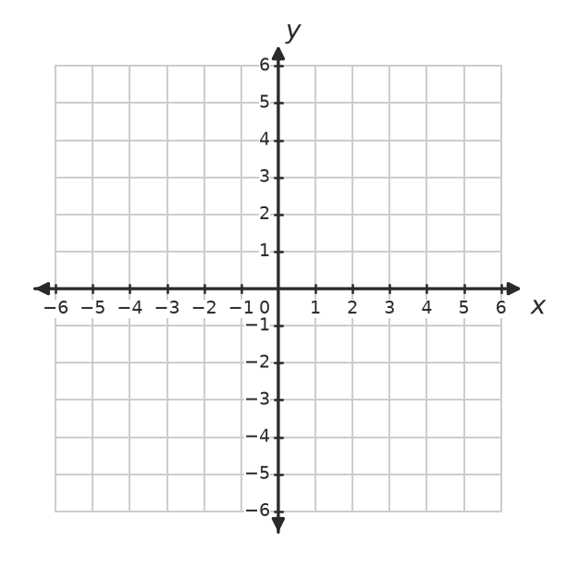
- The graph shows $y=3x−2$ and $y=−x+3$.
- 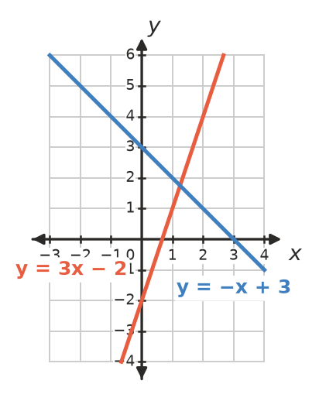
  - Estimate the point of intersection from the graph. ______________
  - Find the exact point with algebra. ______________
  - Why is algebra more useful than the graph here? ______________

 Reasoning
- The lines $y=kx+3$ and $y=2x−1$ are drawn on the same axes.
  - Find $k$ if the lines meet where $x=4$. ______________
  - For what value of $k$ do the lines never meet? ______________
- Do the three lines $y=x+1$, $y=7−x$ and $y=2x−2$ all pass through one point? Show how you know. ______________

- Tom found where $y=2x+3$ and $y=−x+9$ meet like this: “$2x+3=−x+9$, so $x=6$, and the point is (6, 15).” Find his mistake and the correct point. ______________

 Problem solving
- Three gyms charge different fees.
  - Gym A: $80 joining fee, then $12 per week
  - Gym B: no joining fee, $17 per week
  - Gym C: $140 joining fee, then $9 per week
  - After how many weeks do Gyms A and B cost the same? ______________
  - After how many weeks do Gyms A and C cost the same? ______________
  - Which gym is cheapest for someone who goes for a whole year (52 weeks)? ______________
  - For how many weeks is Gym B the cheapest? ______________

- Arrow Creek and Pine Flat are 60 km apart on a rail trail. Jas leaves Arrow Creek riding towards Pine Flat at 15 km/h. At the same time, Kim leaves Pine Flat riding towards Arrow Creek at 25 km/h.
  - Write a rule for each rider’s distance, $d$ km, from Arrow Creek after $t$ hours. ______________
  - Draw both lines on the axes.
- 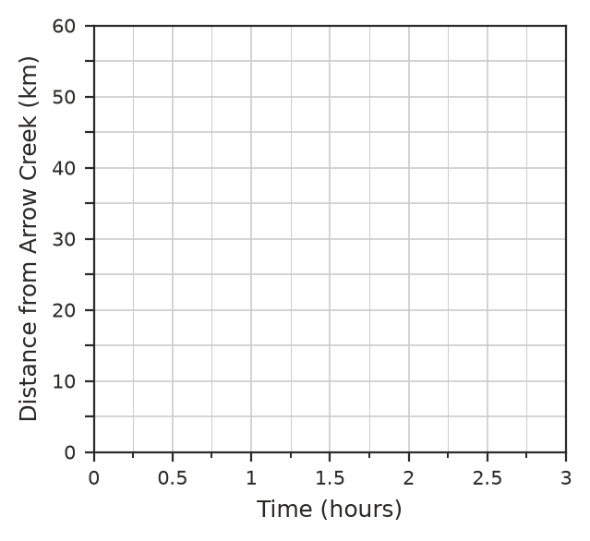
  - When and where do they meet? Check with algebra. ______________
- The lines $y=2x+4$ and $y=−x+7$ and the $x$-axis form a triangle. Find its area.

- A small business spends $1200 to set up a T-shirt printing stall. Each T-shirt costs $8 to make and sells for $20.
  - How many T-shirts must they sell to break even? ______________
  - How much profit do they make if they sell 150 T-shirts? ______________
- Find the equation of the line that passes through the origin and through the point where $y=3x−4$ meets $y=x+2$. ______________

