6.05 Intersecting lines
Year 8 Maths · Worksheet · Level 1 · Warm-up
Name: ____________________ Date: ______________
This worksheet practises finding the point where two lines cross, from a graph and from a table, and checking it by substitution. Tip: the point of intersection is on both lines, so its coordinates must make both rules true.

 Understanding
- The graph shows the lines $y=x+1$ and $y=5−x$.
- 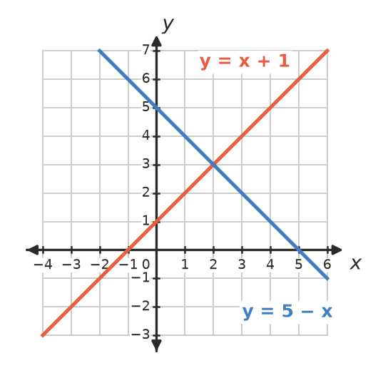
  - Write the point of intersection. ______________
  - Substitute the point into both rules to check it. ______________

- Where do these lines cross? Sketch them on scrap paper if it helps.
  - $y=3$ and $x=−2$ ______________
  - $y=−1$ and $x=4$ ______________

 Fluency
- Use the graph to write the point where each pair of lines crosses.
- 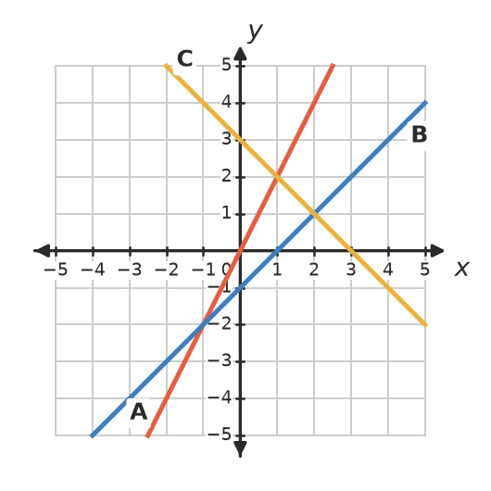
  - Lines A and B ______________
  - Lines A and C ______________
  - Lines B and C ______________
- Complete the tables, then draw both lines on the grid.
$x$ | −2 | −1 | 0 | 1 | 2 | 3
$y=x+3$
$y=−x+5$

- 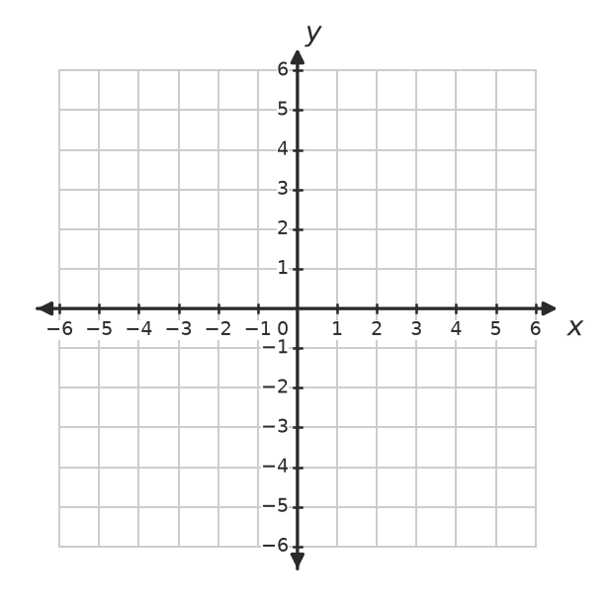
  - Where do the lines cross? ______________
  - How can you see the answer to part a) in the table? ______________
- Use substitution to decide whether the point is where the two lines cross.
  - Is (3, 7) the point of intersection of $y=2x+1$ and $y=x+4$? ______________
  - Is (1, 4) the point of intersection of $y=3x+1$ and $y=2x+3$? ______________

 Reasoning
- The lines $y=2x+1$ and $y=2x−3$ never cross. Explain why. ______________

- Complete the table, then find the value of $x$ where the two rules give the same value of $y$.
$x$ | 0 | 1 | 2 | 3 | 4 | 5
$y=2x+1$
$y=x+4$

- The lines meet at the point ______________

 Problem solving
- Two companies hire out trailers. The graph shows their prices.
- 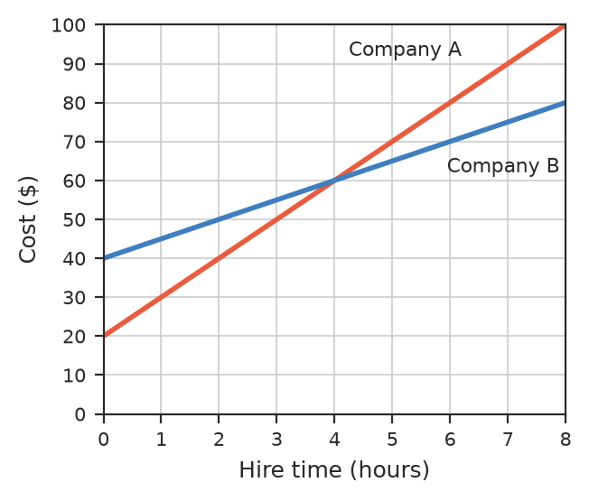
  - How much does each company charge for 2 hours? ______________
  - After how many hours do the two companies charge the same? What is the cost then? ______________
  - Which company is cheaper for 6 hours? By how much? ______________
- Kai has $10 and saves $5 each week. Ruby has $30 and saves $3 each week.
Week | 0 | 2 | 4 | 6 | 8 | 10 | 12
Kai ($)
Ruby ($)

  - Complete the table.
  - After how many weeks do they have the same amount? How much? ______________
  - Who has more money after 12 weeks? ______________
- Write the rules of two different lines that cross at the point (0, 4). ______________

