6.05 Intersecting lines
Year 8 Maths · A5 question sheet · Level 2 · Core
This worksheet practises finding where two lines meet by graphing and with algebra, using intersecting lines to solve equations, and interpreting the point of intersection in real situations. Tip: to find where $y=3x−2$ meets $y=x+6$ with algebra, make the right-hand sides equal: $3x−2=x+6$. Solve for $x$, then substitute to find $y$.

 Understanding
- The graph shows the lines $y=2x−1$ and $y=−x+5$.
- 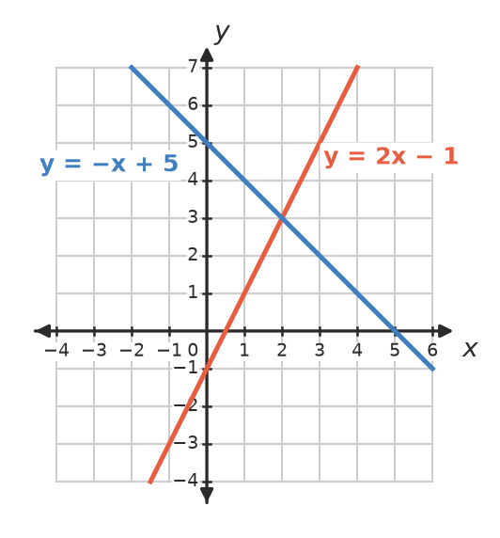
  - Write the point of intersection.
  - Check your answer by substituting into both equations.
- Without drawing them, decide whether each pair of lines crosses. If they do, say where.
  - $y=3x+2$ and $y=3x−1$
  - $y=3x+2$ and $y=−3x+2$

 Fluency
- Draw $y=2x+1$ and $y=4−x$ on a grid in your book. Write the point of intersection.
- Draw $y=x−2$ and $y=−2x+4$ on a grid in your book. Write the point of intersection.
- Use algebra to find the point of intersection of each pair of lines.
  - $y=3x−2$ and $y=x+6$
  - $y=5−2x$ and $y=x−7$
  - $y=4x+1$ and $y=2x−5$
  - $y=−x+2$ and $y=3x+10$
  - $y=0.5x+3$ and $y=2x−3$
- Find the point where each pair of lines meets.
  - $y=2x−5$ and $y=7$
  - $y=−3x+4$ and $x=−2$
  - $x=3$ and $y=−4$
- The graph shows $y=2x−3$ and $y=6−x$.
- 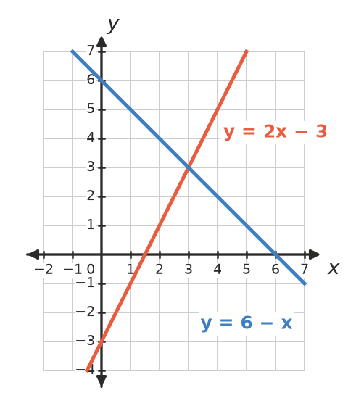
  - Use the graph to solve the equation $2x−3=6−x$.
  - Check your answer by substitution.

 Reasoning
- Explain why the lines $y=2x+1$ and $y=2x−4$ never meet. What happens if you try to find the point of intersection with algebra?
- Ella says that the lines $y=3x−1$ and $y=x+5$ meet at (2, 5). Show that she is wrong, then find the correct point.

 Problem solving
- The graph shows the total cost of two phone plans.
- 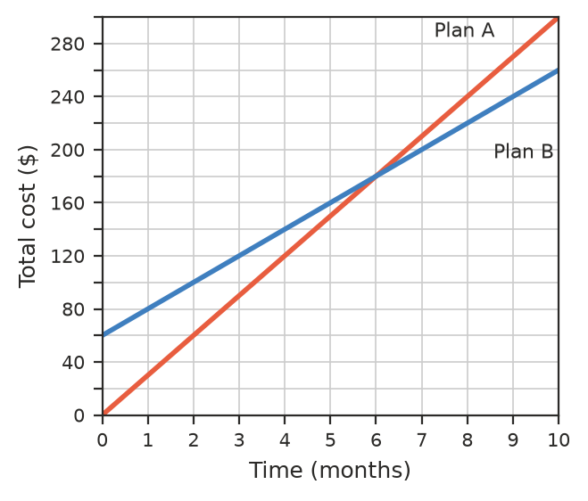
  - Plan A has no set-up fee. Plan B has a set-up fee. How much is it?
  - After how many months have the plans cost the same?
  - Write a rule for the total cost, $C$, of each plan after $m$ months.
  - Use your rules to check your answer to part b).
  - Which plan is cheaper for someone who keeps it for 10 months?
- Candle A is 24 cm tall and burns down 2 cm every hour. Candle B is 16 cm tall and burns down 1 cm every hour. Both are lit at the same time.
  - Write a rule for the height, $h$ cm, of each candle after $t$ hours.
  - Use algebra to find when the candles are the same height, and what that height is.
- For a bake sale, the Year 8s spend $45 on equipment. Each cupcake costs $1.50 to make and sells for $3.
  - Write a rule for their total cost, $C$, and a rule for their income, $I$, from $n$ cupcakes.
  - How many cupcakes must they sell to break even (income = cost)?
  - What happens if they sell more cupcakes than this?
- A line passes through (0, 1). It crosses the line $y=7−x$ where $x=2$. Find the equation of the line.
- The lines $y=x+2$, $y=−x+6$ and the $x$-axis form a triangle. Find the coordinates of its three corners and its area.

