6.05 Intersecting lines
Year 8 Maths · A5 question sheet · Level 1 · Warm-up
This worksheet practises finding the point where two lines cross, from a graph and from a table, and checking it by substitution. Tip: the point of intersection is on both lines, so its coordinates must make both rules true.

 Understanding
- The graph shows the lines $y=x+1$ and $y=5−x$.
- 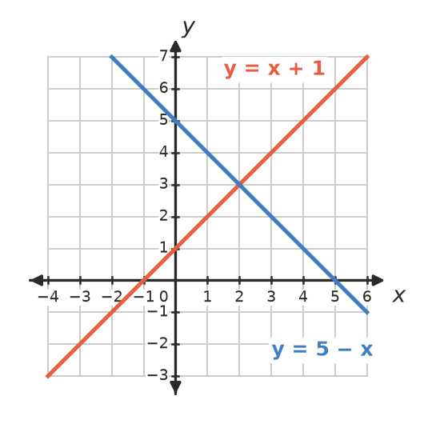
  - Write the point of intersection.
  - Substitute the point into both rules to check it.
- Where do these lines cross? Sketch them on scrap paper if it helps.
  - $y=3$ and $x=−2$
  - $y=−1$ and $x=4$

 Fluency
- Use the graph to write the point where each pair of lines crosses.
- 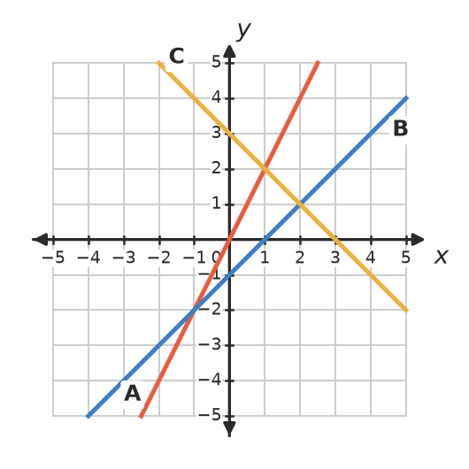
  - Lines A and B
  - Lines A and C
  - Lines B and C
- Copy and complete the tables, then draw both lines on a grid in your book.
$x$ | −2 | −1 | 0 | 1 | 2 | 3
$y=x+3$
$y=−x+5$

  - Where do the lines cross?
  - How can you see the answer to part a) in the table?
- Use substitution to decide whether the point is where the two lines cross.
  - Is (3, 7) the point of intersection of $y=2x+1$ and $y=x+4$?
  - Is (1, 4) the point of intersection of $y=3x+1$ and $y=2x+3$?

 Reasoning
- The lines $y=2x+1$ and $y=2x−3$ never cross. Explain why.
- Copy and complete the table, then find the value of $x$ where the two rules give the same value of $y$.
$x$ | 0 | 1 | 2 | 3 | 4 | 5
$y=2x+1$
$y=x+4$

- The lines meet at the point

 Problem solving
- Two companies hire out trailers. The graph shows their prices.
- 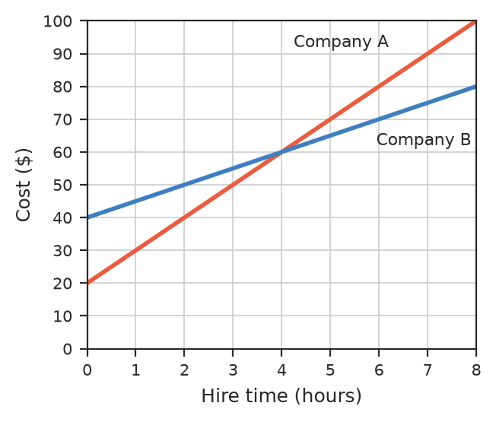
  - How much does each company charge for 2 hours?
  - After how many hours do the two companies charge the same? What is the cost then?
  - Which company is cheaper for 6 hours? By how much?
- Kai has $10 and saves $5 each week. Ruby has $30 and saves $3 each week.
Week | 0 | 2 | 4 | 6 | 8 | 10 | 12
Kai ($)
Ruby ($)

  - Copy and complete the table.
  - After how many weeks do they have the same amount? How much?
  - Who has more money after 12 weeks?
- Write the rules of two different lines that cross at the point (0, 4).

