6.03 Linear graphs
Year 8 Maths · Worksheet · Level 3 · Challenge
Name: ____________________ Date: ______________
This worksheet extends linear graphs to finding gradients from two points, finding the equation of a line, graphing with intercepts and modelling real situations. Tip: gradient = rise ÷ run = (change in $y$) ÷ (change in $x$). Once you know the gradient $m$, substitute one point into $y=mx+c$ to find $c$.

 Understanding
- Complete the table. For the last column, write rising, falling or horizontal.
Line | Gradient | $y$-intercept | $x$-intercept | Rising, falling or horizontal
$y=−3x+6$
$y=\frac{1}{2}x−4$
$2y=4x+10$
$y=7$

- Find the gradient of the line through each pair of points.
  - (1, 2) and (4, 11) ______________
  - (−2, 5) and (2, −3) ______________
  - (0, −3) and (6, 1) ______________

 Fluency
- Draw both lines on the grid.
  - Complete the table for $y=−\frac{1}{2}x+2$, then draw the line.
$x$ | −4 | −2 | 0 | 2 | 4 | 6
$y$

  - Find the intercepts of $3x+2y=12$, then use them to draw the line. ______________
- 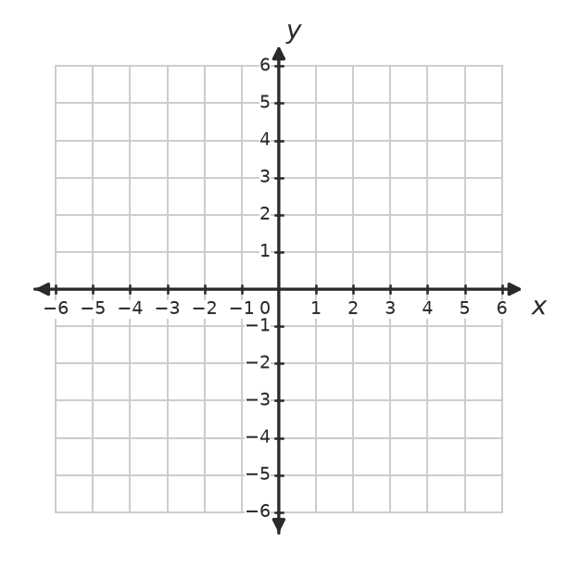
  - What do you notice about the two lines? ______________
- Write the equation of each line.
- 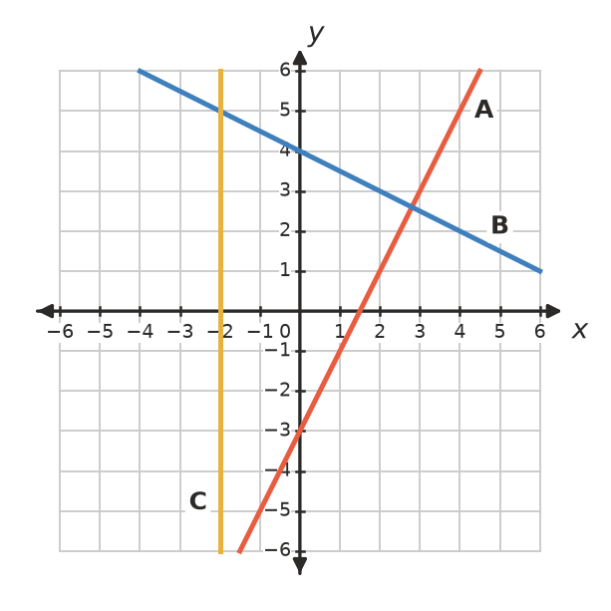
Line | A | B | C
Equation

- Write the equation of each line.
  - gradient 4 and $y$-intercept −1 ______________
  - passes through the origin and (3, −6) ______________
  - horizontal, passing through (5, −3) ______________
  - $y$-intercept 6 and $x$-intercept 3 ______________
  - passes through (2, 7) and (4, 11) ______________

 Reasoning
- Answer each question using substitution.
  - Does (−4, 15) lie on $y=3−3x$? ______________
  - Does the line $y=0.5x+1$ pass through (10, 5)? ______________
  - The point $(k,11)$ lies on $y=4x−5$. Find $k$. ______________
- Explain why the vertical line $x=2$ can’t be written in the form $y=mx+c$. ______________

- Will the lines $y=3x+2$ and $y=3x−5$ ever cross? Explain. ______________

 Problem solving
- During a dry summer, a farm dam loses water at a steady rate.
- 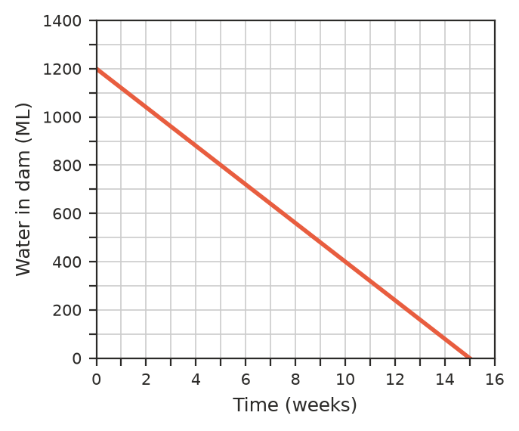
  - How much water was in the dam at the start? ______________
  - Find the gradient of the line, including its units. What does it mean? ______________
  - Write a rule for the volume, $V$ ML, after $w$ weeks. ______________
  - After how many weeks did the dam hold 560 ML? ______________
  - What does the $w$-intercept tell you? Would it make sense to extend the line past it? ______________

- The graph changes temperatures from degrees Celsius to degrees Fahrenheit. Its rule is $F=1.8C+32$.
- 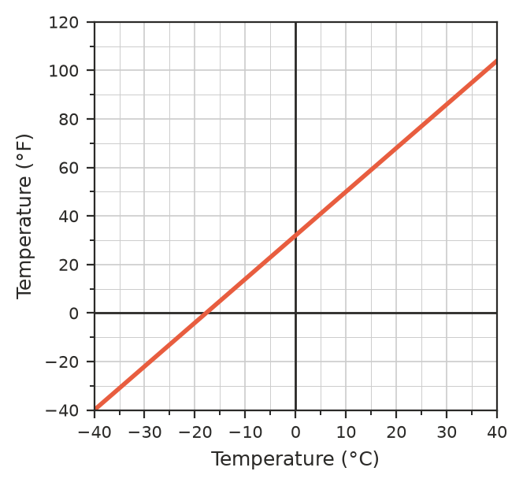
  - Use the graph to estimate the Fahrenheit temperature for 20 °C. Check with the rule. ______________
  - Use the graph to find the Celsius temperature for 50 °F. ______________
  - There is one temperature that is the same in both scales. Find it on the graph, then check it with algebra. ______________

- A line passes through (−2, −1) and (4, 8).
  - Find its gradient. ______________
  - Find its equation. ______________
  - Where does it cross the $x$-axis? ______________
  - Does it pass through (10, 17)? ______________
- A gym charges a joining fee plus a weekly fee. After 5 weeks Tom had paid $195 in total. After 9 weeks he had paid $315.
  - What is the weekly fee? ______________
  - What is the joining fee? ______________
  - Write a rule for the total cost, $C$, after $w$ weeks. ______________
  - What do the gradient and the $C$-intercept of the graph of this rule stand for? ______________

