6.03 Linear graphs
Year 8 Maths · Worksheet · Level 2 · Core
Name: ____________________ Date: ______________
This worksheet practises plotting straight lines, finding intercepts and gradients, horizontal and vertical lines, and reading graphs of real situations. Tip: in $y=mx+c$, $m$ is the gradient (how much $y$ goes up when $x$ goes up by 1) and $c$ is the y-intercept. To find the $x$-intercept, put $y=0$ and solve.

 Understanding
- The graph shows the line $y=−2x+3$.
- 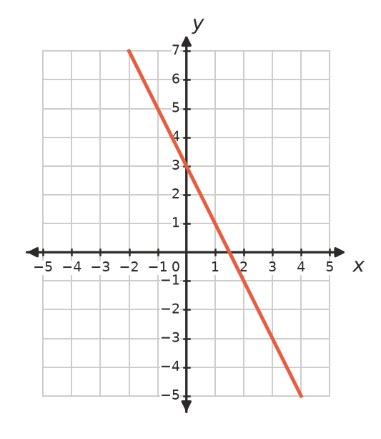
  - What is the $y$-intercept? ______________
  - What is the $x$-intercept? ______________
  - Does the point (−1, 5) lie on the line? Check by substitution. ______________
  - Use the rule to find $y$ when $x=2$. ______________
- Write the gradient and the $y$-intercept of each line.
Equation | Gradient, $m$ | $y$-intercept, $c$
$y=3x−2$
$y=−x+5$
$y=0.5x$
$y=4−2x$

 Fluency
- The rule is $y=2x+3$.
$x$ | −4 | −3 | −2 | −1 | 0 | 1
$y$

  - Complete the table.
  - Plot the points on the grid and join them with a ruler.
- 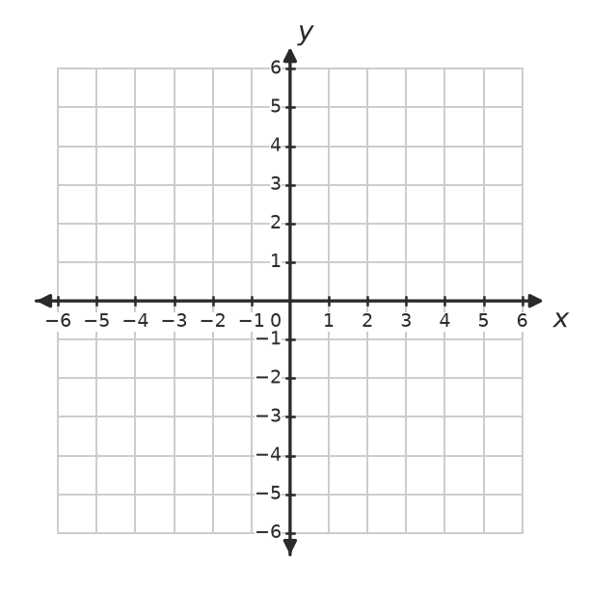
  - Write the $x$-intercept and the $y$-intercept. ______________
- Find the $x$-intercept and the $y$-intercept of each line, without drawing it.
  - $y=2x−6$ ______________
  - $y=−3x+9$ ______________
  - $y=4x$ ______________
  - $x+y=7$ ______________
  - $y=5$ ______________
- Write the equation of each line.
- 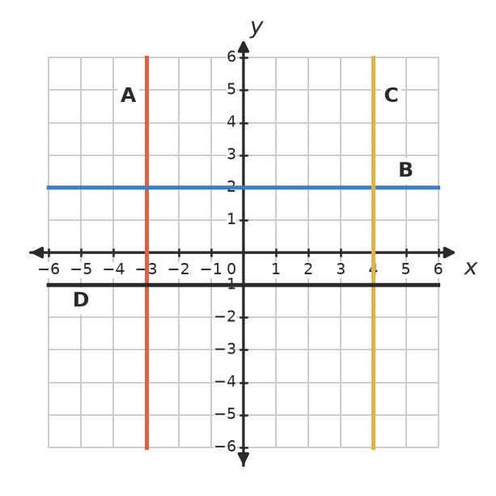
Line | A | B | C | D
Equation

- Does each point lie on the line $y=−2x+7$? Write Yes or No.
Point | Working | Yes or No
(3, 1)
(−2, 11)
(5, −2)
(0.5, 6)

 Reasoning
- Match each rule with a line on the graph. Explain how you decided.
- 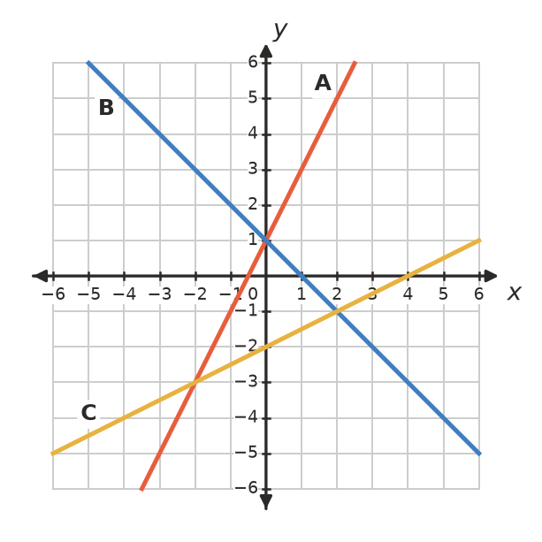
  - $y=2x+1$ is line ______________
  - $y=1−x$ is line ______________
  - $y=0.5x−2$ is line ______________

- The line passes through P(−1, 4) and Q(3, −4).
- 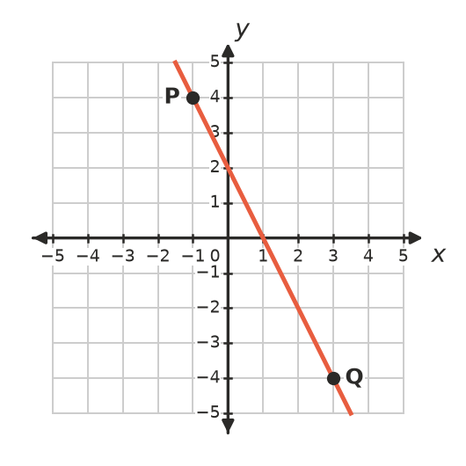
  - Going from P to Q, what is the rise and what is the run? ______________
  - Find the gradient (rise ÷ run). ______________
  - Write the equation of the line. ______________
- Explain why the graph of $y=3x$ passes through the origin, but the graph of $y=3x+1$ does not. ______________

 Problem solving
- Use your graph of $y=2x+3$ from Question 3 to solve each equation. Check each answer by substitution.
  - $2x+3=7$ ______________
  - $2x+3=−3$ ______________
- The graph shows a phone charging.
- 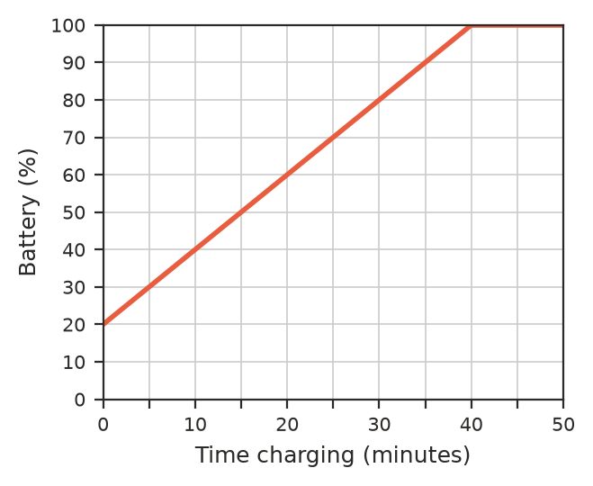
  - What was the battery level when charging started? ______________
  - What was the battery level after 15 minutes? ______________
  - How long did it take to reach 80%? ______________
  - By how many percent does the battery go up each minute? ______________
  - Write a rule for the battery level, $B$ %, after $t$ minutes, until it is full. ______________
  - Why does the graph become flat after 40 minutes? ______________
- A pool cleaner charges a $40 call-out fee plus $30 per hour.
  - Write a rule for the cost, $C$, of an $h$-hour job. ______________
  - Draw the graph of the cost for jobs from 0 to 6 hours.
- 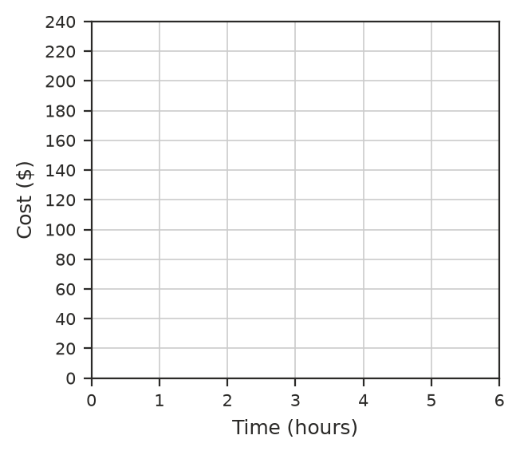
  - Use your graph to find how long a job that costs $145 took. ______________
- Without drawing the line, find where $y=5x−12$ crosses each axis. ______________

