6.03 Linear graphs
Year 8 Maths · Worksheet · Level 1 · Warm-up
Name: ____________________ Date: ______________
This worksheet practises plotting straight-line graphs from a table of values, reading points and intercepts from a graph, and reading graphs of real situations. Tip: plot at least three points and join them with a ruler. If the three points don’t line up, check your table.

 Understanding
- The graph shows the line $y=x+2$.
- 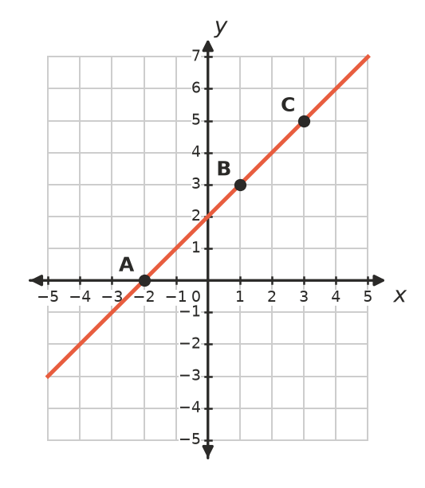
  - Write the coordinates of A, B and C. ______________
  - Use the graph to find $y$ when $x=3$. ______________
  - Where does the line cross the $y$-axis? ______________
- Fill in the gaps with x-intercept or y-intercept.
  - The point where a line crosses the $y$-axis is called the ______________
  - The point where a line crosses the $x$-axis is called the ______________

 Fluency
- The rule is $y=2x−1$.
$x$ | −1 | 0 | 1 | 2 | 3
$y$

  - Complete the table.
  - Plot the points on the grid and join them with a ruler.
- 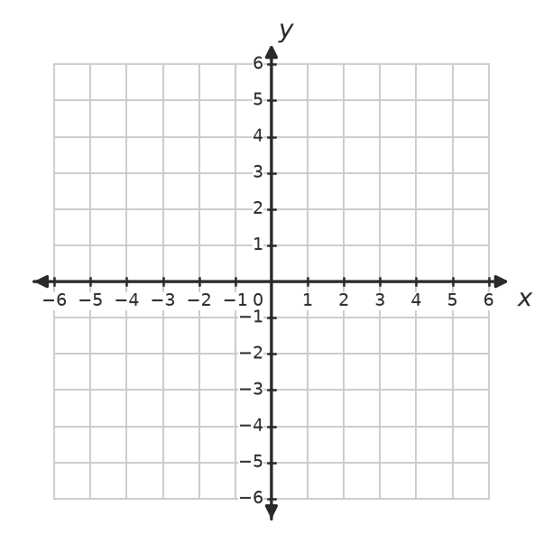
  - What is the $y$-intercept? ______________
- The rule is $y=4−x$.
$x$ | −1 | 0 | 1 | 2 | 3 | 4
$y$

  - Complete the table.
  - Plot the points on the grid and join them with a ruler.
  - Write the $x$-intercept and the $y$-intercept. ______________
- Use the graph to complete the table.
- 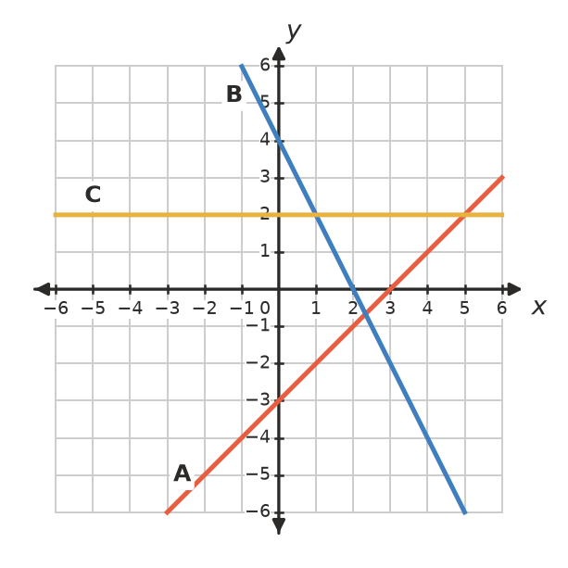
Line | $y$-intercept | $x$-intercept
A
B
C

 Reasoning
- Use substitution to decide whether each point lies on the line $y=3x+1$. Write Yes or No.
Point | Working | Yes or No
(2, 7)
(−1, −2)
(4, 12)
(0, 1)

- Think about the line $y=4$.
  - Write three points that lie on this line. ______________
  - Is the line horizontal or vertical? ______________
  - Why does line C in Question 5 have no $x$-intercept? ______________

 Problem solving
- The graph shows the cost of hiring a kayak.
- 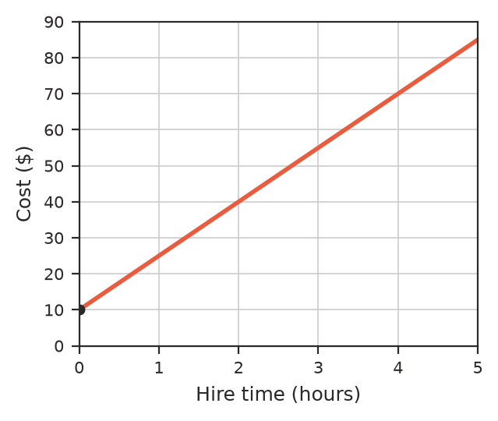
  - What is the cost at 0 hours? What do you think this amount is for? ______________
  - How much does it cost to hire a kayak for 2 hours? ______________
  - For how long can you hire a kayak for $70? ______________
  - How much does the cost go up for each extra hour? ______________
- A tank is drained through a tap. The graph shows the water left in the tank.
- 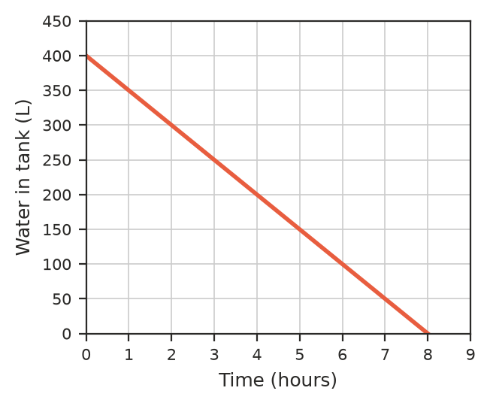
  - How much water was in the tank at the start? ______________
  - How much water was left after 3 hours? ______________
  - After how many hours were there 100 L left? ______________
  - Where does the line meet the horizontal axis? What does this point tell you? ______________

- Use your graph of $y=2x−1$ from Question 3 to solve the equation $2x−1=3$. Hint: find the point on the line where $y=3$. ______________
- Ruby says the points (0, 5), (1, 7) and (2, 10) all lie on one straight line. Plot them in your head or on scrap paper and explain whether she is right. ______________

