6.03 Linear graphs
Year 8 Maths · A5 question sheet · Level 3 · Challenge
This worksheet extends linear graphs to finding gradients from two points, finding the equation of a line, graphing with intercepts and modelling real situations. Tip: gradient = rise ÷ run = (change in $y$) ÷ (change in $x$). Once you know the gradient $m$, substitute one point into $y=mx+c$ to find $c$.

 Understanding
- Copy and complete the table. For the last column, write rising, falling or horizontal.
Line | Gradient | $y$-intercept | $x$-intercept
$y=−3x+6$
$y=\frac{1}{2}x−4$
$2y=4x+10$
$y=7$

- Find the gradient of the line through each pair of points.
  - (1, 2) and (4, 11)
  - (−2, 5) and (2, −3)
  - (0, −3) and (6, 1)

 Fluency
- Draw both lines on a grid in your book.
  - Copy and complete the table for $y=−\frac{1}{2}x+2$, then draw the line.
$x$ | −4 | −2 | 0 | 2 | 4 | 6
$y$

  - Find the intercepts of $3x+2y=12$, then use them to draw the line.
  - What do you notice about the two lines?
- Write the equation of each line.
- 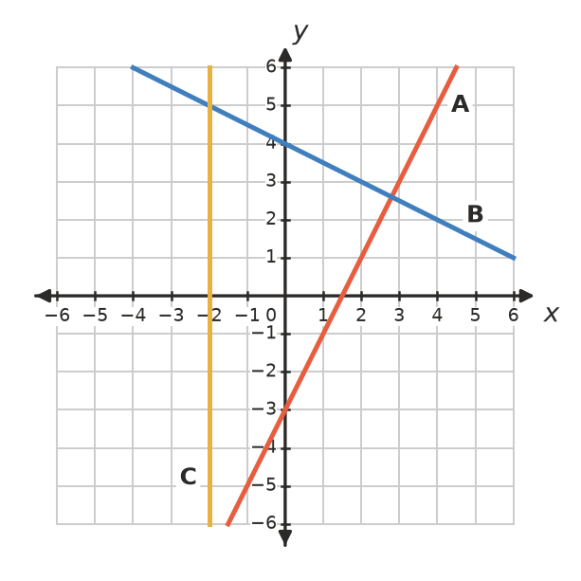
Line | A | B | C
Equation

- Write the equation of each line.
  - gradient 4 and $y$-intercept −1
  - passes through the origin and (3, −6)
  - horizontal, passing through (5, −3)
  - $y$-intercept 6 and $x$-intercept 3
  - passes through (2, 7) and (4, 11)

 Reasoning
- Answer each question using substitution.
  - Does (−4, 15) lie on $y=3−3x$?
  - Does the line $y=0.5x+1$ pass through (10, 5)?
  - The point $(k,11)$ lies on $y=4x−5$. Find $k$.
- Explain why the vertical line $x=2$ can’t be written in the form $y=mx+c$.
- Will the lines $y=3x+2$ and $y=3x−5$ ever cross? Explain.

 Problem solving
- During a dry summer, a farm dam loses water at a steady rate.
- 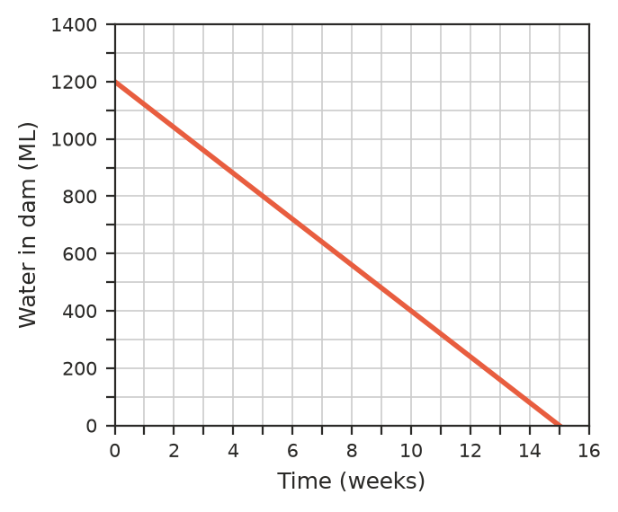
  - How much water was in the dam at the start?
  - Find the gradient of the line, including its units. What does it mean?
  - Write a rule for the volume, $V$ ML, after $w$ weeks.
  - After how many weeks did the dam hold 560 ML?
  - What does the $w$-intercept tell you? Would it make sense to extend the line past it?
- The graph changes temperatures from degrees Celsius to degrees Fahrenheit. Its rule is $F=1.8C+32$.
- 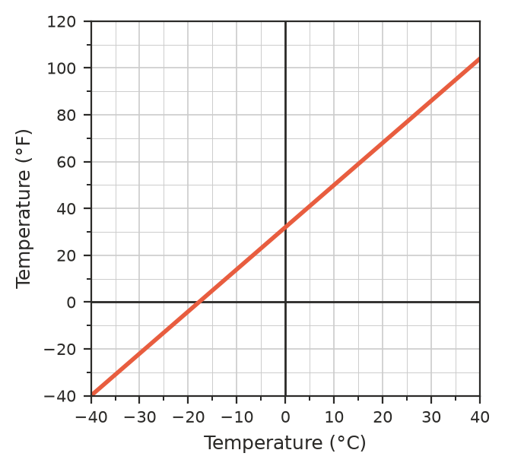
  - Use the graph to estimate the Fahrenheit temperature for 20 °C. Check with the rule.
  - Use the graph to find the Celsius temperature for 50 °F.
  - There is one temperature that is the same in both scales. Find it on the graph, then check it with algebra.
- A line passes through (−2, −1) and (4, 8).
  - Find its gradient.
  - Find its equation.
  - Where does it cross the $x$-axis?
  - Does it pass through (10, 17)?
- A gym charges a joining fee plus a weekly fee. After 5 weeks Tom had paid $195 in total. After 9 weeks he had paid $315.
  - What is the weekly fee?
  - What is the joining fee?
  - Write a rule for the total cost, $C$, after $w$ weeks.
  - What do the gradient and the $C$-intercept of the graph of this rule stand for?

