6.02 Tables of values
Year 8 Maths · Worksheet · Level 2 · Core
Name: ____________________ Date: ______________
This worksheet practises tables of values with negative numbers and decimals, finding rules of the form $y=mx+c$, and using tables to model real situations. Tip: the number multiplying $x$ is the change in $y$ for each step of 1 in $x$. The number added on is the value of $y$ when $x=0$.

 Understanding
- The rule is $y=4x−3$.
$x$ | −2 | −1 | 0 | 1 | 2
$y$

  - Complete the table of values.
  - How does $y$ change each time $x$ goes up by 1? ______________
- Which rule matches this table? Answer: ______________
$x$ | 0 | 1 | 2 | 3
$y$ | 5 | 3 | 1 | −1

  - $y=2x+5$
  - $y=5−2x$
  - $y=x+5$
  - $y=−2x−5$

 Fluency
- Complete each row of the table using its rule.
$x$ | −2 | −1 | 0 | 1 | 2
a) $y=5x+2$
b) $y=−3x+1$
c) $y=0.5x+3$
d) $y=6−2x$

- Write the rule for each row in the last column.
$x$ | 0 | 1 | 2 | 3 | 4 | Rule
a) $y$ | 3 | 7 | 11 | 15 | 19
b) $y$ | −5 | −3 | −1 | 1 | 3
c) $y$ | 12 | 9 | 6 | 3 | 0
d) $y$ | 1 | 1.5 | 2 | 2.5 | 3

- In this table, $x$ goes up by 2 each time.
$x$ | 1 | 3 | 5 | 7
$y$ | 5 | 11 | 17 | 23

  - How much does $y$ go up when $x$ goes up by 1? ______________
  - Write the rule. ______________
- Use the rule $y=3x−4$ to fill in the four empty cells.
$x$ | −1 |  | 3
$y$ |  | 2 |  | 14

- The rule is $y=2x−1$.
$x$ | −2 | −1 | 0 | 1 | 2 | 3
$y$

  - Complete the table.
  - Plot the points on the grid and join them with a ruler.
- 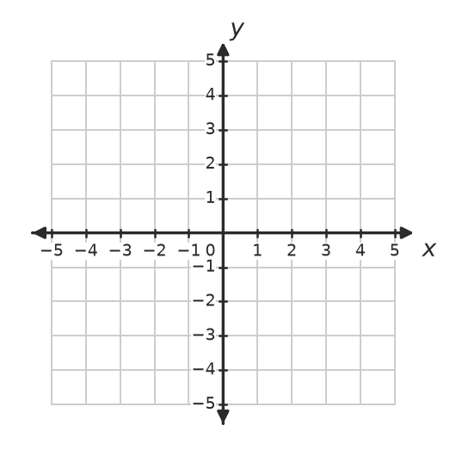

 Reasoning
- Look at these two tables.
$x$ | 1 | 2 | 3 | 4
Table A: $y$ | 2 | 5 | 8 | 11
Table B: $y$ | 1 | 4 | 9 | 16

- Which table shows a linear relationship? Explain how you can tell without plotting the points. ______________

- Lena says the rule for this table is $y=x+6$, because 1 + 6 = 7.
$x$ | 1 | 2 | 3 | 4
$y$ | 7 | 9 | 11 | 13

- Explain why Lena is wrong and write the correct rule. ______________

 Problem solving
- A plumber charges a $70 call-out fee plus $60 for each hour of work.
Hours, $h$ | 0 | 1 | 2 | 3 | 4
Cost, $C$ ($)

  - Complete the table.
  - Write a rule for $C$ in terms of $h$. ______________
  - How much does a 6-hour job cost? ______________
  - A bill was $340. How long did the plumber work? ______________
- A phone battery is fully charged at 100%. While a video plays, it loses 8% every hour.
  - Write a rule for the battery level, $B$ %, after $t$ hours. ______________
  - Complete the table.
$t$ (hours) | 0 | 2 | 4 | 6 | 8
$B$ (%)

  - After how many hours will the battery be at 20%? ______________
- Here is a pattern of hexagons made with matchsticks.
- 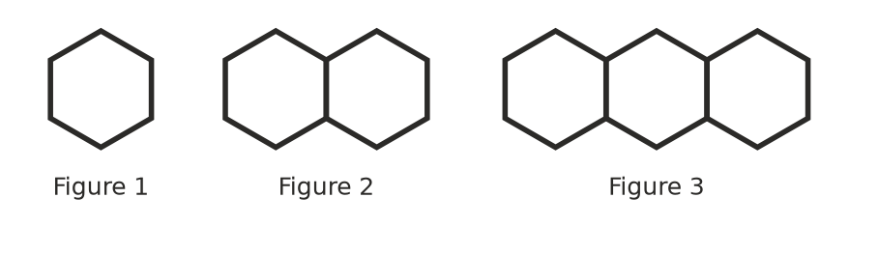
  - Complete the table.
Figure number, $n$ | 1 | 2 | 3 | 4
Matchsticks, $m$

  - Write a rule for $m$ in terms of $n$. ______________
  - How many matchsticks are in Figure 20? ______________
  - Which figure uses 76 matchsticks? ______________
- The youth group runs a car wash to raise money. They spend $30 on soap and sponges and charge $8 per car. Their profit is $P=8c−30$, where $c$ is the number of cars.
  - Complete the table.
Cars, $c$ | 0 | 5 | 10 | 15 | 20
Profit, $P$ ($)

  - What does the profit for 0 cars mean? ______________
  - How many cars must they wash to make a profit of $250? ______________

