6.02 Tables of values
Year 8 Maths · Worksheet · Level 1 · Warm-up
Name: ____________________ Date: ______________
This worksheet practises completing tables of values from a rule, finding the rule from a table, and using tables for real situations. Tip: to find a rule, look at how much $y$ goes up each time $x$ goes up by 1. That number multiplies $x$ in the rule.

 Understanding
- The rule is $y=x+4$. Complete the table of values.
$x$ | 0 | 1 | 2 | 3 | 4
$y$

- The rule is $y=2x$.
$x$ | −2 | −1 | 0 | 1 | 2
$y$

  - Complete the table of values.
  - Each time $x$ goes up by 1, $y$ goes up by ______________

 Fluency
- Complete each row of the table using its rule.
$x$ | −1 | 0 | 1 | 2 | 3
a) $y=3x$
b) $y=x−2$
c) $y=2x+1$
d) $y=10−x$

- Each row of the table follows a different rule. Write the rule for each row in the last column.
$x$ | 1 | 2 | 3 | 4 | Rule
a) $y$ | 6 | 7 | 8 | 9
b) $y$ | 4 | 8 | 12 | 16
c) $y$ | 3 | 5 | 7 | 9
d) $y$ | 9 | 8 | 7 | 6

- Write the five points from row c) of Question 3 as coordinates $(x,y)$. ______________

 Reasoning
- The rule is $y=3x+1$. Would each point appear in a table of values for this rule? Write Yes or No.
Point | Working | Yes or No
(2, 7)
(3, 9)
(0, 1)
(4, 13)

- Explain how you can find $y$ when $x=10$ for the rule $y=2x+1$ without writing out the whole table. What is $y$? ______________

 Problem solving
- A bike hire shop charges $5 for a helmet plus $3 for each hour.
Hours, $h$ | 1 | 2 | 3 | 4 | 5
Cost, $C$ ($)

  - Complete the table.
  - Write a rule for the cost, $C$, for $h$ hours. ______________
  - How much does it cost to hire a bike for 8 hours? ______________
- Here is a pattern made with matchsticks.
- 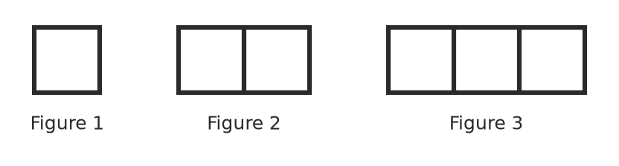
Figure number, $n$ | 1 | 2 | 3 | 4
Matchsticks, $m$

  - Complete the table.
  - Write a rule for the number of matchsticks, $m$, in Figure $n$. ______________
  - How many matchsticks are in Figure 10? ______________
- A water tank holds 50 L. It has a small leak and loses 4 L every hour.
Time, $t$ (hours) | 0 | 1 | 2 | 3 | 4
Water, $W$ (L)

  - Complete the table.
  - Write a rule for the water left, $W$, after $t$ hours. ______________
  - How much water is left after 10 hours? ______________
- Plot the five points from row b) of Question 3 on the grid. Do they lie on a straight line? ______________
- 