6.02 Tables of values
Year 8 Maths · A5 question sheet · Level 3 · Challenge
This worksheet extends tables of values to fractions, decimals and tables where $x$ does not go up by 1, and uses them to model real situations. Tip: to find the rule $y=mx+c$, divide the change in $y$ by the change in $x$ to find $m$. Then substitute one point to find $c$.

 Understanding
- The rule is $y=−2x+5$.
$x$ | −3 | −2 | −1 | 0 | 1 | 2 | 3
$y$

  - Copy and complete the table.
  - Which number in the rule tells you the value of $y$ when $x=0$?
  - Which number in the rule tells you how $y$ changes when $x$ goes up by 1?

 Fluency
- Complete each row of the table using its rule.
$x$ | −4 | −2 | 0 | 2 | 4
a) $y=\frac{3x}{2}−1$
b) $y=−0.5x+2$
c) $y=3(x−2)$
d) $y=1−4x$

- Find the rule for each table.

$x$ | −2 | 0 | 2 | 4
$y$ | −7 | −1 | 5 | 11

$x$ | −3 | −1 | 1 | 3
$y$ | 10 | 6 | 2 | −2

$x$ | 0 | 3 | 6 | 9
$y$ | 4 | 6 | 8 | 10

$x$ | 1 | 2 | 4 | 7
$y$ | 0.5 | 2 | 5 | 9.5

- Use the rule $y=5−3x$ to copy and fill in the four empty cells.
$x$ | −2 |  |  | 4
$y$ |  | −1 | −10

- The rule is $y=\frac{1}{2}x−2$.
$x$ | −4 | −2 | 0 | 2 | 4
$y$

  - Copy and complete the table.
  - Plot the points on a grid in your book and join them with a ruler.

 Reasoning
- Which of these tables show a linear relationship? Explain how you decided.
Table A: $x$ | 0 | 1 | 2 | 3
$y$ | 1 | 2 | 4 | 8

Table B: $x$ | 0 | 2 | 4 | 6
$y$ | 3 | 8 | 13 | 18

Table C: $x$ | 1 | 2 | 3 | 4
$y$ | 20 | 15 | 10 | 5

- A table of values has the rule $y=mx+c$. When $x=0$, $y=−4$. When $x=3$, $y=8$.
  - Find $m$ and $c$.
  - What is $y$ when $x=10$?
- The rule is $y=3−3x$. Use substitution to decide whether each point fits the rule.
  - (−6, 21)
  - (50, −145)

 Problem solving
- A taxi charges $4.20 flagfall plus $2.10 per kilometre.
Distance, $d$ (km) | 0 | 5 | 10 | 15 | 20
Fare, $F$ ($)

  - Copy and complete the table.
  - Write a rule for $F$ in terms of $d$.
  - A fare was $56.70. How far was the trip?
- A candle is 30 cm tall when it is lit. It burns down 2.5 cm every hour.
  - Write a rule for the height, $H$ cm, after $t$ hours.
  - After how many hours is the candle 7.5 cm tall?
  - After how many hours does the candle burn out? Why does the rule stop working after that?
- Square tables are pushed together in a row for a youth group dinner. One chair fits on each free side.
- 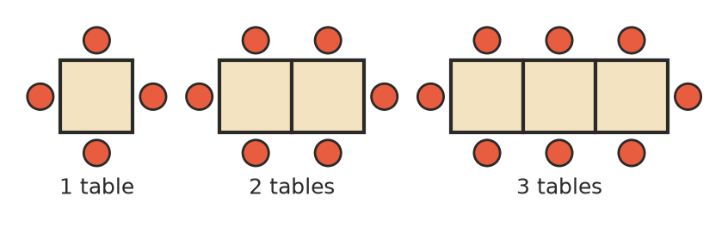
  - Write a rule for the number of chairs, $c$, around $n$ tables.
  - How many chairs fit around 25 tables?
  - How many tables are needed to seat 70 people?
- As an aeroplane climbs, the air outside gets colder. On one day the temperature at ground level is 24 °C, and it drops by 6.5 °C for every kilometre of height.
  - Copy and complete the table.
Height, $h$ (km) | 0 | 1 | 2 | 3 | 4
Temperature, $T$ (°C)

  - Write a rule for $T$ in terms of $h$.
  - What is the temperature at a cruising height of 10 km?
  - At about what height is the temperature 0 °C? Give your answer to the nearest 100 m.
- Write a real-life situation that could be described by the rule $y=20−4x$. Say what $x$ and $y$ stand for.

