Geometry: Practice test 3
Year 8 Maths · Test · Test 3
Name: ____________________ Date: ______________
Time: 45 minutes
Total: 40 marks
Show your working in the boxes. Then write each final answer on the answer sheet on the last page.

 Section A: No calculator
- Find the size of each angle marked with a letter.
- 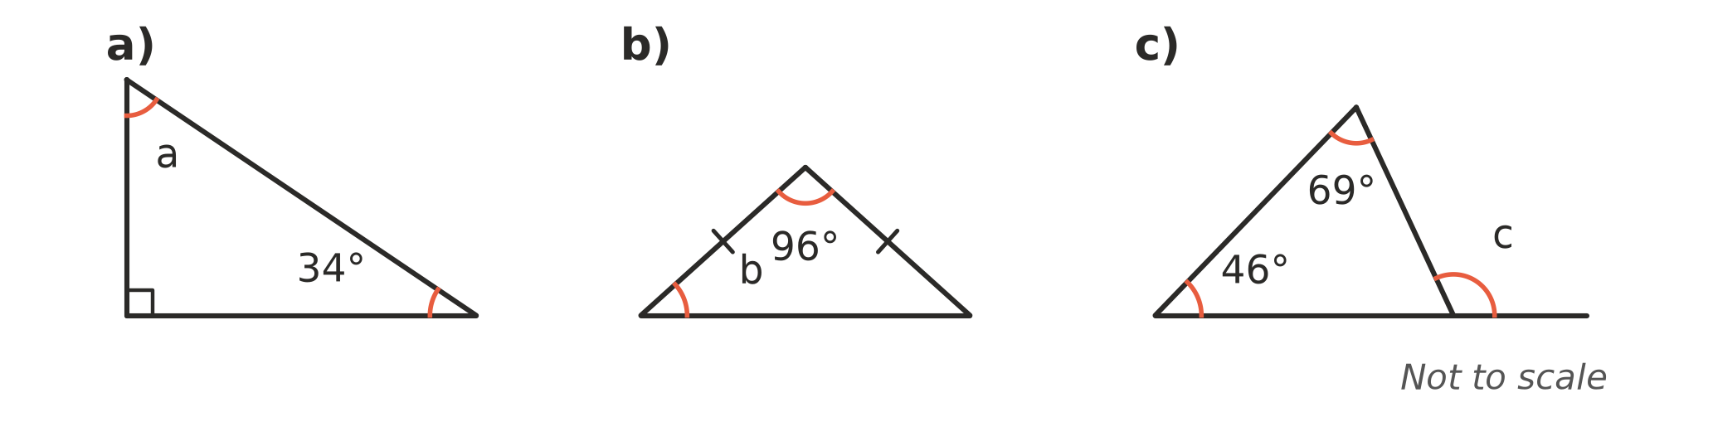
  - (1 mark) a = ______________
  - (1 mark) b = ______________
  - (1 mark) c = ______________

- The two lines marked with arrows are parallel. Find the value of x and give a reason. (2 marks)
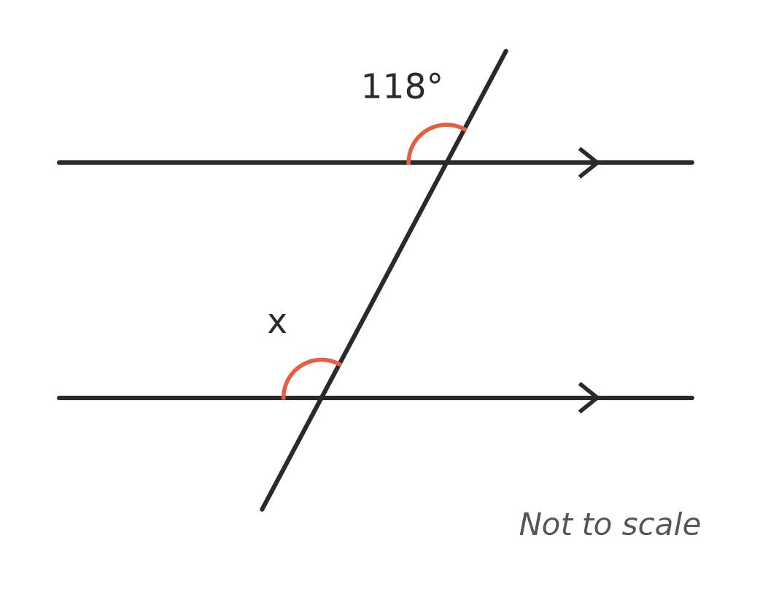

- Explain why a triangle cannot have sides of 5 cm, 7 cm and 13 cm. (1 mark)

- Triangle KLM is congruent to triangle RST (△KLM ≅ △RST).
- 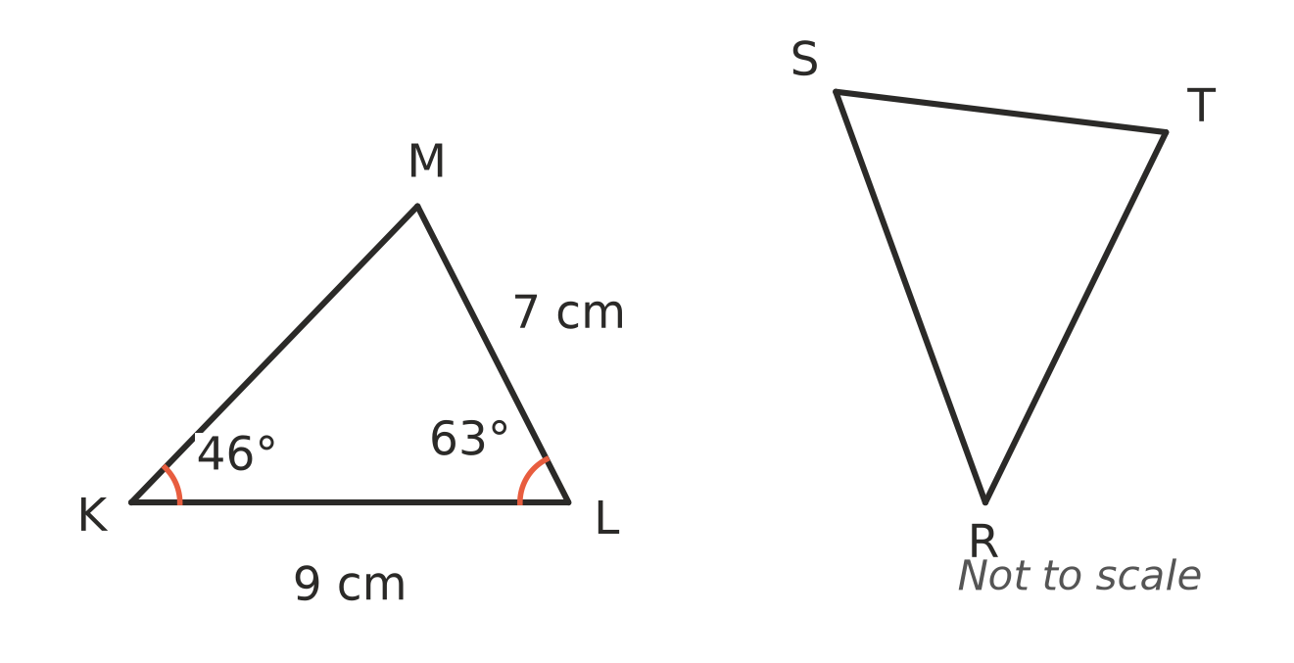
  - Find the length of ST. (1 mark)

  - Find the size of ∠T. (1 mark)

- Shapes A, B and C are drawn on the number plane.
- 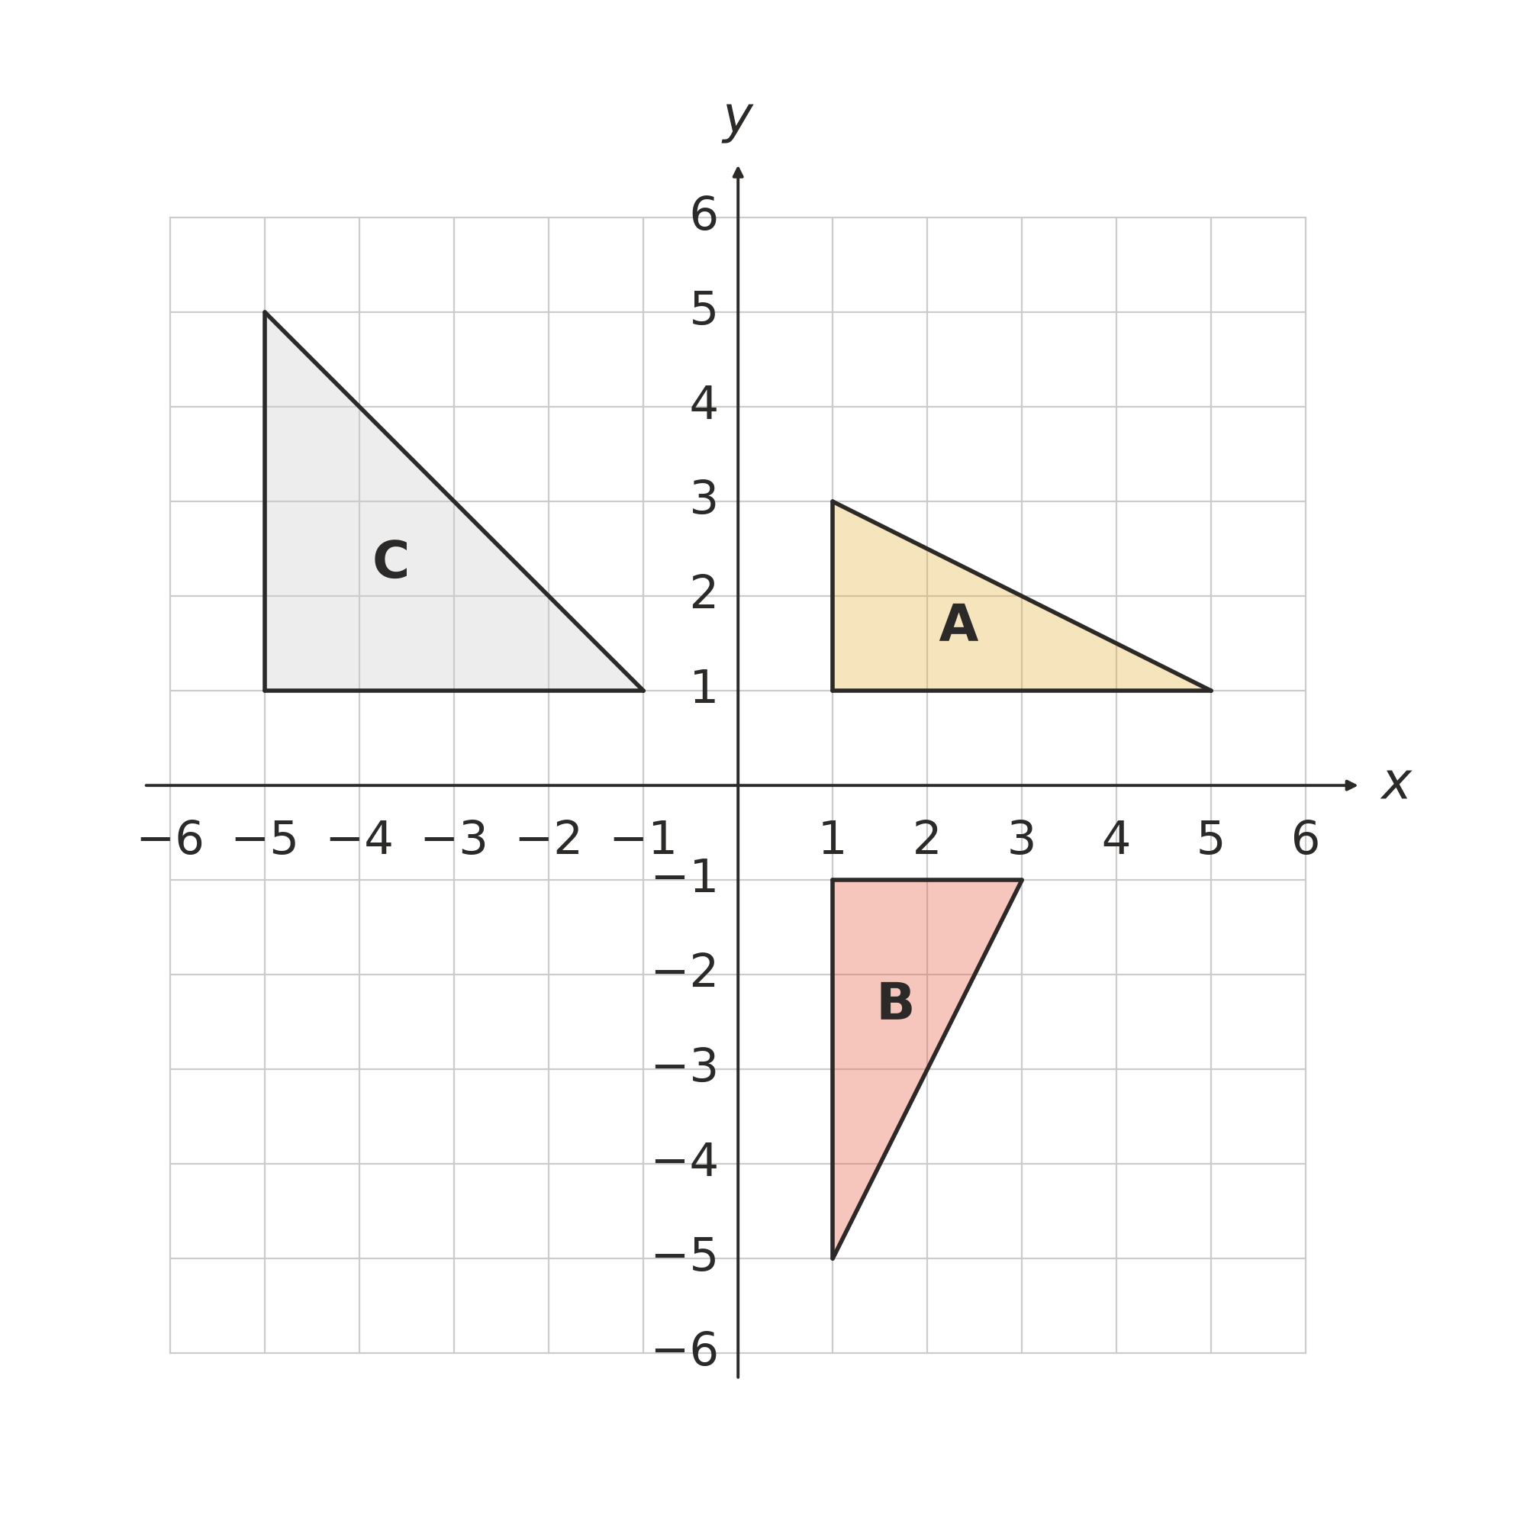
  - Describe the single transformation that maps shape A onto shape B. (1 mark)

  - Is shape C congruent to shape A? Explain. (1 mark)

- Each pair of triangles has equal sides and angles marked the same way. For each pair, write the congruence test (SSS, SAS, AAS or RHS) that proves the triangles are congruent. If the markings are not enough to prove it, write “not enough information”.
- 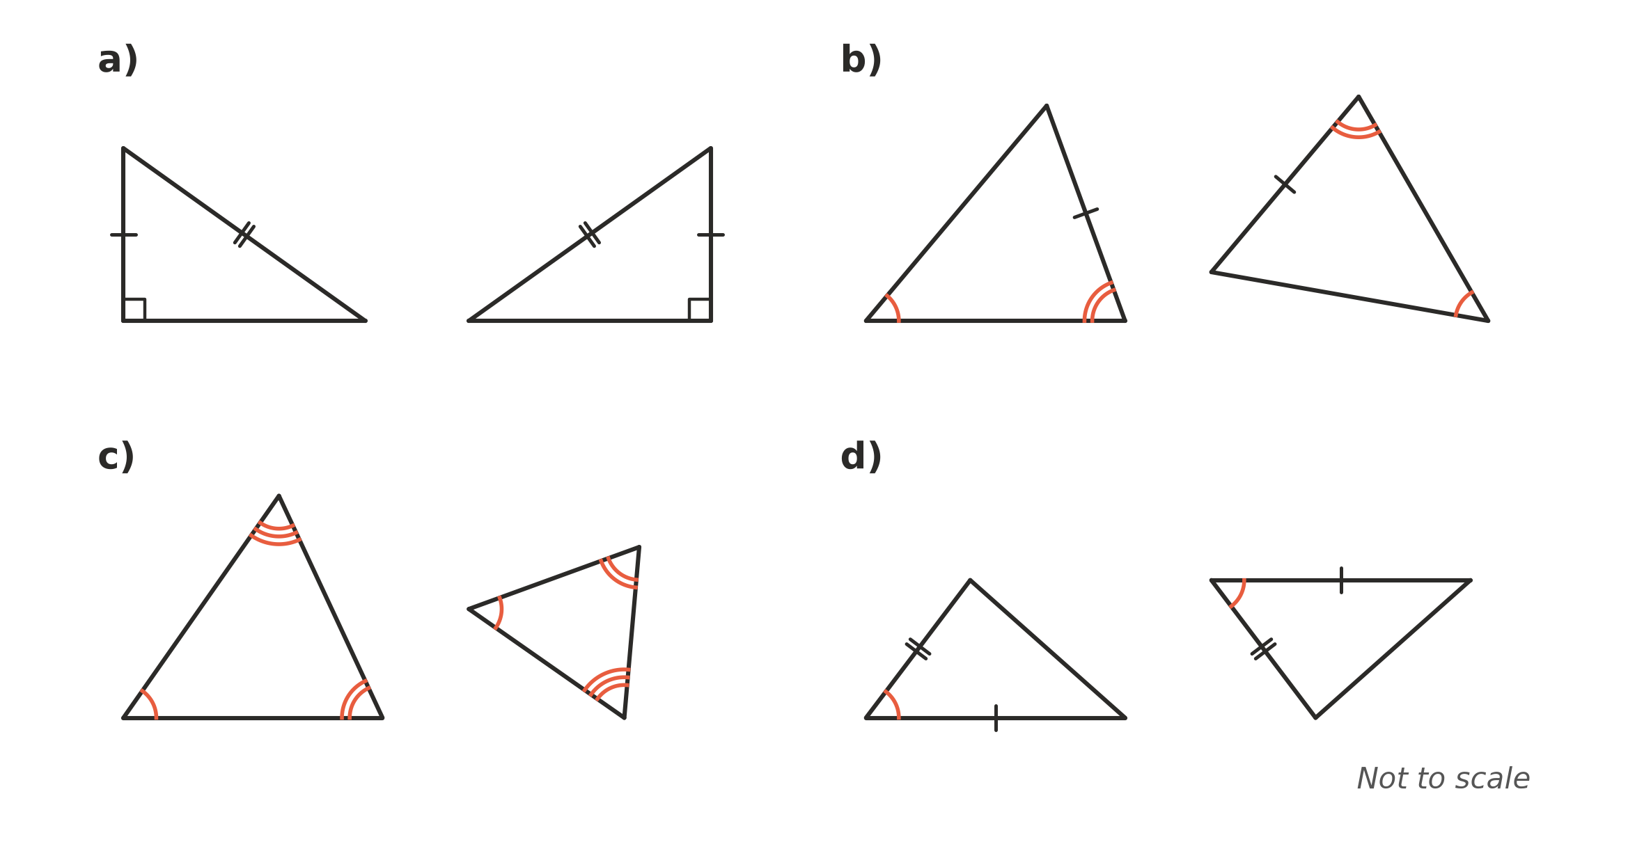
  - (1 mark) Test: ______________
  - (1 mark) Test: ______________
  - (1 mark) Test: ______________
  - (1 mark) Test: ______________

- In △PQR, PQ = PR, and M is the midpoint of QR.
- 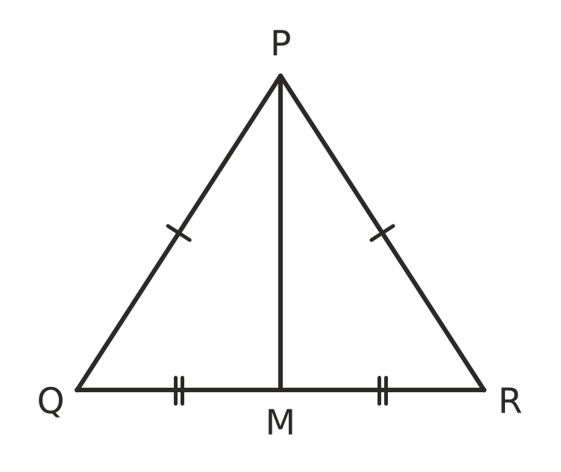
  - Prove that △PQM ≅ △PRM. Give a reason for each step and name the test. (2 marks)

  - Hence show that PM is perpendicular to QR. (1 mark)

- Shape A was enlarged with centre O to make shape B.
- 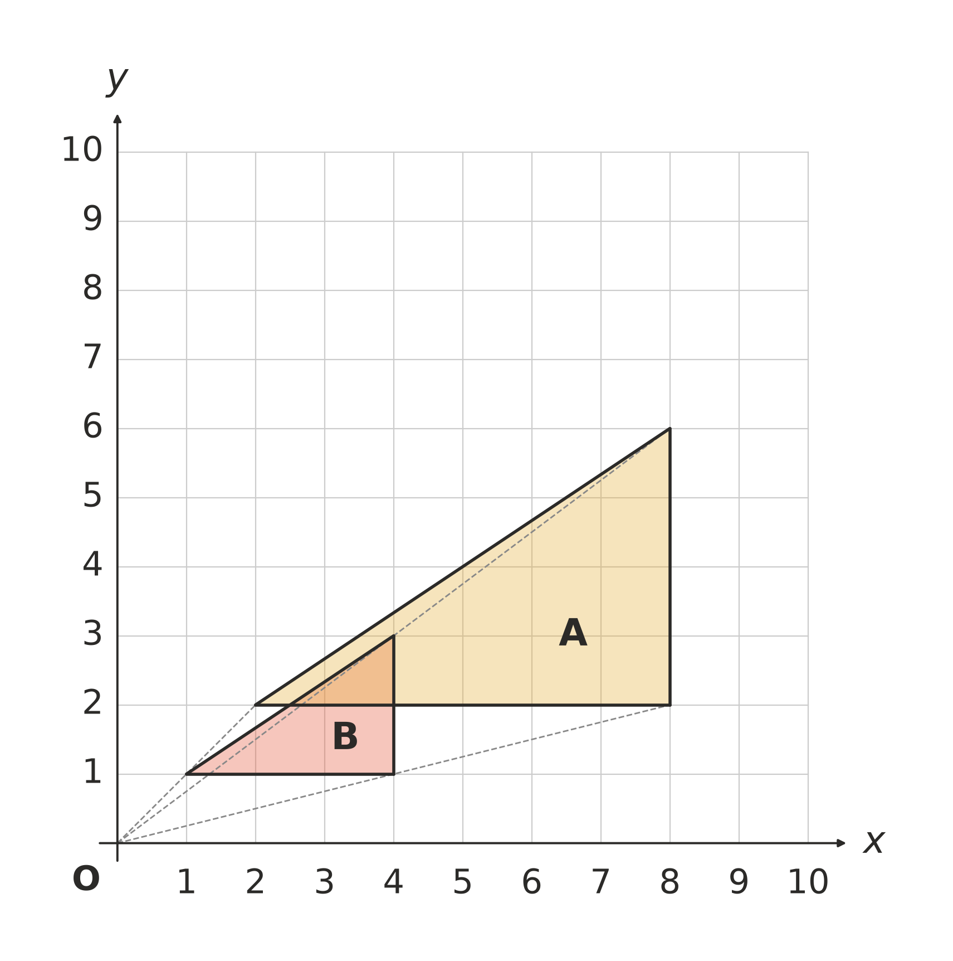
  - What is the scale factor of the enlargement? (1 mark)

  - Is shape B congruent to A, similar to A, or both? Explain. (1 mark)

- The two triangles are similar. Matching angles are marked the same way.
- 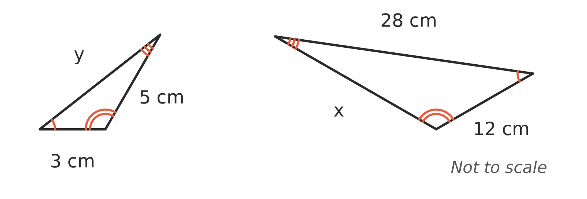
  - Find the scale factor from the small triangle to the large triangle. (1 mark)

  - Find the value of x. (1 mark)

  - Find the value of y. (1 mark)

- Are these two triangles similar? Show your working. (2 marks)
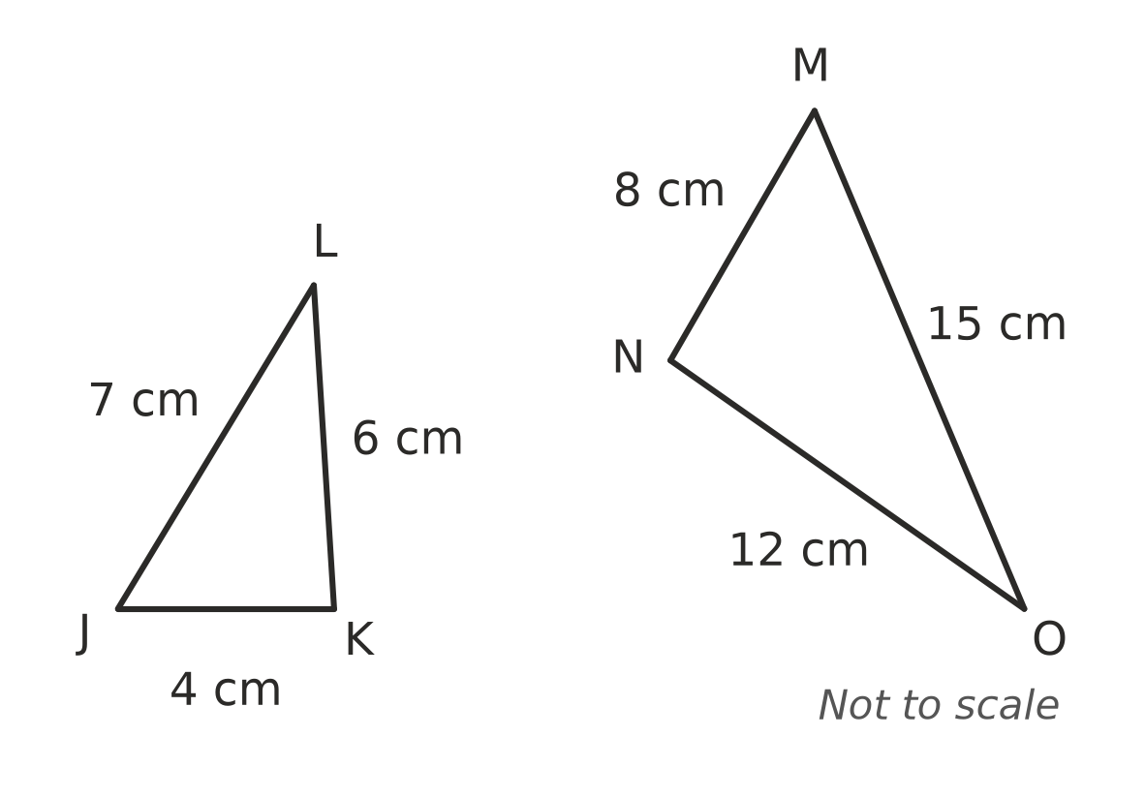

- ABCD is a rhombus and the diagonal AC is drawn. Find the value of each pronumeral.
- 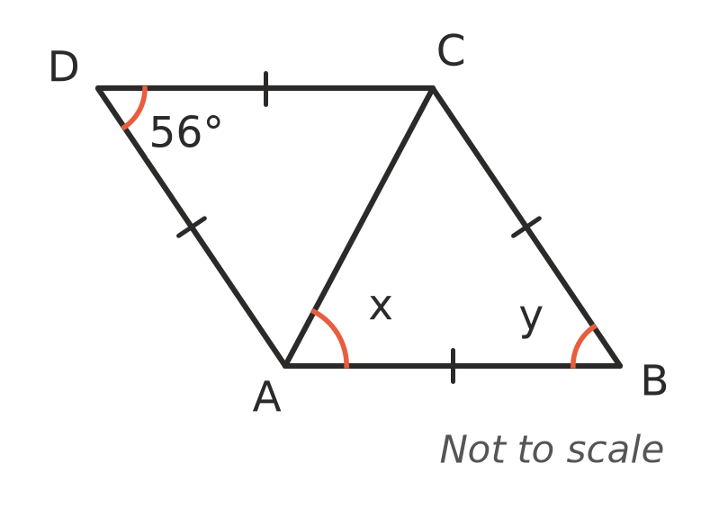
  - (1 mark) x = ______________
  - (1 mark) y = ______________

- This algorithm checks whether two triangles are congruent.
Step | Instruction
1 | If all three pairs of matching sides are equal, output “congruent (SSS)” and stop. Otherwise go to step 2.
2 | If two pairs of sides are equal, and the angles A those sides are equal, output “congruent (SAS)” and stop. Otherwise go to step 3.
3 | If both triangles have a right angle, and the hypotenuses and one other pair of sides are equal, output “congruent (RHS)” and stop. Otherwise go to step 4.
4 | If two pairs of angles and one pair of matching sides are equal, output “congruent (AAS)” and stop. Otherwise go to step 5.
5 | Output “not enough information” and stop.

  - What word should be written in place of A? (1 mark)

  - Leo wants to add a step: “If all three pairs of angles are equal, output ‘congruent (AAA)’.” Explain why this step would give wrong answers. (1 mark)

 Section B: Calculator allowed
- Sam puts a small mirror on the ground and stands so that he can see the top of a building in it. Light reflects off a mirror at equal angles, as marked.
- 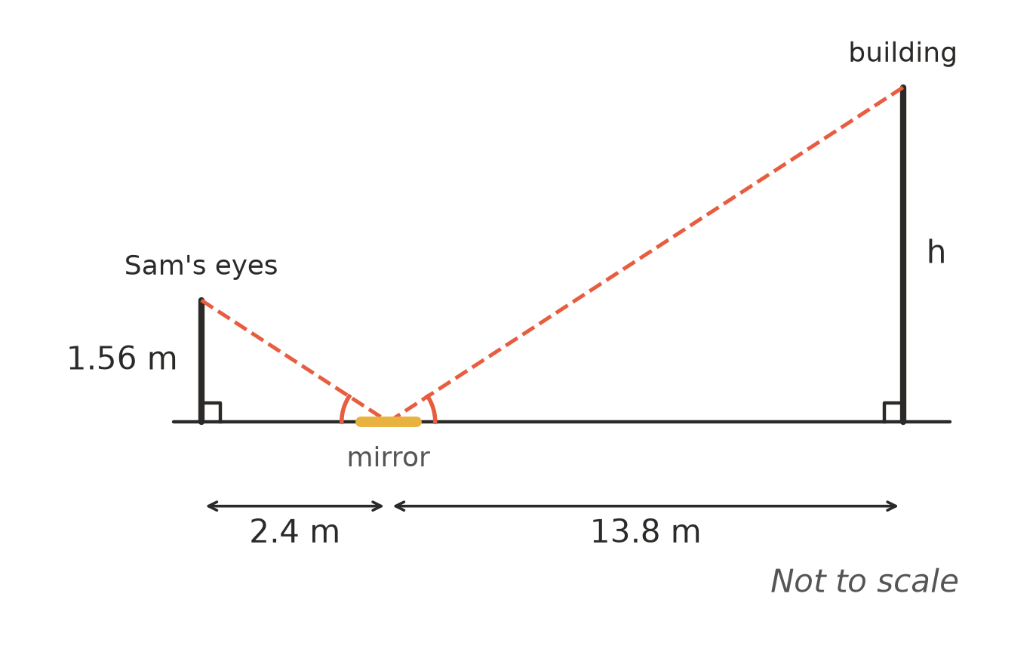
  - Explain why the two triangles in the diagram are similar. (1 mark)

  - Find the height of the building, h. Give your answer to two decimal places. (2 marks)

- The rectangular prism has one corner at the origin O, and its edges lie along the x-, y- and z-axes. The edge lengths are in units. The corner (3, 7, 0) is labelled. M is the midpoint of the edge it lies on.
- 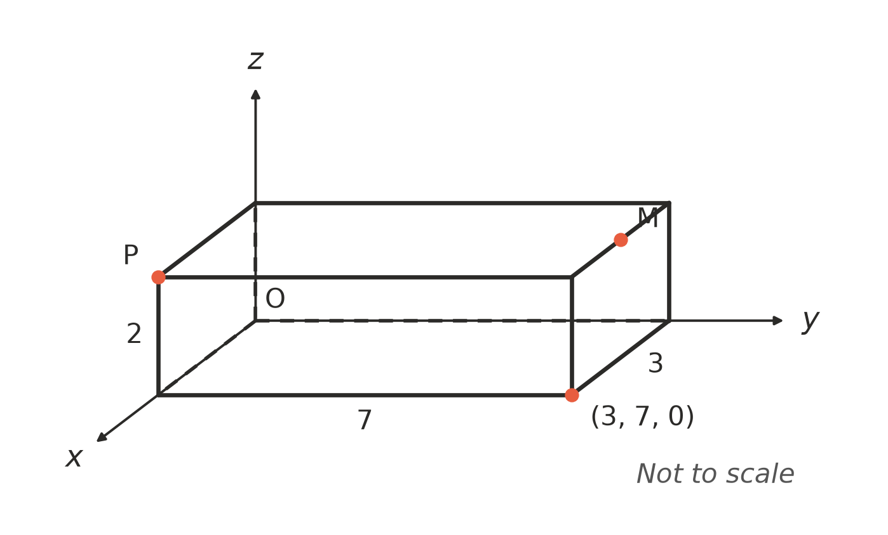
  - Write the coordinates of P. (1 mark)

  - Write the coordinates of M. (1 mark)

- The lines AE and BD cross at C, and AB is parallel to DE.
- 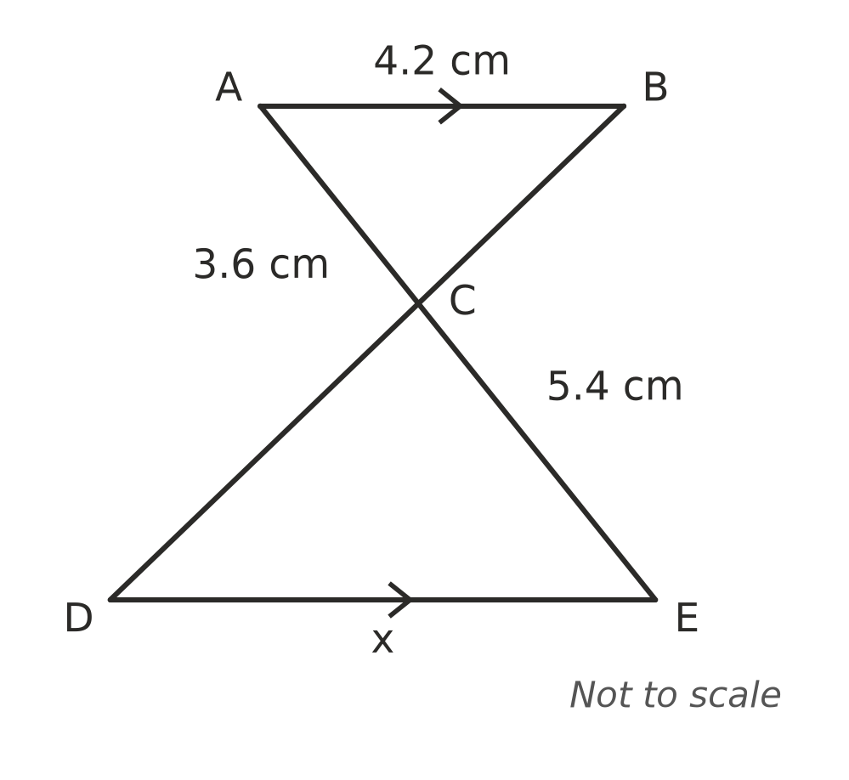
  - Explain why △ABC is similar to △EDC. (1 mark)

  - Find the value of x. (2 marks)

- ABCD is a kite. Find the value of x. (2 marks)
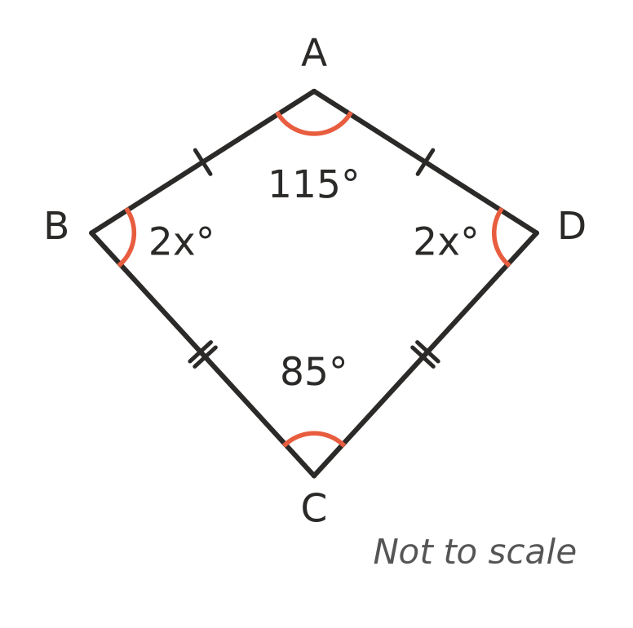

- ABCD is a parallelogram, so AB ∥ DC and AD ∥ BC. The diagonal AC is drawn. Use congruent triangles to prove that AB = CD. (2 marks)
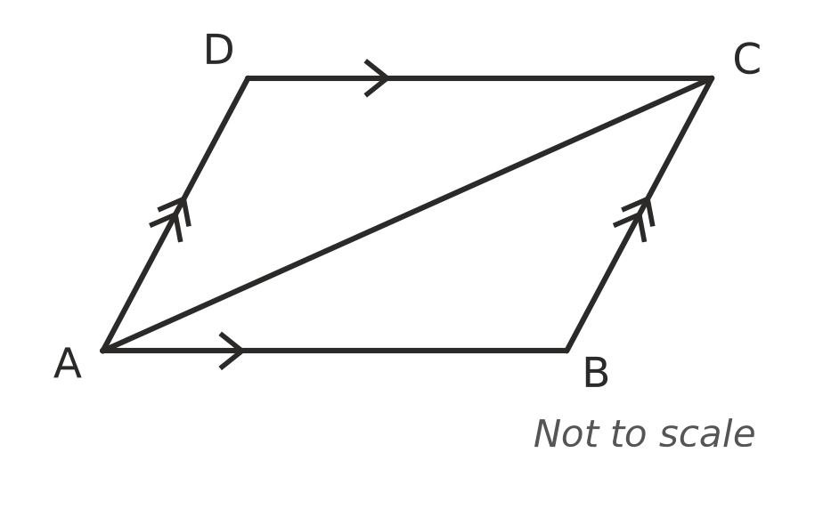

 Answer sheet
Name: ____________________
Write your final answer for each question in the table.
Question | Answer | Marks | Question | Answer | Marks
1a |  | /1 | 9a |  | /1
1b |  | /1 | 9b |  | /1
1c |  | /1 | 9c |  | /1
2 |  | /2 | 10 |  | /2
3 |  | /1 | 11a |  | /1
4a |  | /1 | 11b |  | /1
4b |  | /1 | 12a |  | /1
5a |  | /1 | 12b |  | /1
5b |  | /1 | 13a |  | /1
6a |  | /1 | 13b |  | /2
6b |  | /1 | 14a |  | /1
6c |  | /1 | 14b |  | /1
6d |  | /1 | 15a |  | /1
7a |  | /2 | 15b |  | /2
7b |  | /1 | 16 |  | /2
8a |  | /1 | 17 |  | /2
8b |  | /1
 |  |  |  | Total | /40

