Geometry: Practice test 2
Year 8 Maths · Test · Test 2
Name: ____________________ Date: ______________
Time: 45 minutes
Total: 40 marks
Show your working in the boxes. Then write each final answer on the answer sheet on the last page.

 Section A: No calculator
- Find the size of each angle marked with a letter.
- 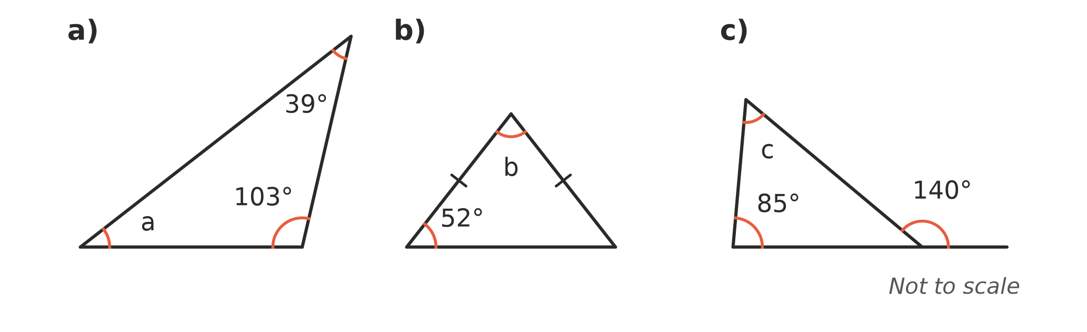
  - (1 mark) a = ______________
  - (1 mark) b = ______________
  - (1 mark) c = ______________

- The two lines marked with arrows are parallel. Find the value of x and give a reason. (2 marks)
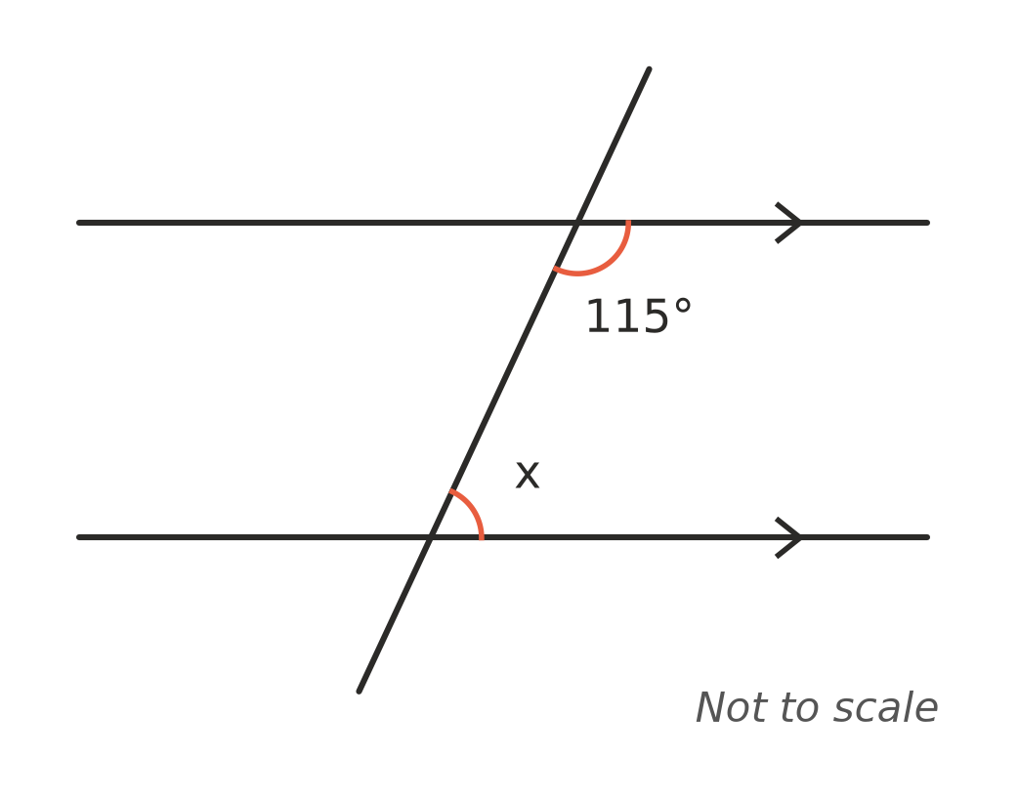

- Kai says a triangle can have angles of 95°, 60° and 30°. Explain why he is wrong. (1 mark)

- Quadrilateral ABCD is congruent to quadrilateral EFGH (ABCD ≅ EFGH).
- 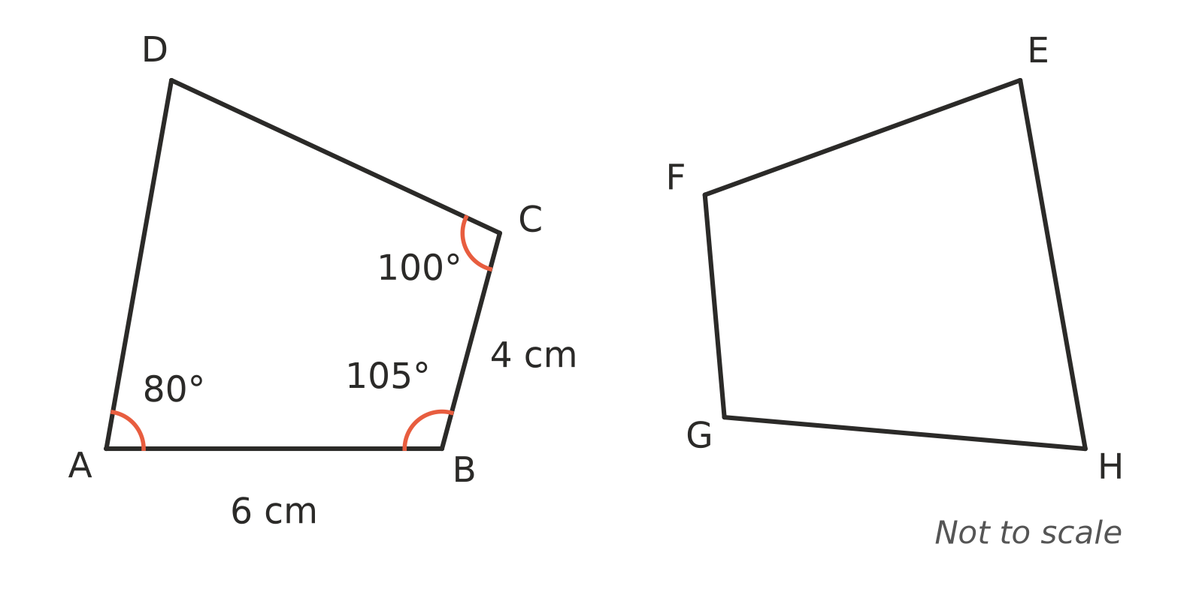
  - Find the length of FG. (1 mark)

  - Find the size of ∠H. (1 mark)

- Shapes A, B and C are drawn on the number plane.
- 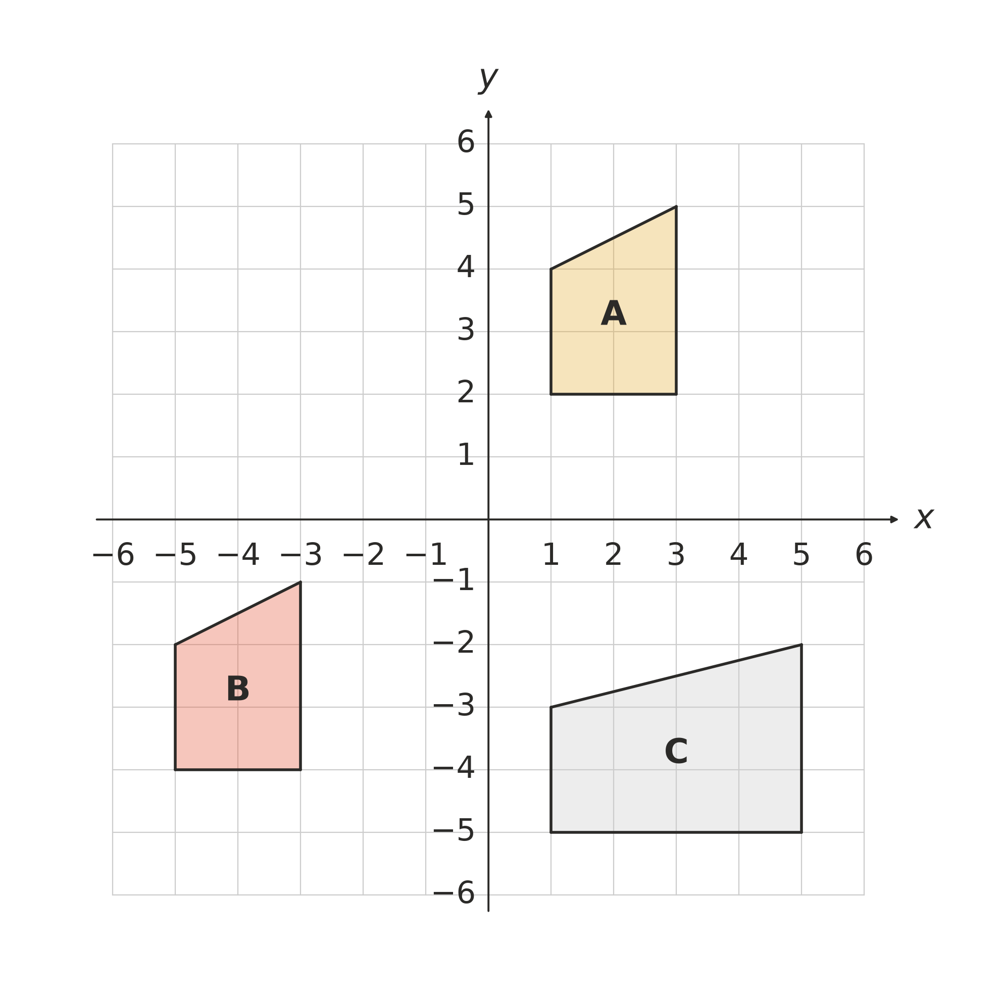
  - Describe the single transformation that maps shape A onto shape B. (1 mark)

  - Which shape, B or C, is congruent to shape A? Explain. (1 mark)

- Each pair of triangles has equal sides and angles marked the same way. For each pair, write the congruence test (SSS, SAS, AAS or RHS) that proves the triangles are congruent. If the markings are not enough to prove it, write “not enough information”.
- 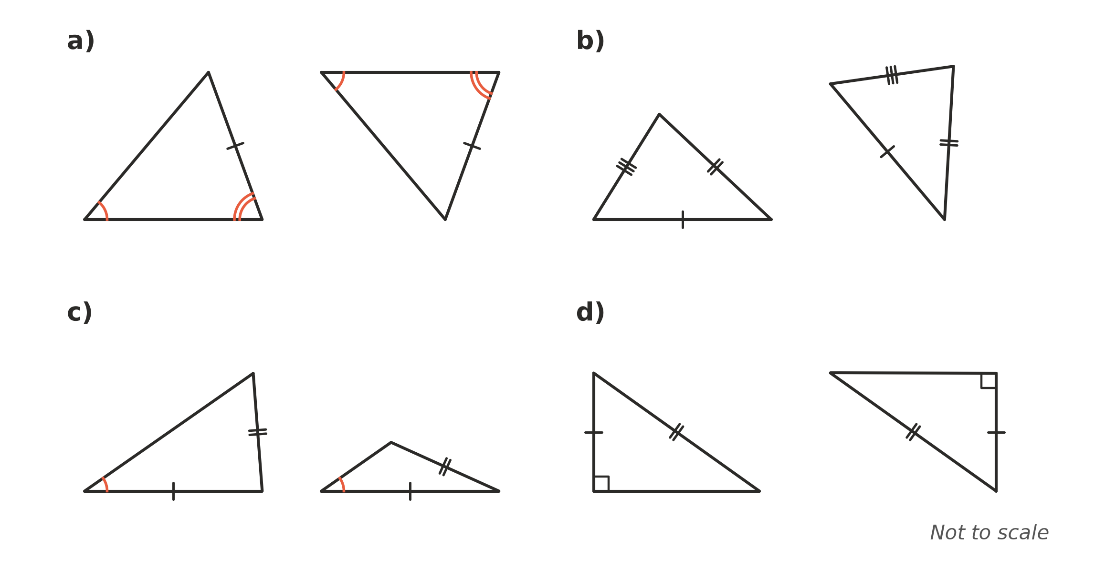
  - (1 mark) Test: ______________
  - (1 mark) Test: ______________
  - (1 mark) Test: ______________
  - (1 mark) Test: ______________

- The lines AE and BD cross at C. AC = CE and BC = CD.
- 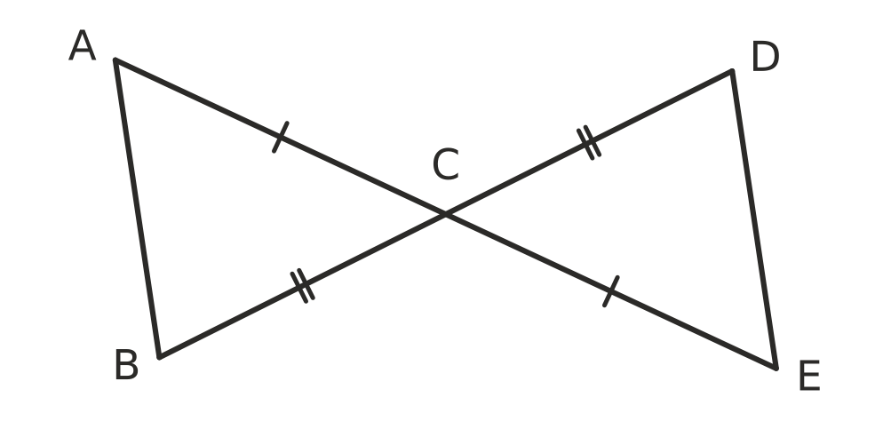
  - Prove that △ABC ≅ △EDC. Give a reason for each step and name the test. (2 marks)

  - Hence explain why AB = ED. (1 mark)

- Shape A was enlarged with centre O to make shape B.
- 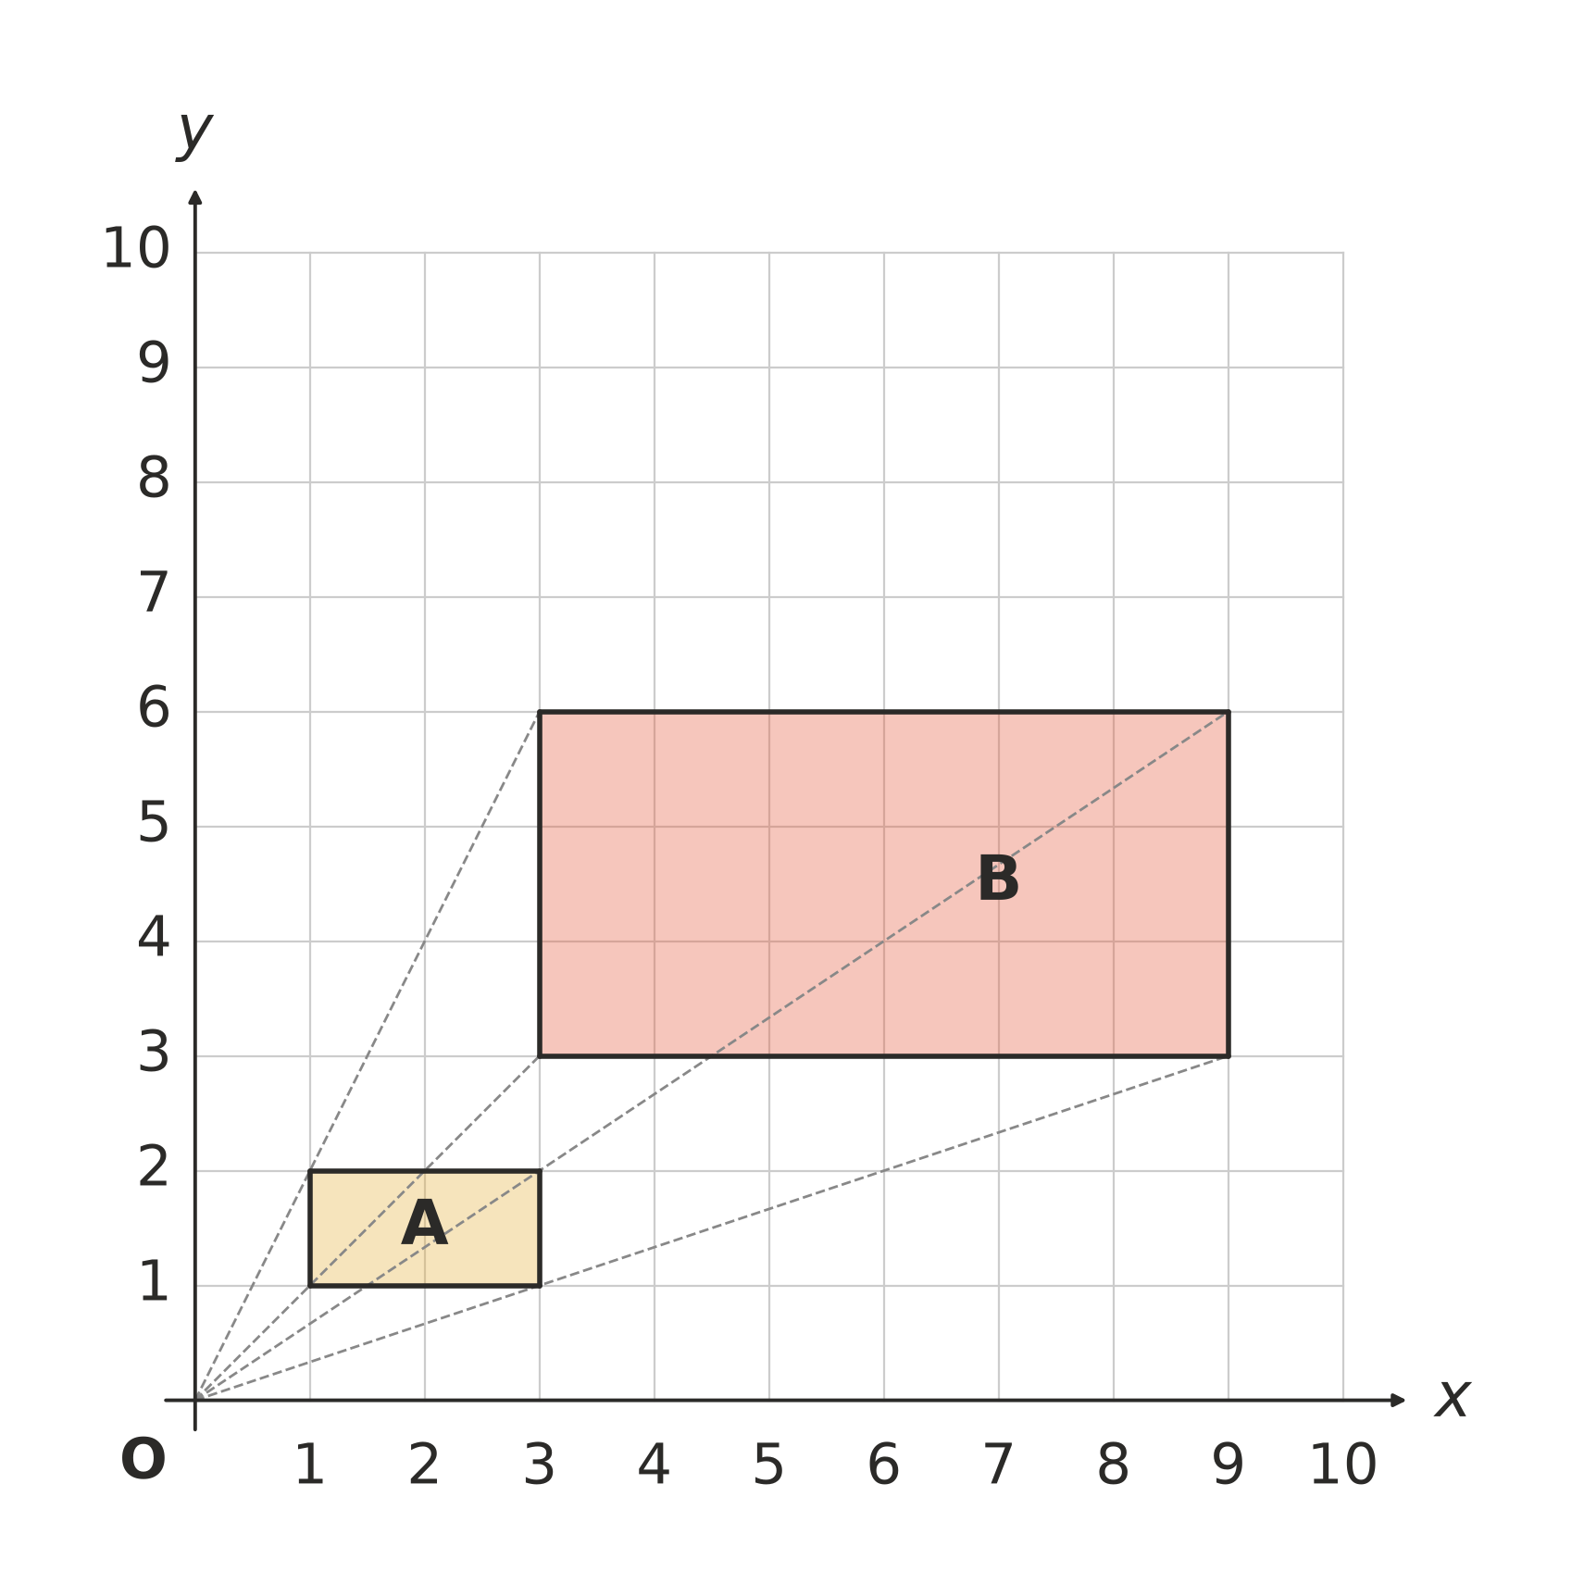
  - What is the scale factor of the enlargement? (1 mark)

  - Write the coordinates of the vertex of B that matches the vertex (3, 2) of A. (1 mark)

- The two triangles are similar. Matching angles are marked the same way.
- 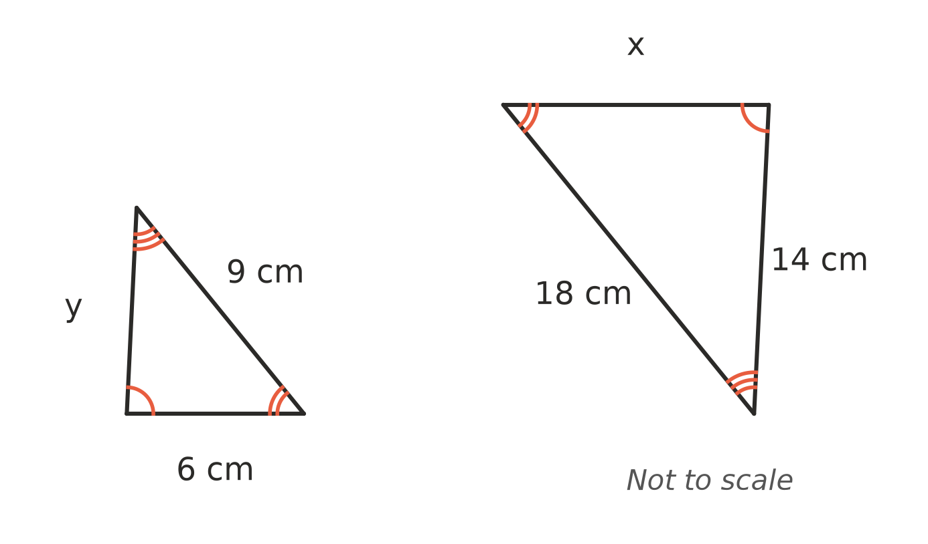
  - Find the scale factor from the small triangle to the large triangle. (1 mark)

  - Find the value of x. (1 mark)

  - Find the value of y. (1 mark)

- Are these two triangles similar? Show your working and name the test you used. (2 marks)
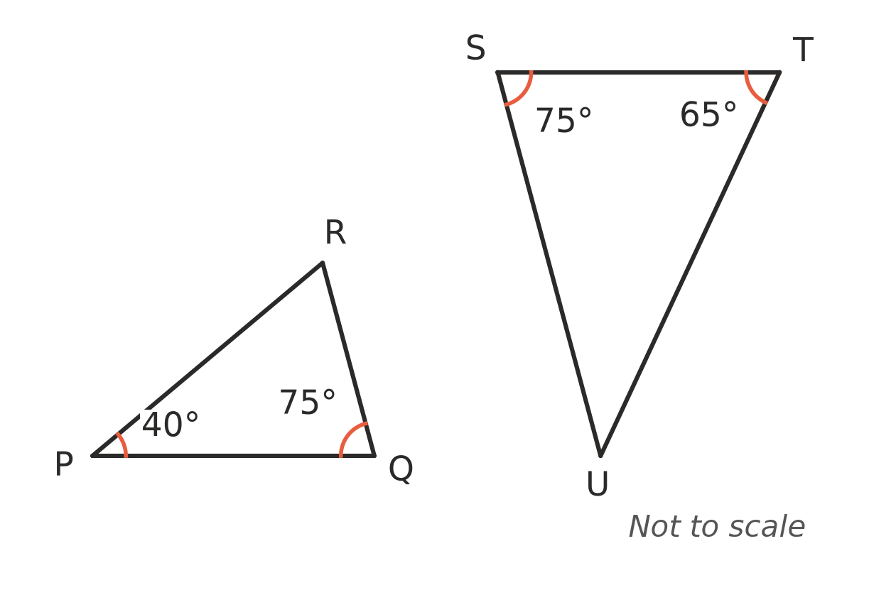

- ABCD is a kite with AB = AD and CB = CD. Its diagonals are drawn. Find the value of each pronumeral.
- 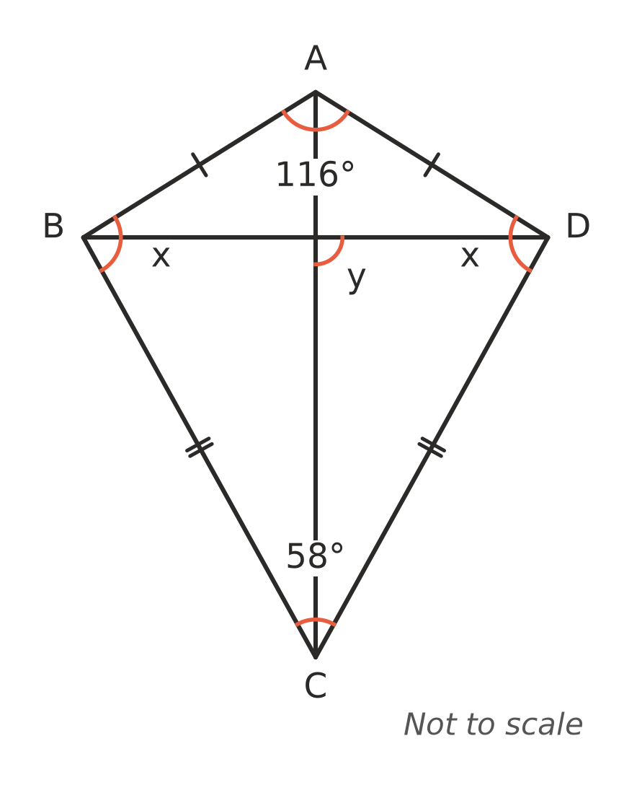
  - (1 mark) x = ______________
  - (1 mark) y = ______________

- This algorithm checks whether two triangles are similar, using their side lengths.
Step | Instruction
1 | Write the side lengths of each triangle in order from shortest to longest.
2 | Divide each side of the second triangle by the matching side of the first triangle.
3 | If all three answers are equal, output “similar (A)” and stop. Otherwise go to step 4.
4 | Output “not similar” and stop.

  - What should be written in place of A? (1 mark)

  - Use the algorithm on triangles with sides 5, 7, 10 and 10, 14, 21. Show the three answers from step 2, and write the output. (1 mark)

 Section B: Calculator allowed
- A ramp is held up by a vertical support post 0.45 m tall. The post is 1.2 m (along the ground) from the bottom of the ramp. The ramp covers 6.4 m along the ground.
- 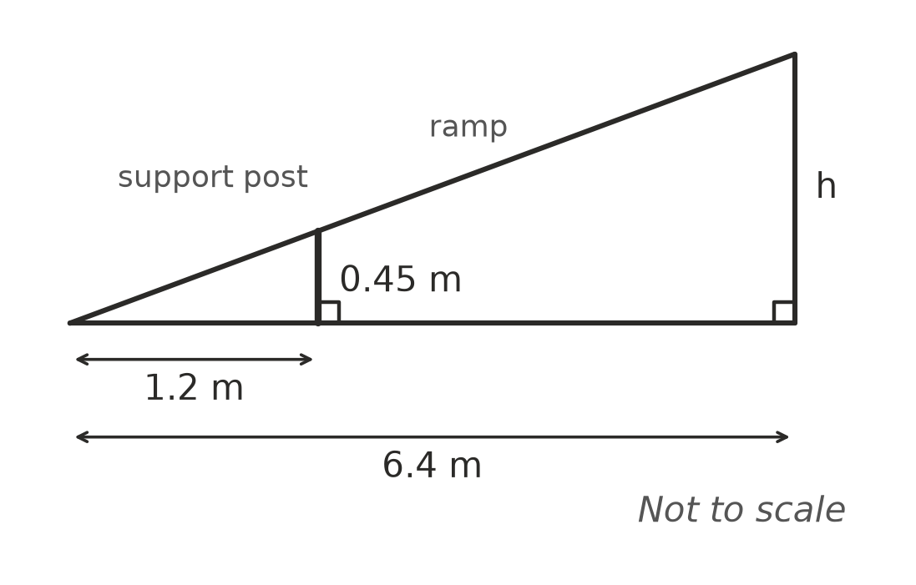
  - Explain why the small triangle and the large triangle are similar. (1 mark)

  - Find the height of the top of the ramp, h. (2 marks)

- The rectangular prism has one corner at the origin O, and its edges lie along the x-, y- and z-axes. The edge lengths are in units. The corner (0, 0, 4) is labelled.
- 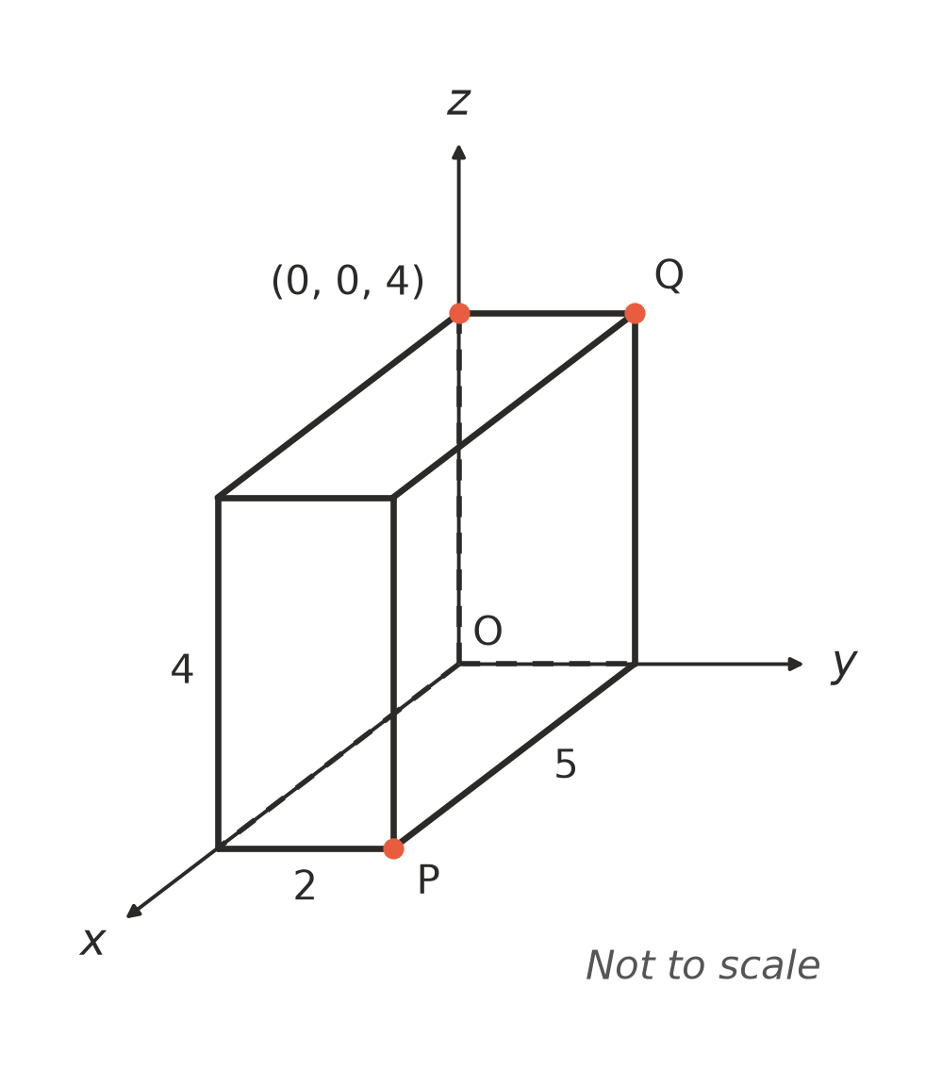
  - Write the coordinates of P. (1 mark)

  - Write the coordinates of Q. (1 mark)

- In △ABC, DE is parallel to BC.
- 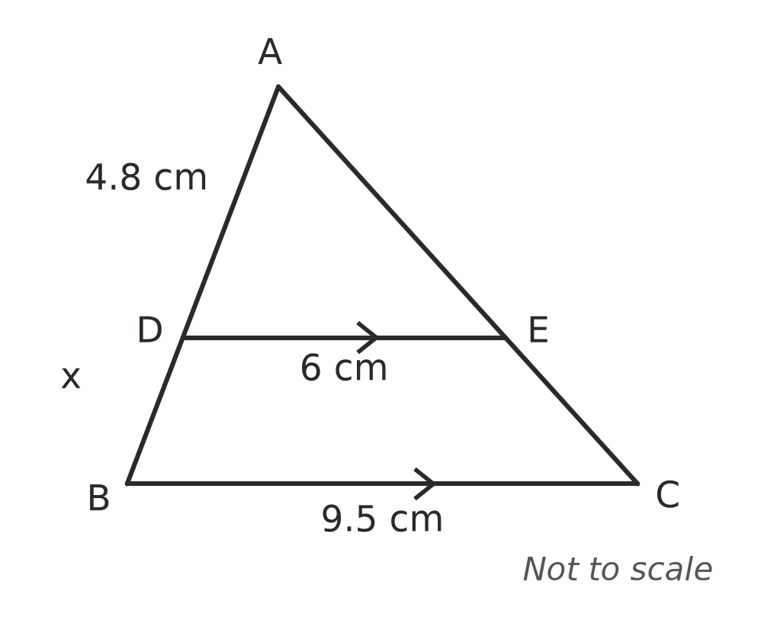
  - Explain why △ADE is similar to △ABC. (1 mark)

  - Find the value of x. (2 marks)

- ABCD is a rhombus. Find the value of x. (2 marks)
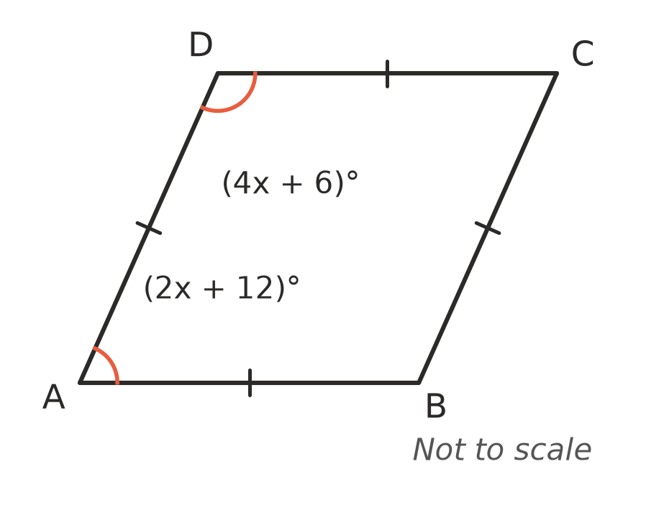

- Mia says: “If the diagonals of a quadrilateral cross at right angles, the quadrilateral must be a rhombus.” Is she right? Name or sketch a quadrilateral that shows your answer, and explain. (2 marks)

 Answer sheet
Name: ____________________
Write your final answer for each question in the table.
Question | Answer | Marks | Question | Answer | Marks
1a |  | /1 | 9a |  | /1
1b |  | /1 | 9b |  | /1
1c |  | /1 | 9c |  | /1
2 |  | /2 | 10 |  | /2
3 |  | /1 | 11a |  | /1
4a |  | /1 | 11b |  | /1
4b |  | /1 | 12a |  | /1
5a |  | /1 | 12b |  | /1
5b |  | /1 | 13a |  | /1
6a |  | /1 | 13b |  | /2
6b |  | /1 | 14a |  | /1
6c |  | /1 | 14b |  | /1
6d |  | /1 | 15a |  | /1
7a |  | /2 | 15b |  | /2
7b |  | /1 | 16 |  | /2
8a |  | /1 | 17 |  | /2
8b |  | /1
 |  |  |  | Total | /40

