Geometry: Practice test 1
Year 8 Maths · Test · Test 1
Name: ____________________ Date: ______________
Time: 45 minutes
Total: 40 marks
Show your working in the boxes. Then write each final answer on the answer sheet on the last page.

 Section A: No calculator
- Find the size of each angle marked with a letter.
- 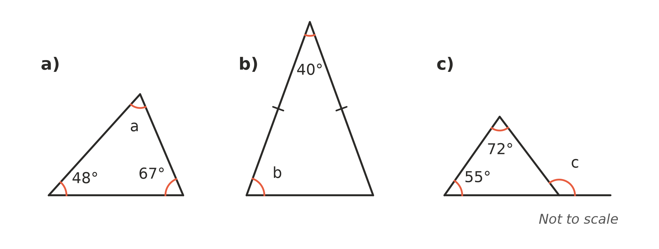
  - (1 mark) a = ______________
  - (1 mark) b = ______________
  - (1 mark) c = ______________

- The two lines marked with arrows are parallel. Find the value of x and give a reason. (2 marks)
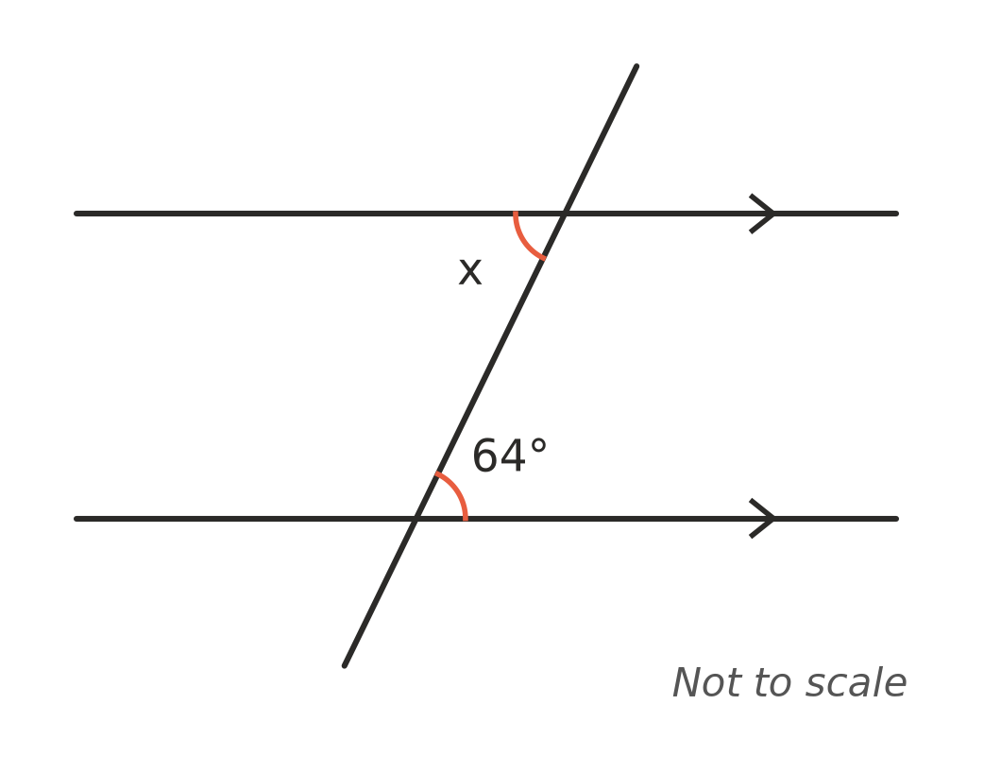

- Explain why a triangle cannot have sides of 3 cm, 6 cm and 10 cm. (1 mark)

- Triangle ABC is congruent to triangle PQR (△ABC ≅ △PQR).
- 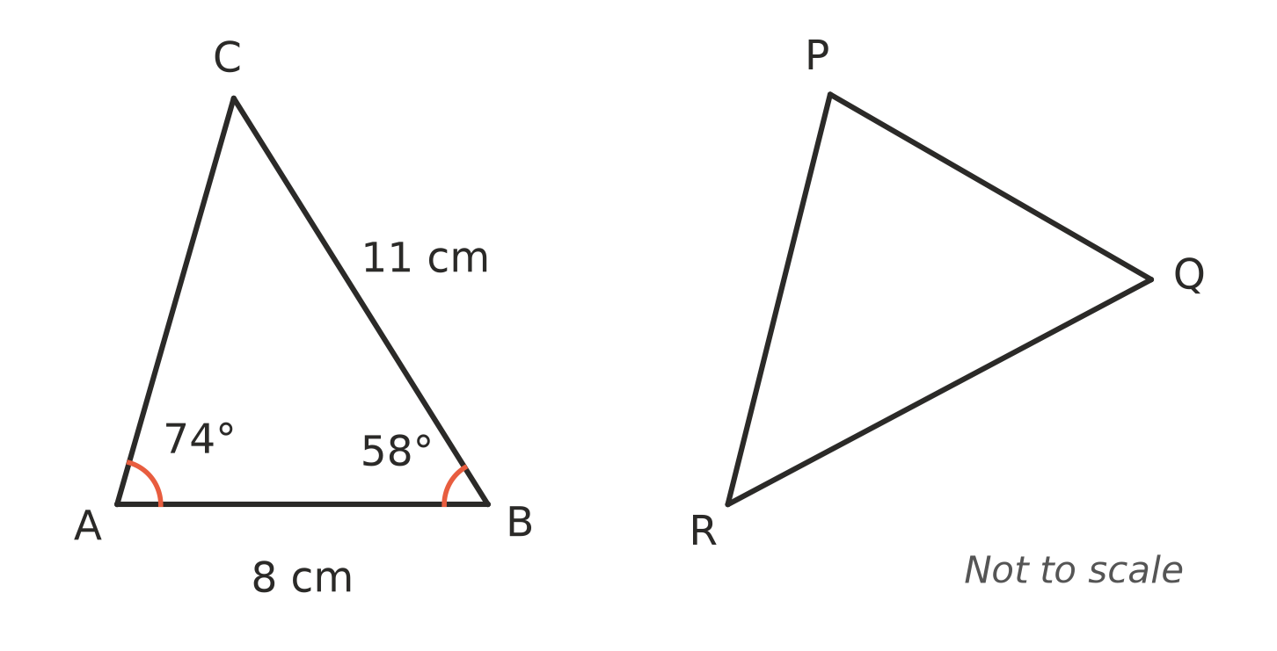
  - Find the length of QR. (1 mark)

  - Find the size of ∠R. (1 mark)

- Shapes A, B and C are drawn on the number plane.
- 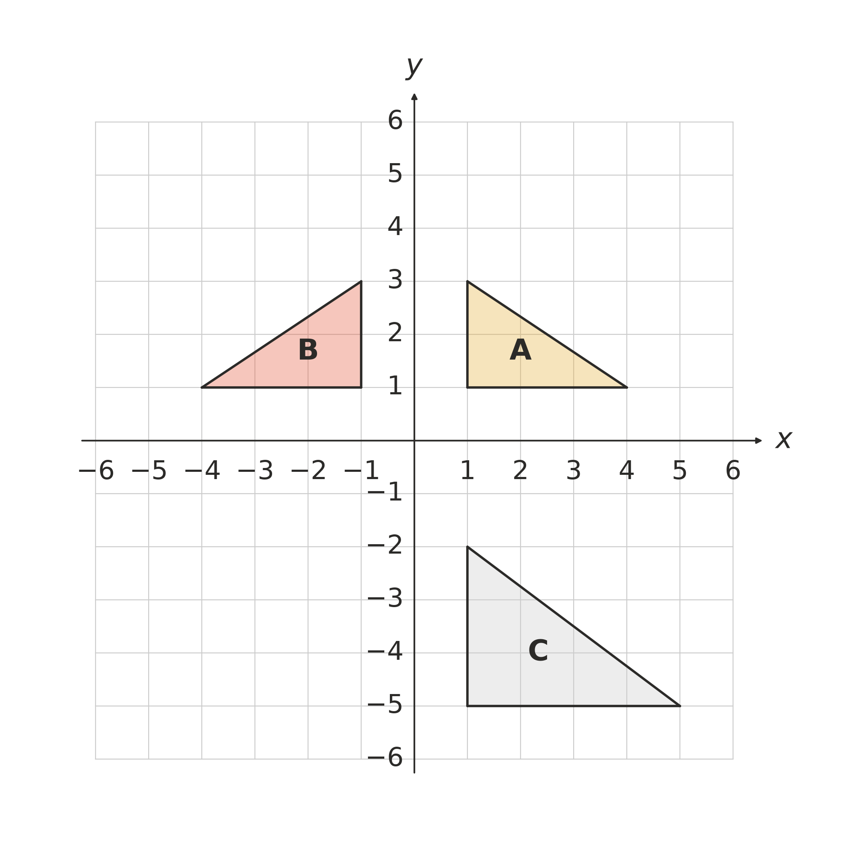
  - Describe the single transformation that maps shape A onto shape B. (1 mark)

  - Is shape C congruent to shape A? Explain. (1 mark)

- Each pair of triangles has equal sides and angles marked the same way. For each pair, write the congruence test (SSS, SAS, AAS or RHS) that proves the triangles are congruent. If the markings are not enough to prove it, write “not enough information”.
- 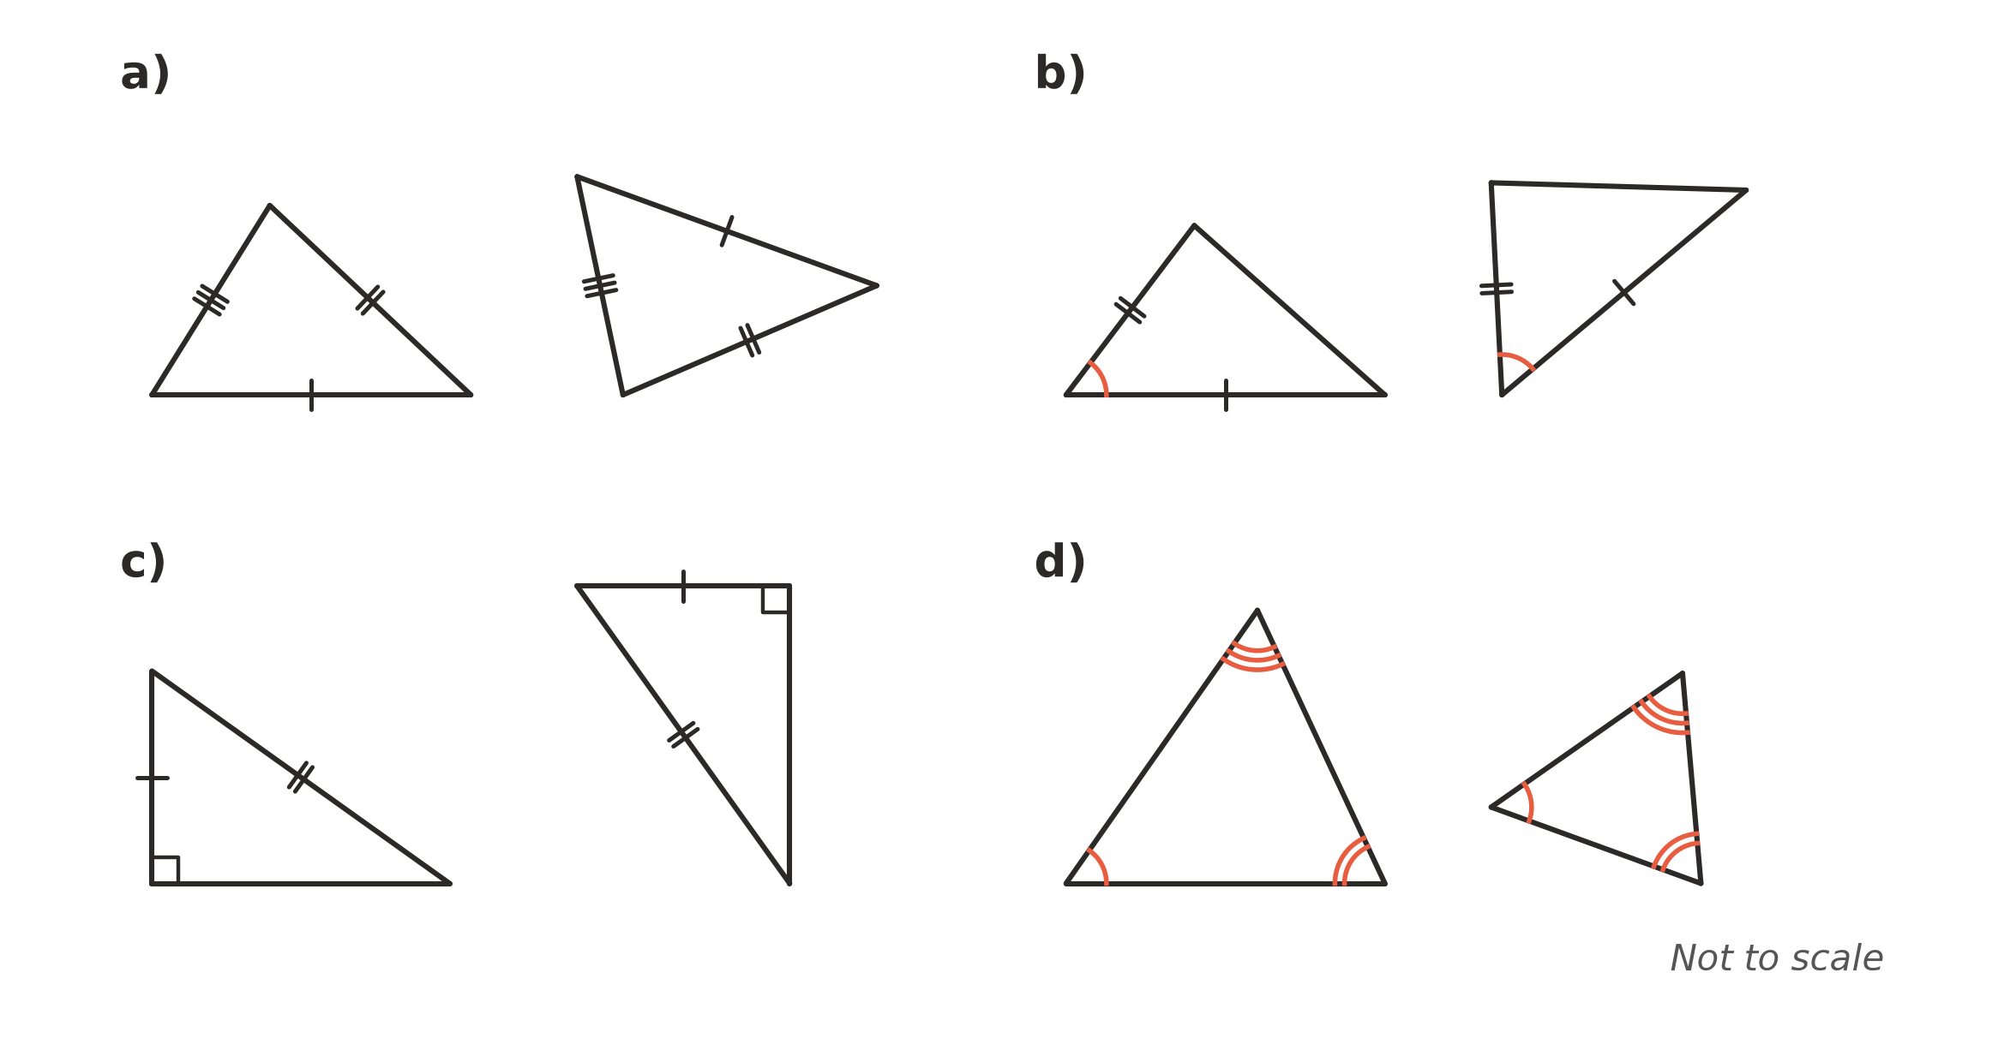
  - (1 mark) Test: ______________
  - (1 mark) Test: ______________
  - (1 mark) Test: ______________
  - (1 mark) Test: ______________

- ABCD is a kite with AB = AD and CB = CD. The diagonal AC is drawn.
- 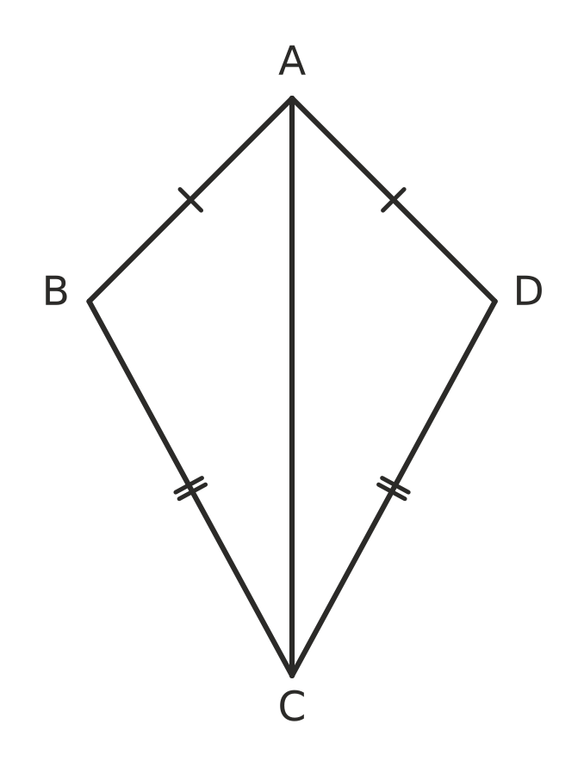
  - Prove that △ABC ≅ △ADC. Give a reason for each step and name the test. (2 marks)

  - Hence explain why ∠ABC = ∠ADC. (1 mark)

- Shape A was enlarged with centre O to make shape B.
- 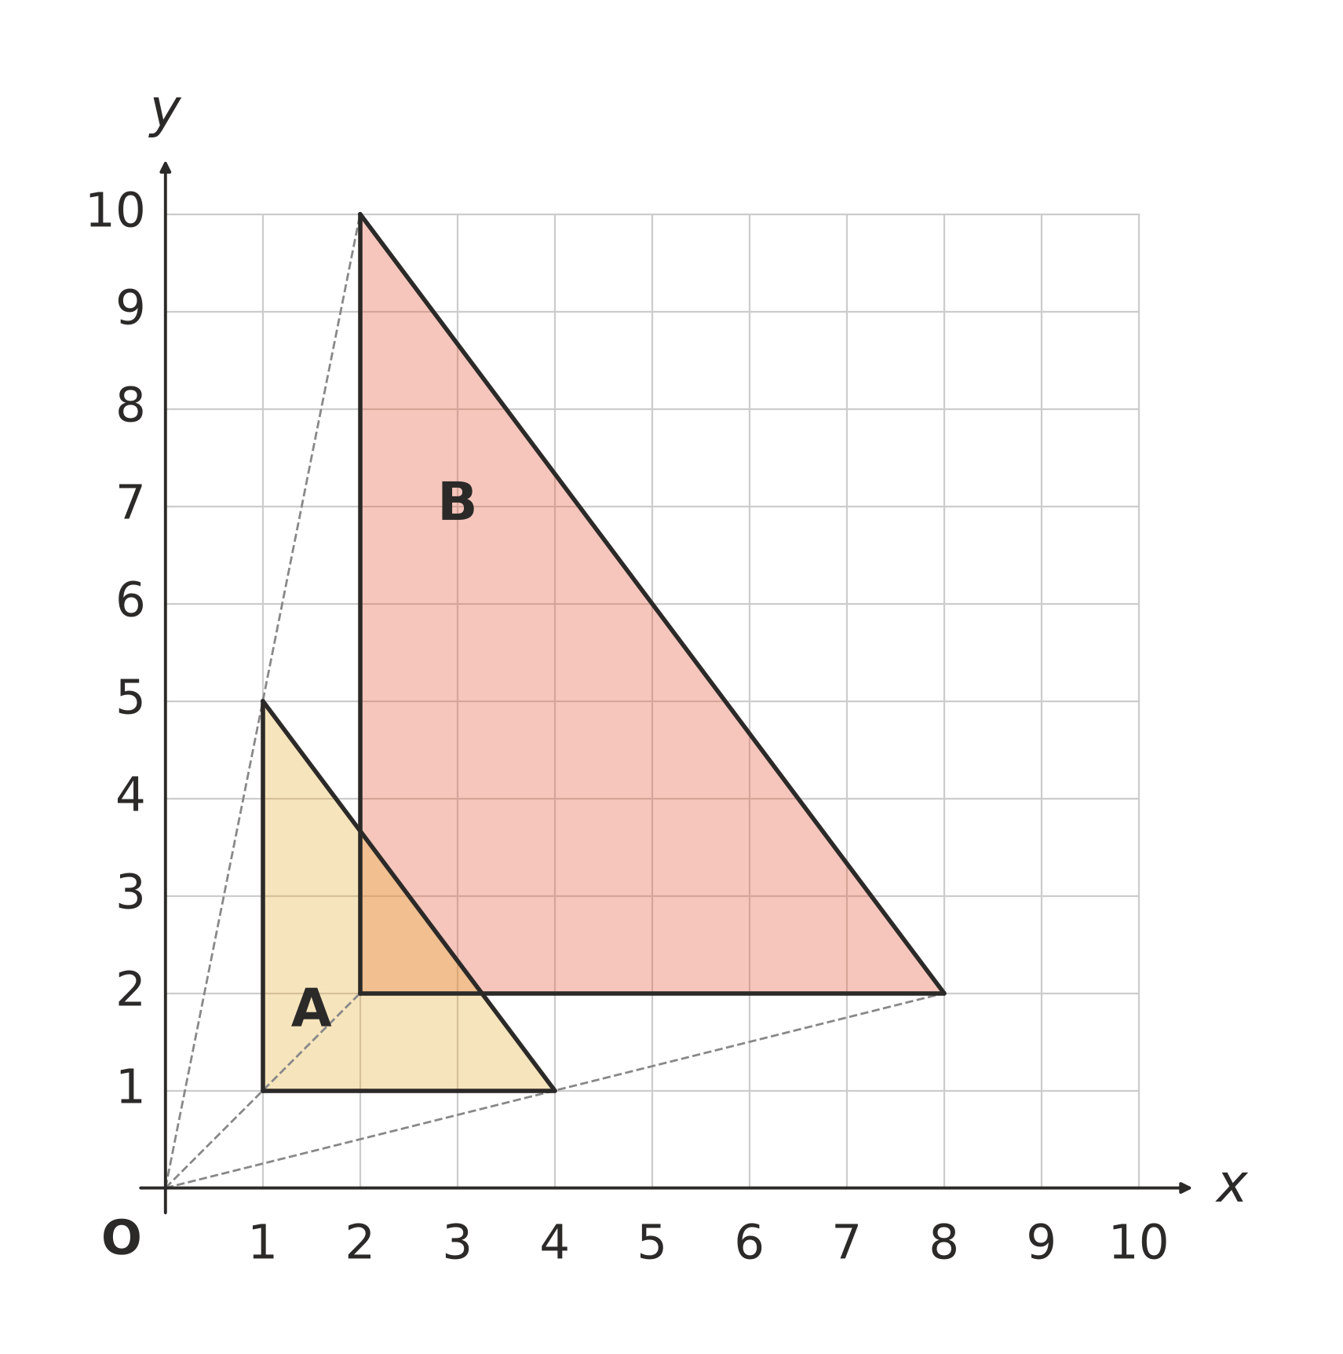
  - What is the scale factor of the enlargement? (1 mark)

  - The perimeter of shape A is 12 units. What is the perimeter of shape B? (1 mark)

- The two triangles are similar. Matching angles are marked the same way.
- 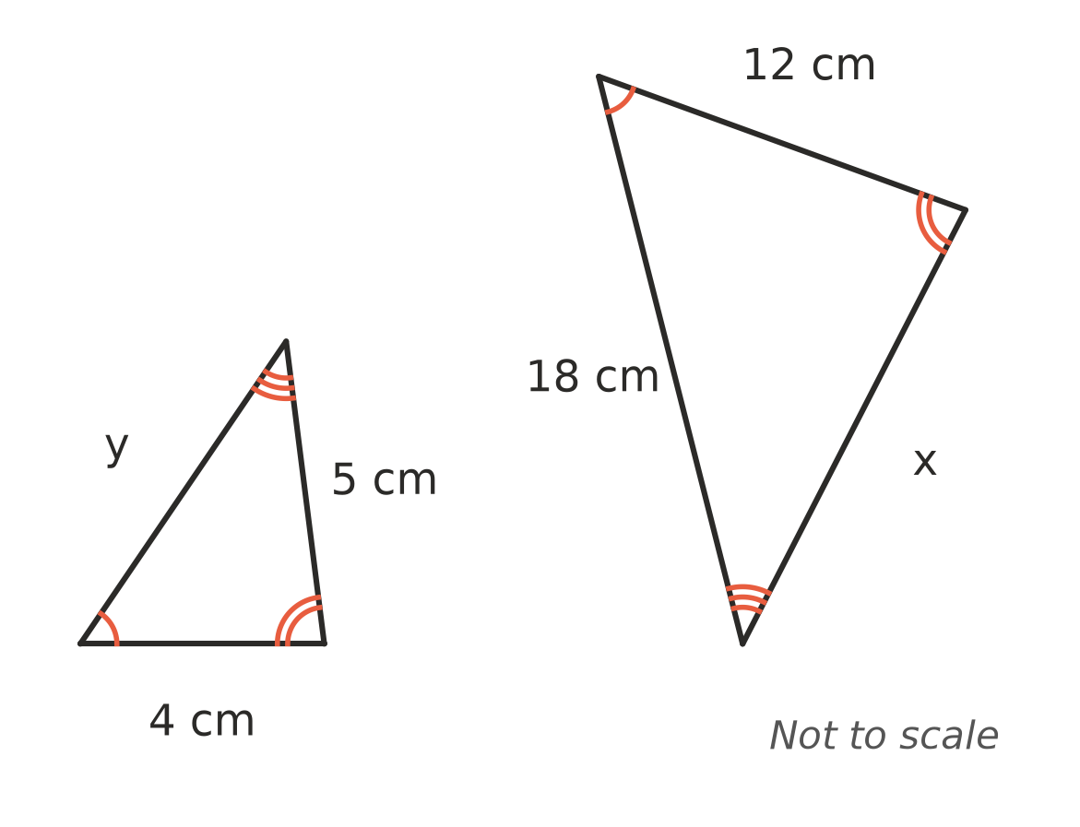
  - Find the scale factor from the small triangle to the large triangle. (1 mark)

  - Find the value of x. (1 mark)

  - Find the value of y. (1 mark)

- Are these two triangles similar? Show your working and name the test you used. (2 marks)
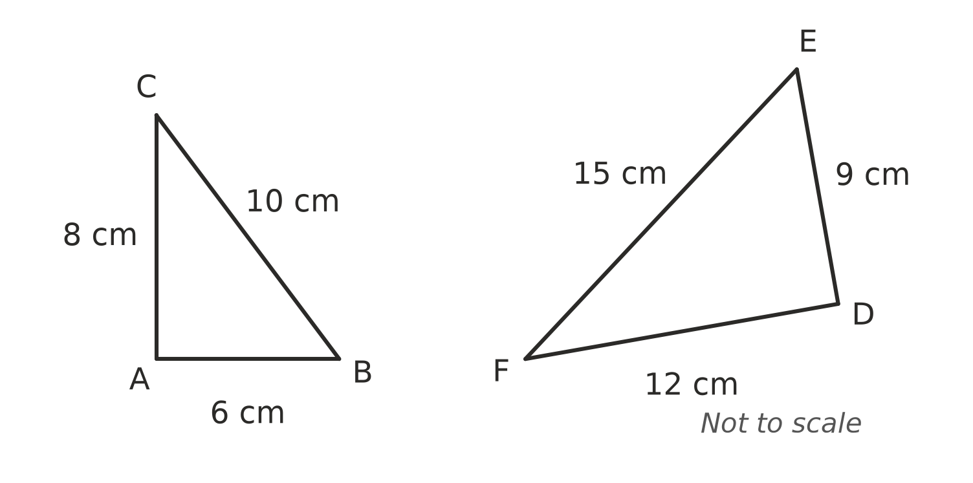

- ABCD is a parallelogram. Find the value of each pronumeral.
- 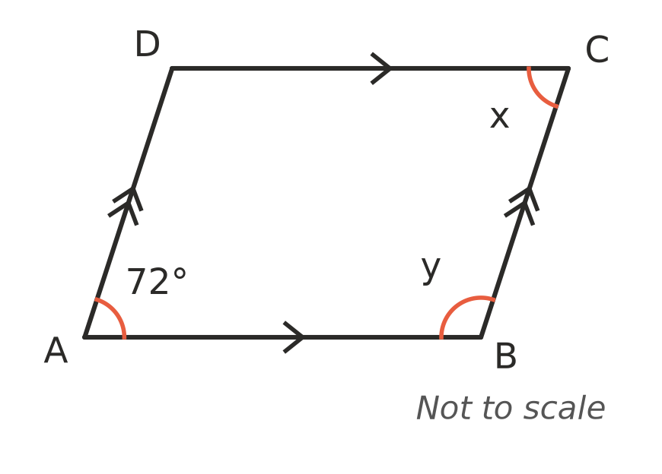
  - (1 mark) x = ______________
  - (1 mark) y = ______________

- This algorithm checks whether two triangles are congruent.
Step | Instruction
1 | If all three pairs of matching sides are equal, output “congruent (SSS)” and stop. Otherwise go to step 2.
2 | If two pairs of sides and the angle between them are equal, output “congruent (A)” and stop. Otherwise go to step 3.
3 | If both triangles have a right angle, and the hypotenuses and one other pair of sides are equal, output “congruent (RHS)” and stop. Otherwise go to step 4.
4 | If two pairs of angles and one pair of matching sides are equal, output “congruent (AAS)” and stop. Otherwise go to step 5.
5 | Output “not enough information” and stop.

  - What should be written in place of A? (1 mark)

  - Two triangles both have angles of 35°, 60° and 85°, but one triangle is larger than the other. At which step does the algorithm stop, and what does it output? (1 mark)

 Section B: Calculator allowed
- At the same time of day, Ava, who is 1.65 m tall, casts a shadow 2.2 m long. A flagpole casts a shadow 10.4 m long.
- 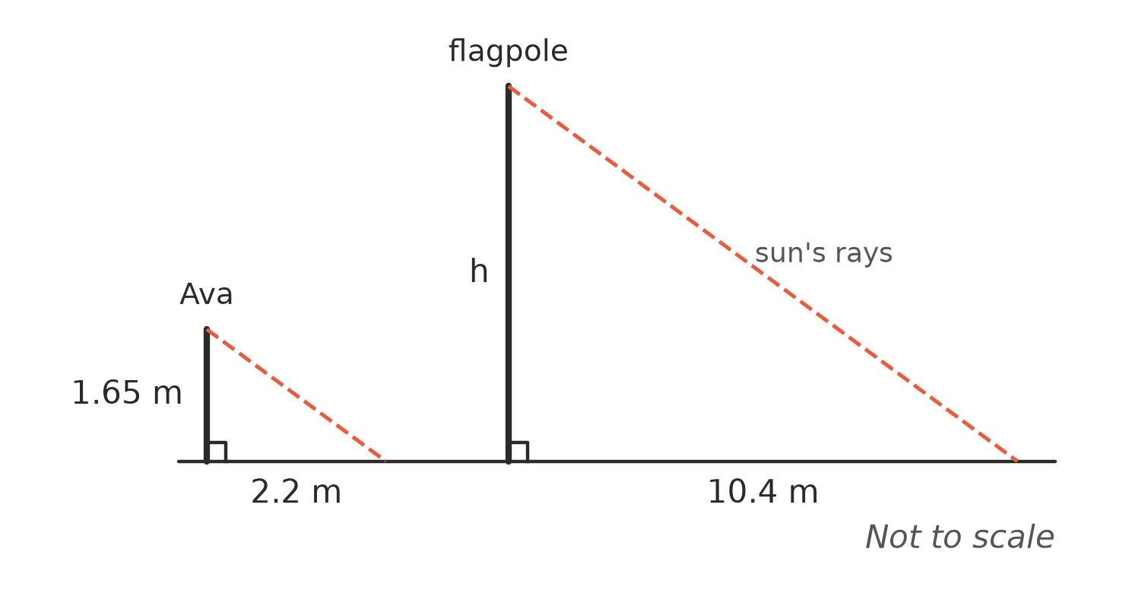
  - Explain why the two triangles in the diagram are similar. (1 mark)

  - Find the height of the flagpole, h. (2 marks)

- The rectangular prism has one corner at the origin O, and its edges lie along the x-, y- and z-axes. The edge lengths are in units. The corner (4, 0, 0) is labelled.
- 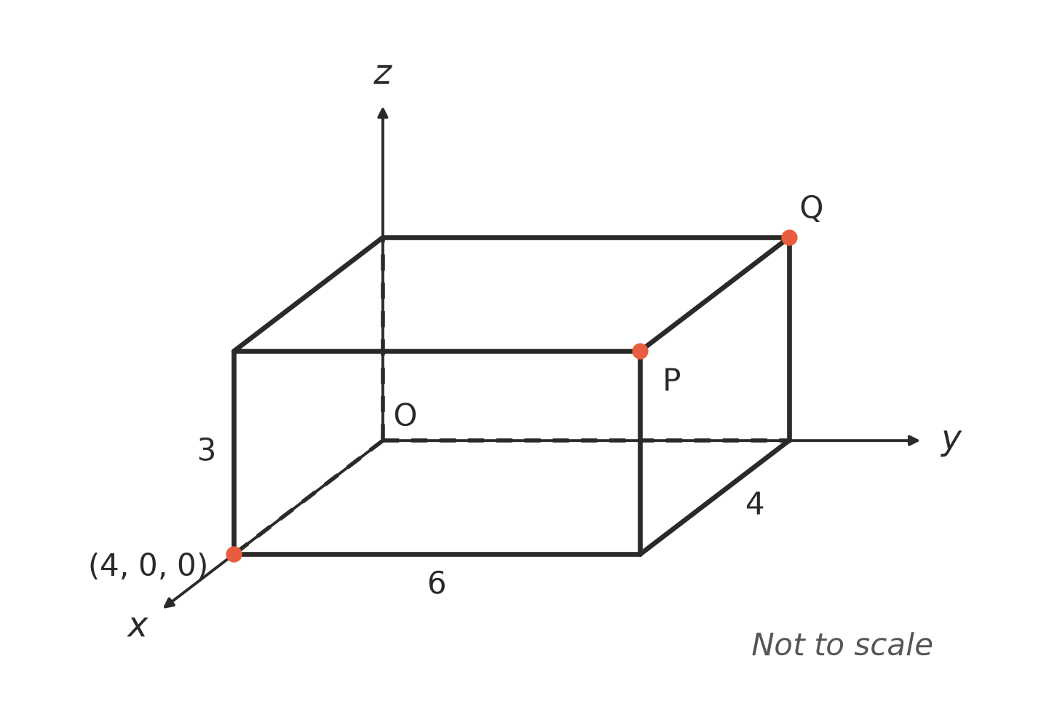
  - Write the coordinates of P. (1 mark)

  - Write the coordinates of Q. (1 mark)

- In △ABC, DE is parallel to BC.
- 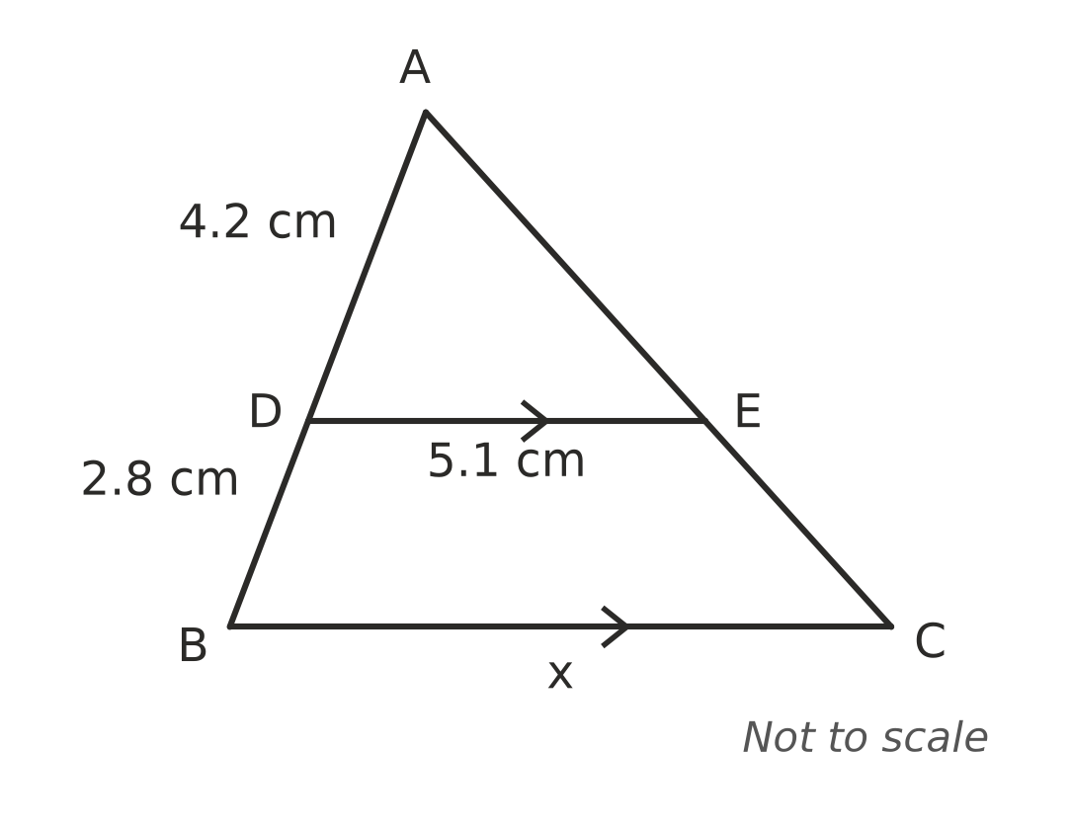
  - Explain why △ADE is similar to △ABC. (1 mark)

  - Find the value of x. (2 marks)

- ABCD is a parallelogram. Find the value of x. (2 marks)
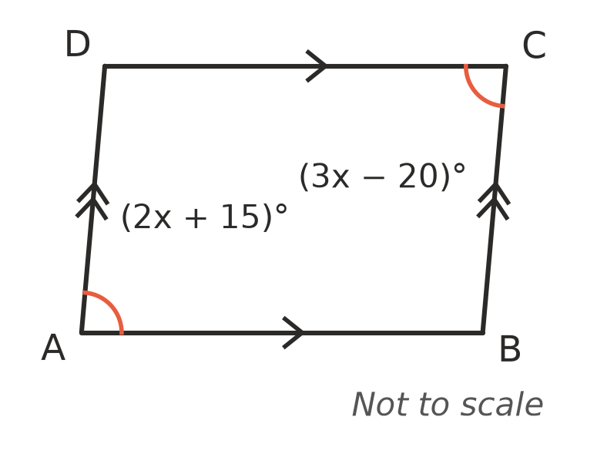

- ABCD is a rectangle. Use congruent triangles to explain why its diagonals AC and BD are equal in length. (2 marks)
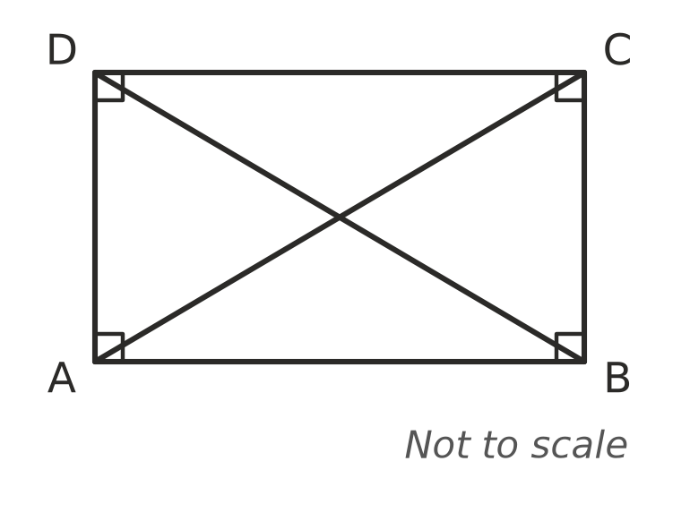

 Answer sheet
Name: ____________________
Write your final answer for each question in the table.
Question | Answer | Marks | Question | Answer | Marks
1a |  | /1 | 9a |  | /1
1b |  | /1 | 9b |  | /1
1c |  | /1 | 9c |  | /1
2 |  | /2 | 10 |  | /2
3 |  | /1 | 11a |  | /1
4a |  | /1 | 11b |  | /1
4b |  | /1 | 12a |  | /1
5a |  | /1 | 12b |  | /1
5b |  | /1 | 13a |  | /1
6a |  | /1 | 13b |  | /2
6b |  | /1 | 14a |  | /1
6c |  | /1 | 14b |  | /1
6d |  | /1 | 15a |  | /1
7a |  | /2 | 15b |  | /2
7b |  | /1 | 16 |  | /2
8a |  | /1 | 17 |  | /2
8b |  | /1
 |  |  |  | Total | /40

