7.06 Properties of quadrilaterals
Year 8 Maths · A5 question sheet · Level 3 · Challenge
This worksheet practises proving the properties of quadrilaterals with congruent triangles, and solving harder problems with algebra and coordinates. Tip: once you have proved one property, you can use it in the next proof. For example, after proving that the diagonals of a parallelogram cut each other in half, you can use that fact for a rhombus, because every rhombus is a parallelogram.

 Understanding
- Name the quadrilateral. Give the most exact name.
  - My diagonals are equal and cross at right angles, and they cut each other in half.
  - I have exactly one pair of parallel sides, and my other two sides are equal.
  - My opposite angles are equal and all my sides are equal, but I have no right angles.
  - I have two pairs of equal sides next to each other, and one of my diagonals is a line of symmetry.
- Alex says, “A quadrilateral with four equal sides must be a square.” Give a counterexample, and say what extra fact would make Alex right.

 Fluency
- ABCD is an isosceles trapezium with AB ∥ DC. Find $a$ and $b$.
- 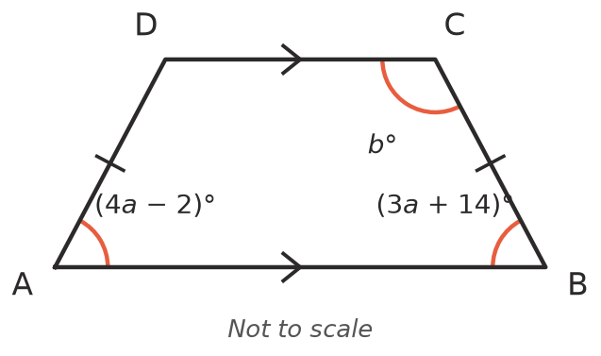
- In rhombus ABCD, ∠A = (2$x$ + 10)° and ∠B = (4$x$ + 20)°. Find $x$ and all four angles.
- In kite ABCD, the angles between the unequal sides are ∠B = ∠D = (2$x$ + 10)°. The other angles are ∠A = $x$° and ∠C = ($x$ + 40)°. Find all four angles.
- The points A(1, 1), B(5, 2), C(6, 6) and D(2, 5) are joined in order. Plot them on grid paper.
  - Show that AB ∥ DC and AD ∥ BC. Hint: compare the moves across and up from one point to the next.
  - Explain why all four sides are equal.
  - What is the most exact name for ABCD? Is it a square? Explain.

 Reasoning
- ABCD is a parallelogram whose diagonals cross at O. Prove that the diagonals cut each other in half (AO = OC and BO = OD).
- 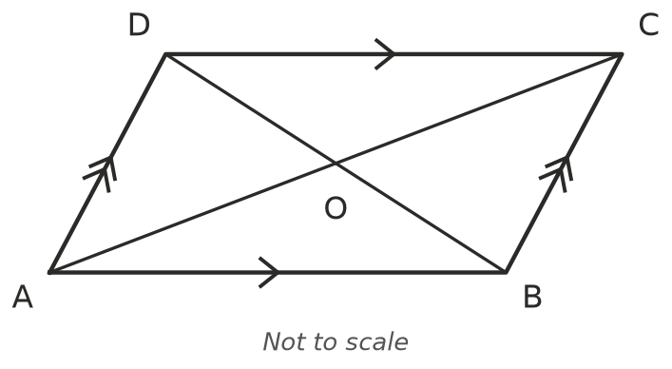
- ABCD is a rhombus whose diagonals cross at O. Use Question 7 to prove that the diagonals cross at right angles.
- 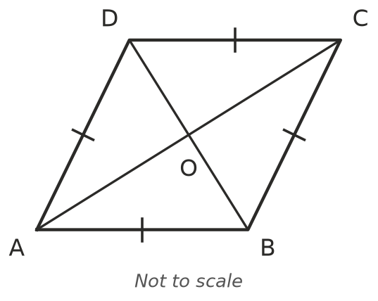
- Prove that if a parallelogram has one right angle, then all four of its angles are right angles.

 Problem solving
- Quadrilateral ABCD has AB = CD and AD = BC, but you are not told that any sides are parallel. Prove that ABCD is a parallelogram. Hint: draw the diagonal AC and look for congruent triangles, then alternate angles.
- A table top is meant to be a rectangle. Write an algorithm (a short list of steps) that a carpenter could follow, using only a tape measure, to check that it really is a rectangle. Explain why your test works.

