7.06 Properties of quadrilaterals
Year 8 Maths · A5 question sheet · Level 2 · Core
This worksheet practises using the properties of quadrilaterals to find unknowns, and proving those properties with congruent triangles and angle facts. Tip: drawing a diagonal turns a quadrilateral problem into a triangle problem, and parallel sides give you alternate and co-interior angles.

 Understanding
- Write True or False.
Statement
Every square is a rhombus.
Every rhombus is a parallelogram.
Every rectangle is a square.
A kite has two pairs of parallel sides.
A trapezium can have two right angles.

- Name the most exact quadrilateral that has these diagonals.
The diagonals…
cut each other in half, are equal, and cross at right angles
cut each other in half and are equal, but don’t cross at right angles
cut each other in half and cross at right angles, but are not equal
cut each other in half only
cross at right angles, and only one is cut in half by the other

 Fluency
- ABCD is a parallelogram. Find $x$ and $y$, and then the size of every angle.
- 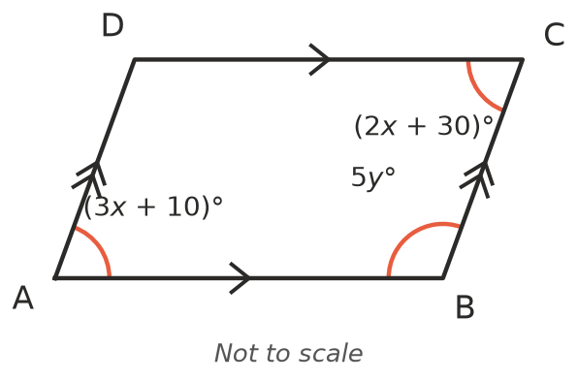
- ABCD is a rhombus with diagonals crossing at O. ∠BAC = 35°.
- 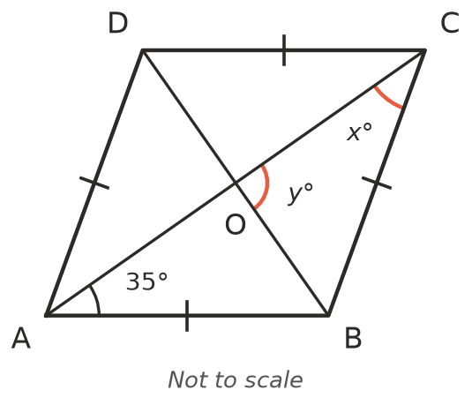
  - $x$ = ______________ b) $y$ = ______________ c) ∠ABC =
- ABCD is a rectangle with diagonals crossing at O. AC = (2$x$ + 4) cm and BD = (5$x$ − 8) cm.
- 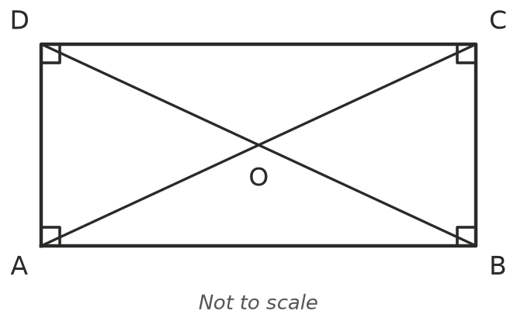
  - Find $x$. ______________ b) Find AC. ______________ c) Find OB.
- ABCD is a kite. Find $x$.
- 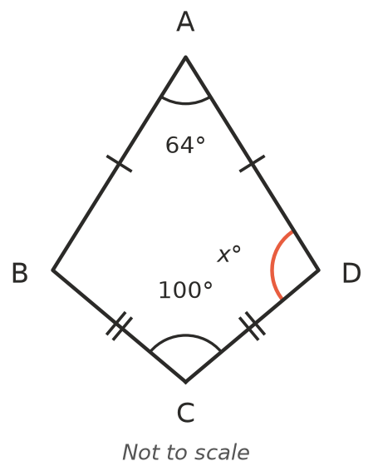
- $x$ =
- ABCD is an isosceles trapezium (AB ∥ DC and AD = BC). Find $x$, $y$ and ∠B.
- 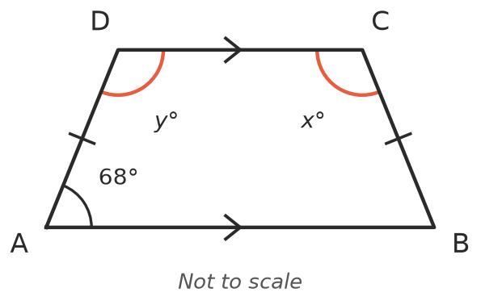

 Reasoning
- ABCD is a parallelogram with diagonal AC. Prove that AB = CD and AD = BC. Give a reason for each step.
- 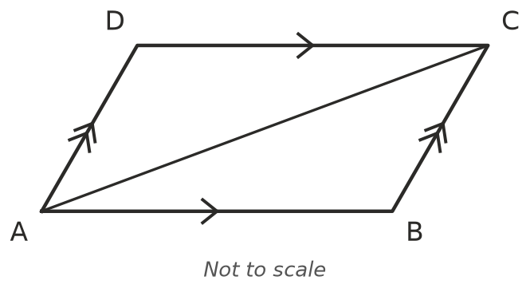
- Use your proof from Question 8 to explain why ∠B = ∠D in a parallelogram.
- ABCD is a rectangle. Use triangles ABC and BAD to prove that the diagonals AC and BD are equal. Name the test.

 Problem solving
- The angles of a quadrilateral are in the ratio 2 : 3 : 3 : 4.
  - Find the four angles.
  - Could the quadrilateral be a trapezium? Explain.
- In a parallelogram, one angle is 40° more than the angle next to it. Find all four angles.

