7.06 Properties of quadrilaterals
Year 8 Maths · A5 question sheet · Level 1 · Warm-up
This worksheet practises the properties of the special quadrilaterals (sides, angles and diagonals), finding unknown angles, and seeing how congruent triangles explain the properties. Tip: arrows show parallel sides, ticks show equal sides, and the angles of any quadrilateral add to 360°.

 Understanding
- Name each quadrilateral: square, rectangle, rhombus, parallelogram, kite or trapezium.
- 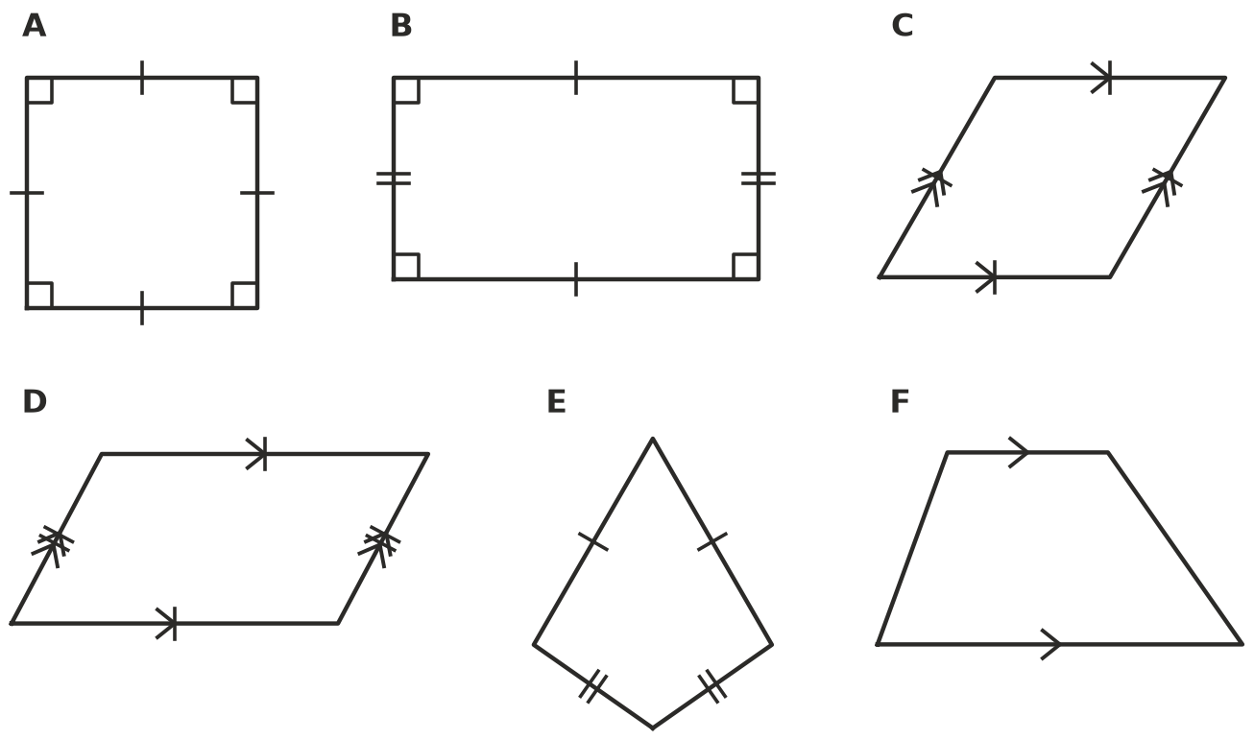
- Write Yes or No in your book.
Property | Square | Rectangle | Rhombus | Parallelogram
Both pairs of opposite sides are parallel
All four sides are equal
All four angles are 90°
The diagonals are equal in length
The diagonals cross at right angles

- A diagonal cuts any quadrilateral into two triangles. Use this to explain why the angles of a quadrilateral add to 360°.

 Fluency
- Find the value of each pronumeral.
- 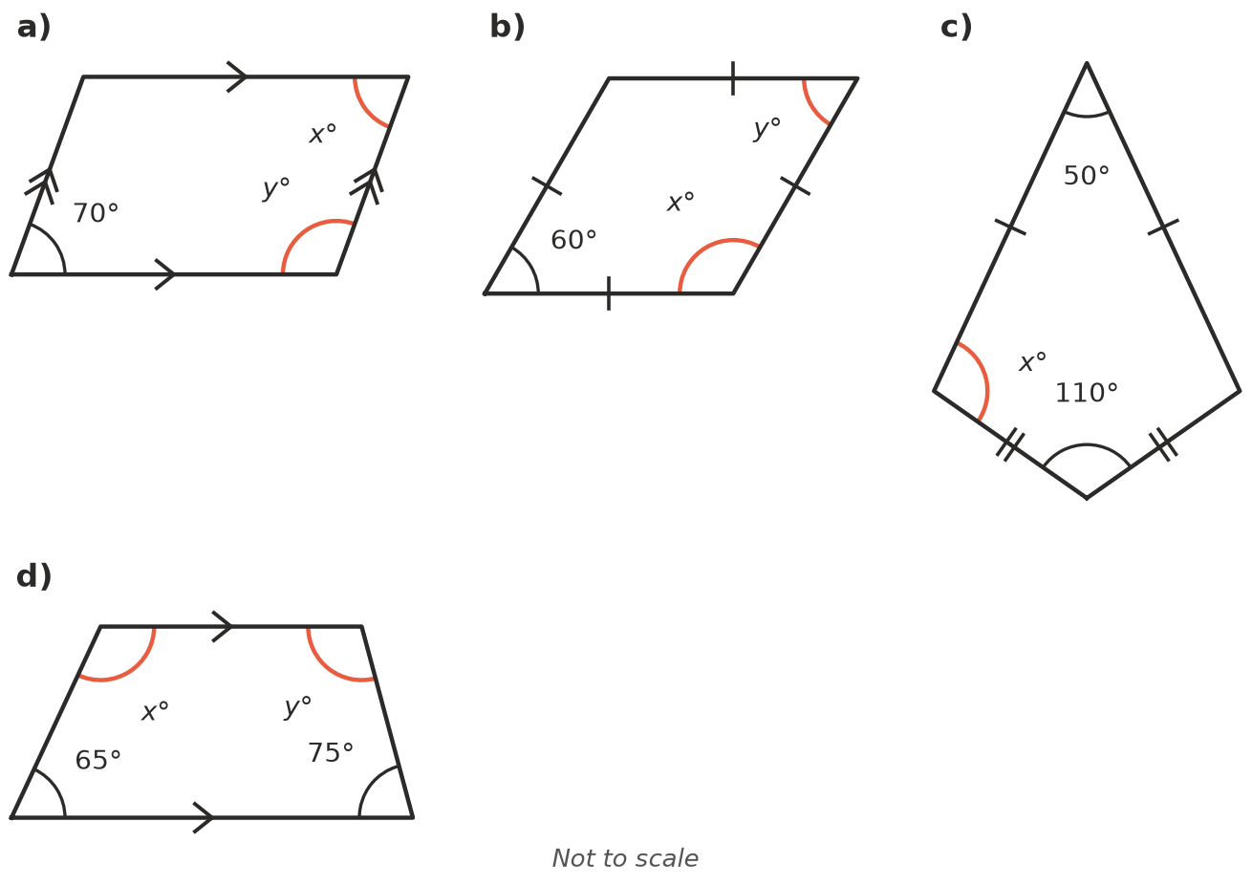
  - $x$ = ______________ $y$ = ______________ b) $x$ = ______________ $y$ =
  - $x$ = ______________ d) $x$ = ______________ $y$ =
- Three angles of a quadrilateral are 85°, 95° and 110°. Find the fourth angle.
- ABCD is a rectangle. Its diagonals cross at O, and AC = 10 cm.
- 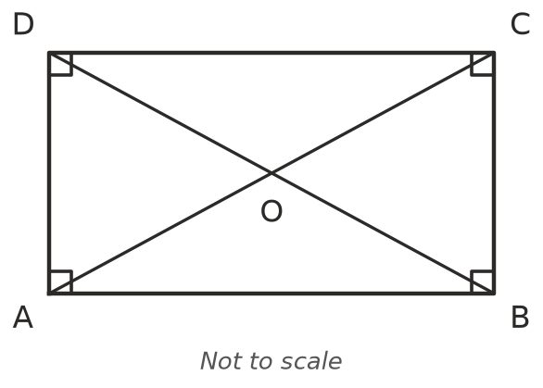
  - BD = ______________ b) OA = ______________ c) OB =
- Parallelogram PQRS has PQ = 7 cm and QR = 4 cm. Find RS, SP and the perimeter.

 Reasoning
- ABCD is a parallelogram. The diagonal AC cuts it into two triangles.
- 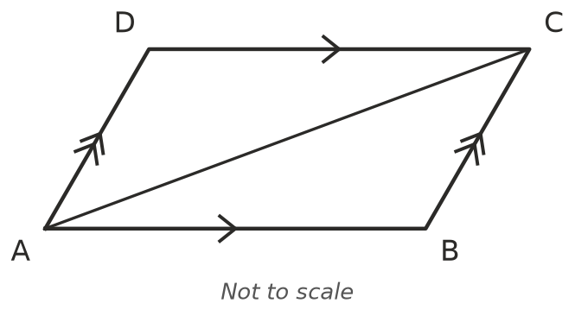
  - ∠BAC = ∠DCA because they are ______________ angles (AB ∥ DC).
  - ∠BCA = ∠DAC because they are ______________ angles (AD ∥ BC).
  - AC is a ______________ side.
  - So △ABC ≅ △CDA by the ______________ test, and so AB = ______________ and BC =
- Is a square a rectangle? Explain.

 Problem solving
- A builder makes a frame with opposite sides equal. She measures both diagonals: each is 2.53 m. What does this tell her about the corners of the frame?
- A rhombus has a perimeter of 36 cm. How long is each side?
- One angle of a rhombus is 50°. Find the other three angles.

