Investigation: 3D coordinate systems
Year 8 Maths · Worksheet
Name: ____________________ Date: ______________
On a flat grid, two numbers $(x,y)$ tell you exactly where a point is. In a room, a box or the sky, you need a third number for height. A 3D coordinate $(x,y,z)$ gives the distance along the $x$-axis, then along the $y$-axis, then up the $z$-axis, all measured from a corner called the origin, O. In this investigation you will read, plot and describe positions in three dimensions, and then explore them with 3D graphing software such as the free GeoGebra 3D Calculator (geogebra.org/3d).

Part A: Points in a room
This classroom is 6 m long, 5 m deep and 3 m high. The origin O is the front bottom-left corner. The $x$-axis runs along the front wall, the $y$-axis runs back into the room, and the $z$-axis runs up. One unit is 1 m.
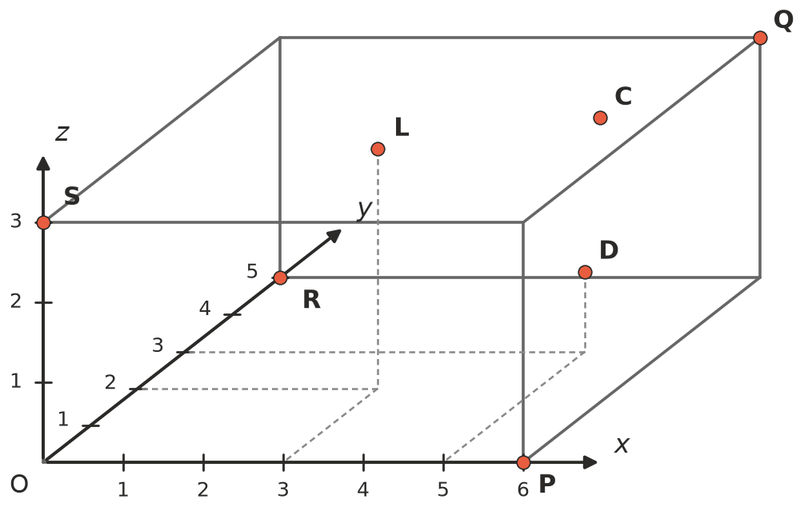
- P, Q, R and S are corners of the room. Write their coordinates.
- P ______________ Q ______________ R ______________ S ______________
- C is a clock on the back wall. L is a light on the ceiling, and D is the top corner of a cupboard. The dashed lines show how far each one is along and into the room. Write their coordinates.
- C ______________ L ______________ D ______________
- Every point on a wall, the floor or the ceiling has one coordinate that never changes. Complete each sentence.
  - Every point on the floor has $z$ = ______________
  - Every point on the back wall has ______________ = ______________
  - Every point on the ceiling has ______________ = ______________
  - Every point on the left wall (through O, S and R) has ______________ = ______________
- A spider sits at (6, 2, 1.5). On which surface of the room is it, and how high is it? ______________

Part B: Plot points in a box
The box is 4 units long, 3 units deep and 2 units high, with one corner at the origin.
- Plot and label these points on the box: A(4, 3, 2), B(4, 0, 0), C(0, 3, 2), D(2, 0, 1) and E(4, 1.5, 1). Hint: for each point, go along $x$, then back $y$, then up $z$.
- 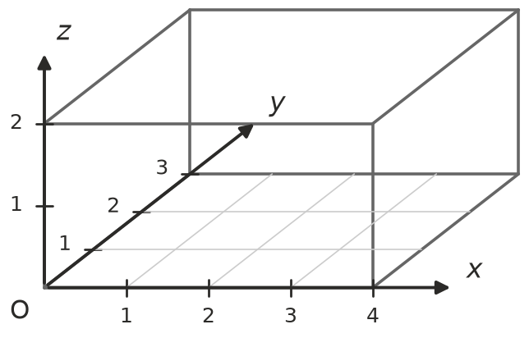
- Answer these about the points in Question 5.
  - Which points are corners of the box? ______________
  - Which points are on the front face of the box? How can you tell from the coordinates? ______________
  - Which point is in the middle of the right-hand face? ______________
- The midpoint of two points is halfway between them.
  - Find the midpoint of O(0, 0, 0) and A(4, 3, 2). Where is it in the box? ______________
  - Write a rule for finding the midpoint of any two points in 3D. ______________
- An ant walks from O to A along the edges of the box.
  - What is the shortest distance it can walk? ______________
  - How many different shortest routes are there? List them as moves, for example “$x$, then $y$, then $z$”. ______________

Part C: Describing positions in other ways
- Describe the position of the light L in words, without using coordinates, so that an electrician could find it. ______________

- A drone starts at O. It flies 2 m up, then 4 m to the right along the front wall, then 3 m back into the room.
  - Write its coordinates now. ______________
  - Write the moves the drone would need to fly from L to D, as changes in $x$, $y$ and $z$. ______________
- Tom uses the same directions for the axes, but puts his origin at corner P instead of O. What are the coordinates of D for Tom? Why are they different? ______________

Part D: Use 3D software
- Open a 3D graphing tool, such as GeoGebra 3D. Type each point in Question 5 on its own line, for example A = (4, 3, 2).
  - Rotate the view. Were your points in Question 5 in the right places? ______________
  - Type the eight corners of the box and join them to make the box. (In GeoGebra you can use Polygon or Segment.) Describe what happens to a point when you change only its $z$-coordinate. ______________

- Use the software to model the classroom from Part A. Place a point at the very centre of the room and write its coordinates. ______________

 Part E: Reflect
- Explain why we need three coordinates to give a position in a room, but only two on a sheet of paper.

- Give two real-life jobs or technologies that use 3D positions, and say what the three numbers would describe.

