7.05 Similar triangles
Year 8 Maths · Worksheet · Level 1 · Warm-up
Name: ____________________ Date: ______________
This worksheet practises the tests for similar triangles and using a scale factor to find unknown sides. Tip: match the sides carefully. The shortest side of one triangle matches the shortest side of the other, and the longest matches the longest.

 Understanding
- Complete the table of tests for similar triangles.
Test | What you need to show
AAA
SSS | all three pairs of matching sides are in the same ______________
SAS | two pairs of sides in the same ratio, and the angle ______________ them equal
RHS | a right angle, and the ______________ and one other side in the same ratio

- Are the triangles similar? Write Yes and the test, or No.
- 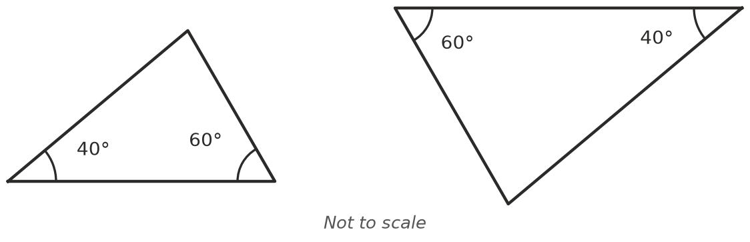
  - ______________
- 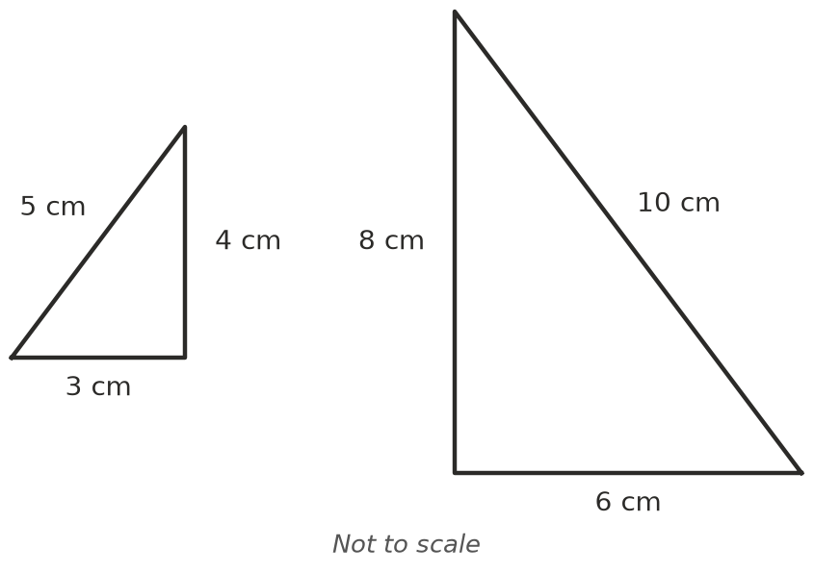
  - ______________
- 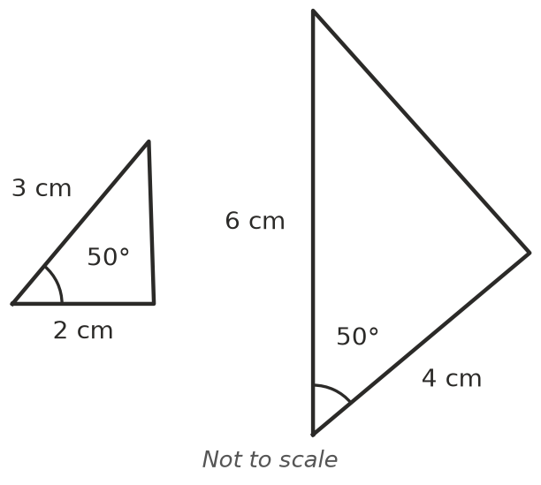
  - ______________
- 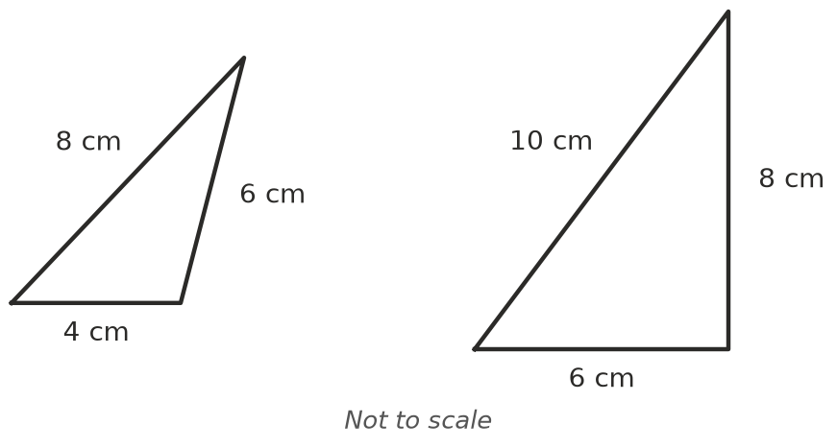
  - ______________
- Two triangles have the side lengths shown. Divide matching sides to decide if they are similar.
First triangle | Second triangle | Divisions | Similar?
2 cm, 3 cm, 4 cm | 6 cm, 9 cm, 12 cm
5 cm, 5 cm, 8 cm | 10 cm, 10 cm, 15 cm

 Fluency
- Each pair of triangles is similar. Find the scale factor, then find the unknown.
- 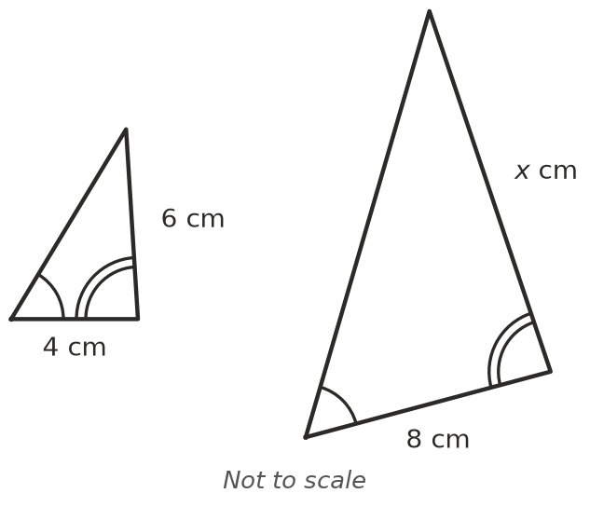
- 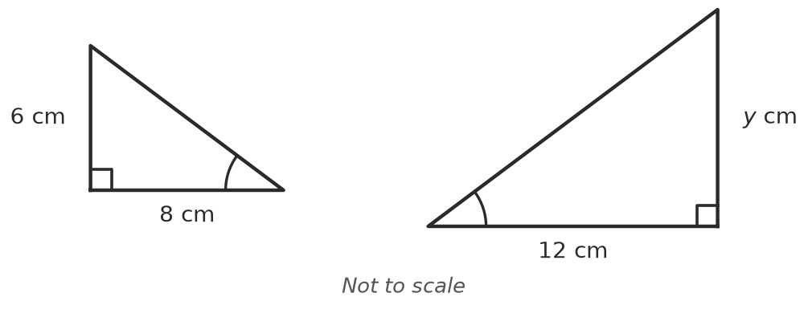
  - Scale factor: ______________ $x$ = ______________
  - Scale factor: ______________ $y$ = ______________
- Two triangles both have angles of 30°, 60° and 90°. The shortest side of the first is 5 cm and its longest side is 10 cm. The shortest side of the second is 15 cm.
  - Why are the triangles similar? ______________
  - Find the longest side of the second triangle. ______________
- In triangle ABC, DE is parallel to BC.
- 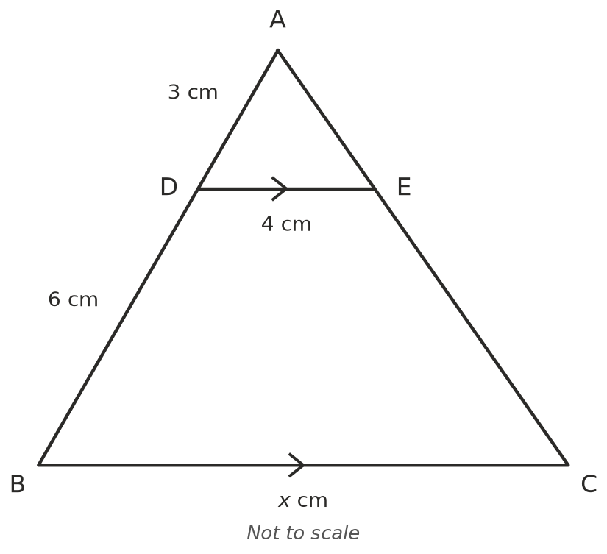
  - Explain why △ADE ||| △ABC. Hint: look for corresponding angles. ______________

  - How long is AB? ______________ What is the scale factor from △ADE to △ABC? ______________
  - Find $x$. ______________

 Reasoning
- Explain why two triangles that have two pairs of equal angles must be similar.

- Ella says a triangle with sides 3 cm, 4 cm and 5 cm is similar to one with sides 5 cm, 6 cm and 7 cm, “because each side is 2 more”. Explain why she is wrong.

 Problem solving
- A 2 m post casts a shadow 3 m long. At the same time, a tree casts a shadow 12 m long. Find the height of the tree, $h$.
- 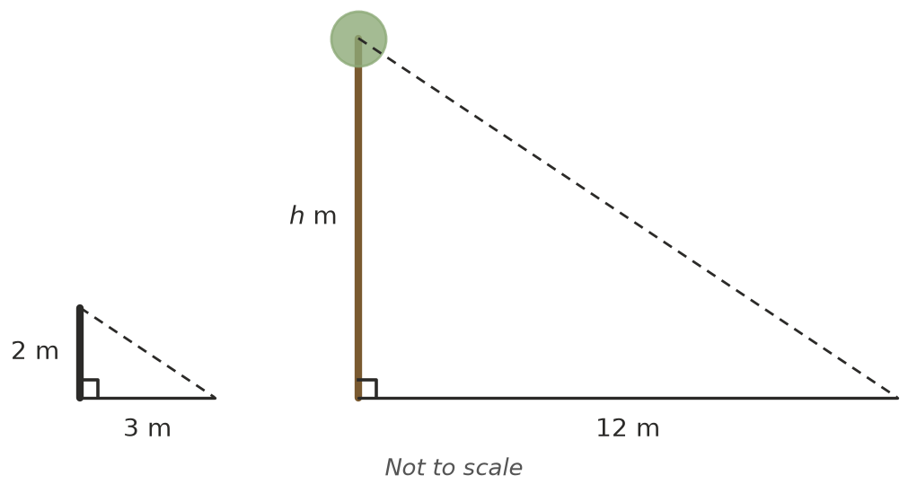
- $h$ = ______________
- A ramp rises 0.5 m over a horizontal distance of 2 m. How high is the ramp at a horizontal distance of 6 m, if it keeps the same slope? ______________
- An isosceles triangle has a base of 6 cm and two sides of 8 cm. A similar triangle has a base of 9 cm. How long are its two equal sides? ______________

