7.05 Similar triangles
Year 8 Maths · A5 question sheet · Level 3 · Challenge
This worksheet practises proving triangles similar, solving for unknowns with algebra, and using similar triangles to measure things you can’t reach. Tip: write the matching sides as a pair of fractions, for example $\frac{AD}{AB}=\frac{DE}{BC}$. Always use whole sides of the triangles, not the pieces left over.

 Understanding
- In the diagram, ∠ABC and ∠ADE are right angles. AD = 3 cm, AB = 7.5 cm and DE = 2 cm.
- 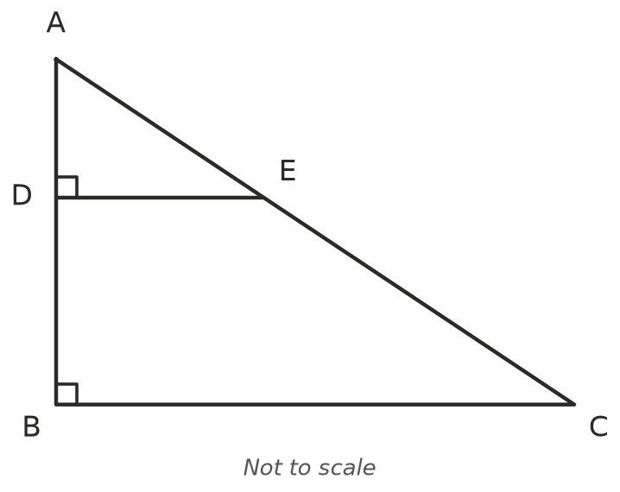
  - Prove that △ADE ||| △ABC.
  - Find BC. ______________ c) Find DB.
- Are the triangles similar? Show your working.
  - Sides 6 cm, 8 cm, 10 cm and 9 cm, 12 cm, 15 cm
  - Sides 4 cm, 6 cm, 9 cm and 6 cm, 9 cm, 13 cm
  - Two sides of 5 cm and 8 cm with a 40° angle between them, and two sides of 7.5 cm and 12 cm with a 40° angle between them

 Fluency
- DE is parallel to BC. Find $x$, then find AB.
- 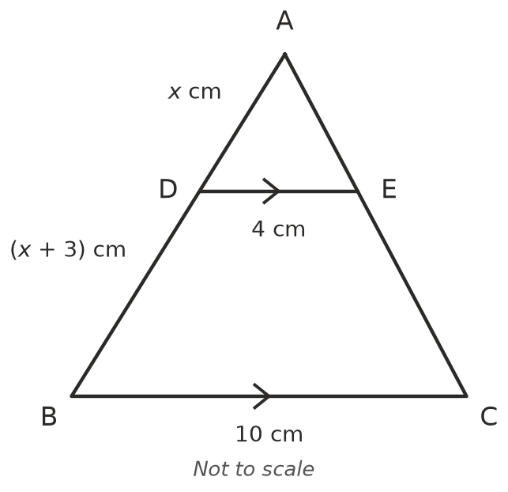
- AB is parallel to DC. Find $y$.
- 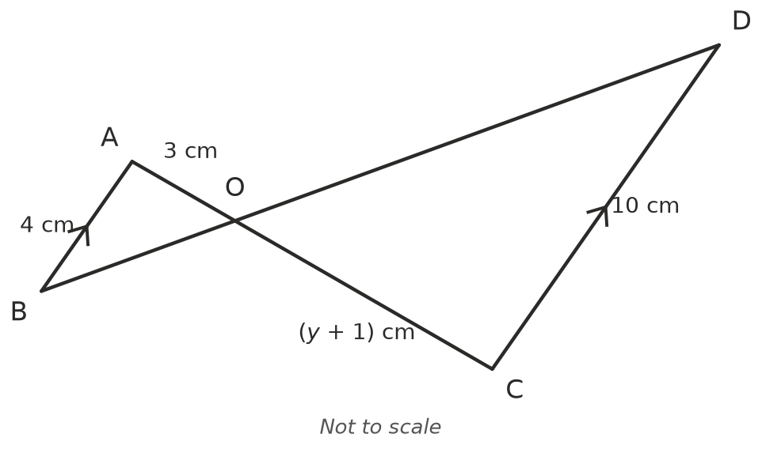
- In triangle ABC, DE is parallel to BC, with D on AB and E on AC. AD : DB = 2 : 3 and DE = 8 cm.
  - Find BC.
  - What fraction of the area of triangle ABC is the area of triangle ADE?

 Reasoning
- Prove that a line drawn parallel to one side of a triangle cuts off a smaller triangle that is similar to the original. Use a labelled sketch.
- Sam writes $\frac{AD}{DB}=\frac{DE}{BC}$ for Question 3. Use the numbers from Question 3 to show that his equation is wrong, and write the correct one.
- Two similar triangles have a scale factor of $k$. Explain what happens to their perimeters and to their areas.

 Problem solving
- Kai puts a small mirror on flat ground 9 m from a tree. He stands 2 m from the mirror, on the other side, and sees the top of the tree in it. His eyes are 1.5 m above the ground. The angles the light makes with the ground on each side of the mirror are equal. Find the height of the tree.
- 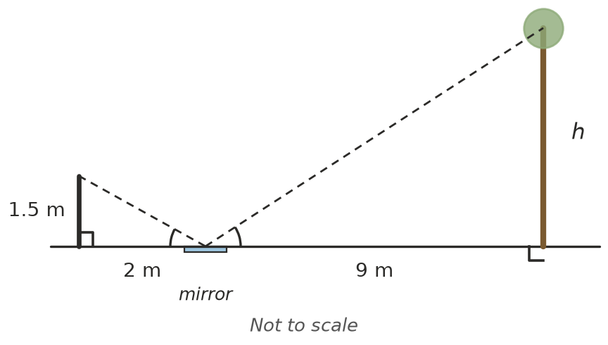
- $h$ =
- In a pinhole camera, light from the top and bottom of an object passes through a pinhole and makes an upside-down image on the back of the box. A person 1.8 m tall stands 6 m from the pinhole, and the box is 20 cm deep. How tall is the image? Draw a sketch.
- A triangle has sides 4 cm, 5 cm and 6 cm. A similar triangle has a perimeter of 45 cm. Find its sides.
- The midpoints of the three sides of a triangle are joined to make a smaller triangle inside.
  - Each side of the small triangle is parallel to one side of the big triangle and half its length. What is the scale factor?
  - What fraction of the big triangle’s area is the small triangle?
  - How many copies of the small triangle fit inside the big one? Explain.

