7.05 Similar triangles
Year 8 Maths · A5 question sheet · Level 2 · Core
This worksheet practises the four similarity tests (AAA, SSS, SAS and RHS), writing similarity statements, and finding unknown sides in nested and crossed triangles. Tip: when one triangle sits inside another, redraw the two triangles separately, side by side, before you match the sides.

 Understanding
- The congruence test SSS and the similarity test SSS both talk about three pairs of sides. Explain the difference between them.
- Are the triangles similar? Write Yes and the test (AAA, SSS, SAS or RHS), or No.
  - 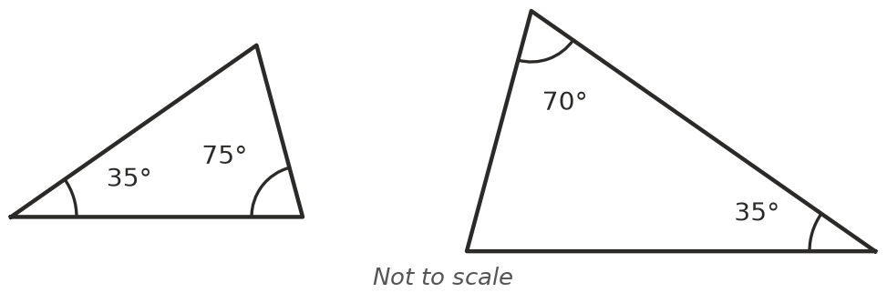
  - 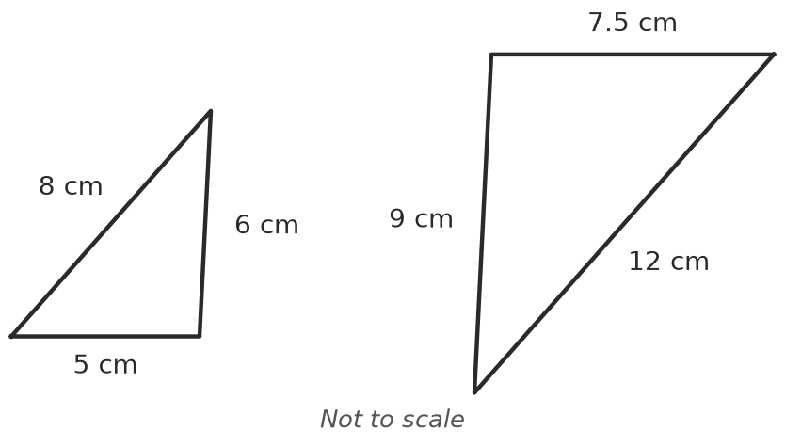
  - 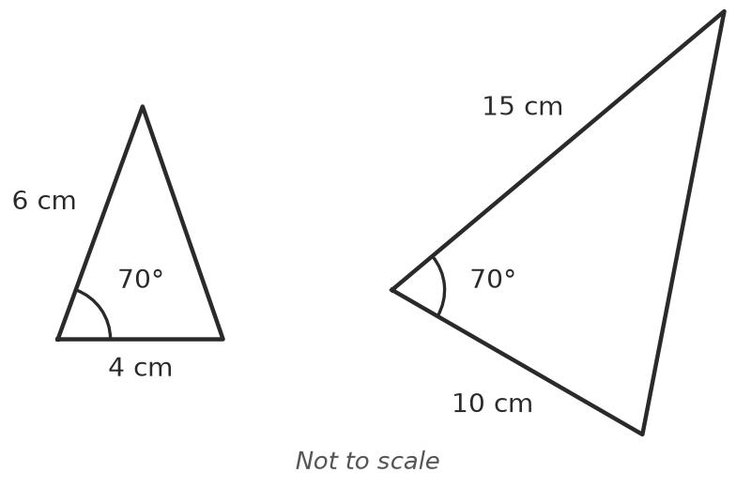
  - 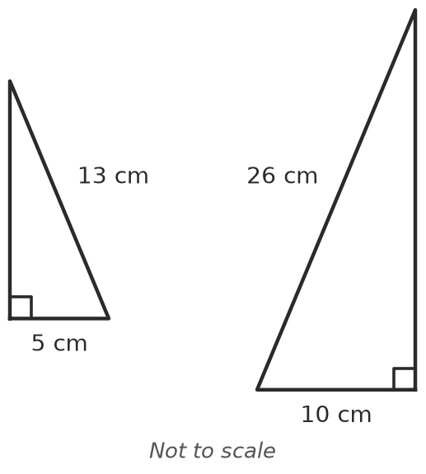
  - 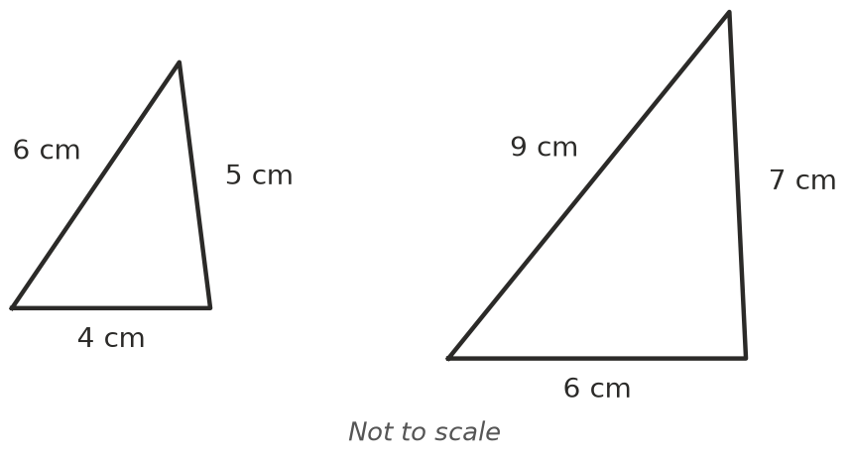
- Use the matching angle marks to complete the similarity statement, and name the test.
- 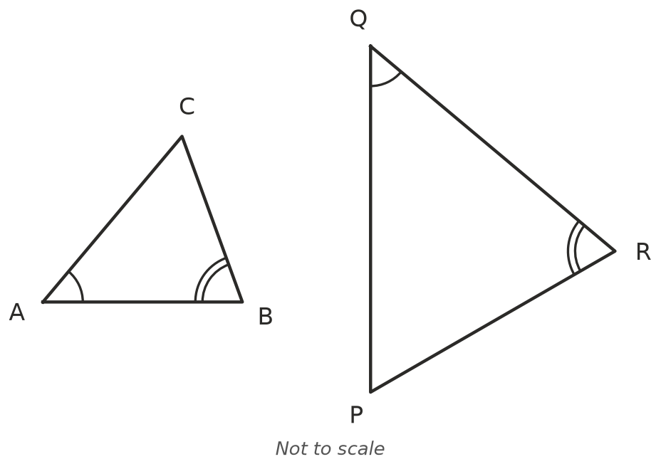

 Fluency
- △ABC ||| △DEF. Find the scale factor, then $x$ and $y$.
- 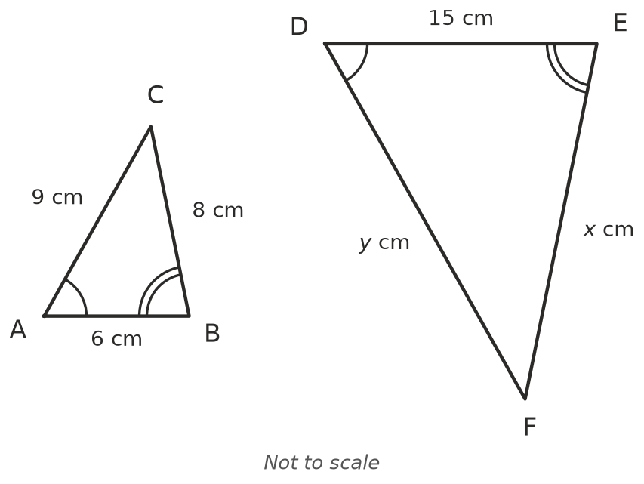
- In triangle ABC, DE is parallel to BC.
- 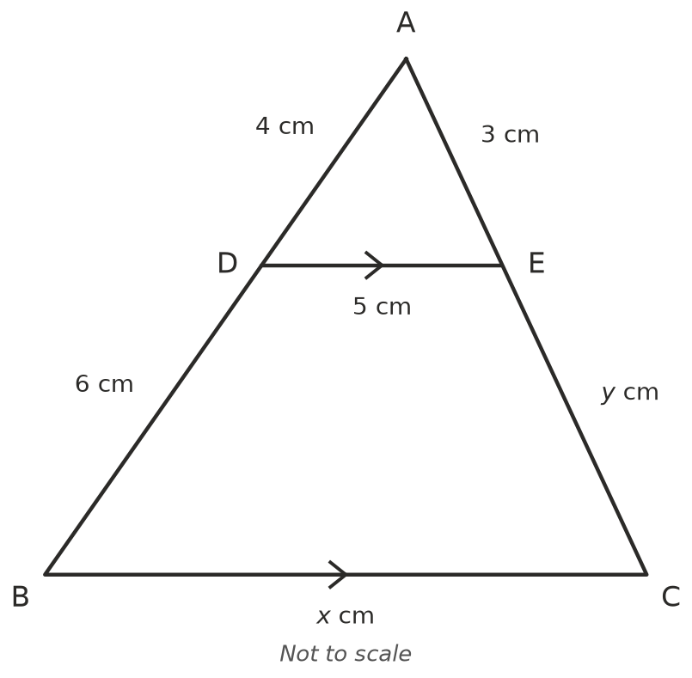
  - Find the scale factor from △ADE to △ABC.
  - Find $x$. ______________ c) Find $y$.
- AB is parallel to DC, and AC and BD cross at O.
- 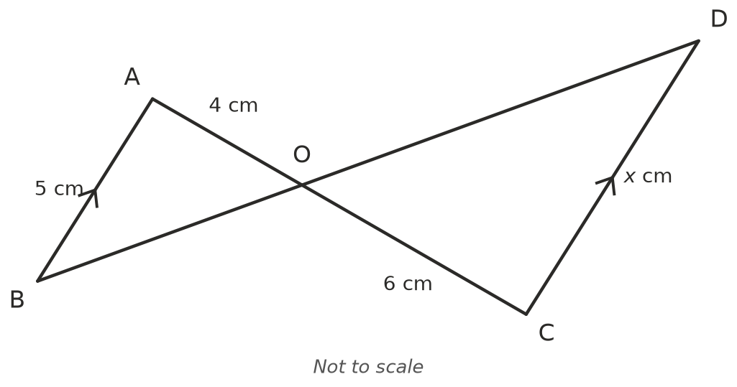
  - Explain why △OAB ||| △OCD.
  - Find $x$.
- △PQR ||| △XYZ, with the vertices in matching order. PQ = 4 cm, QR = 6 cm, XY = 10 cm and XZ = 12.5 cm.
  - Find the scale factor. ______________ b) Find YZ. ______________ c) Find PR.

 Reasoning
- Write True or False, and give a reason.
  - All right-angled triangles are similar.
  - All right-angled isosceles triangles are similar.
  - If two triangles are congruent, they are also similar.
- Explain why you only need to check two pairs of angles to show that two triangles are similar.

 Problem solving
- A person 1.6 m tall casts a shadow 2.4 m long. At the same time, a building casts a shadow 15 m long. Find the height of the building.
- 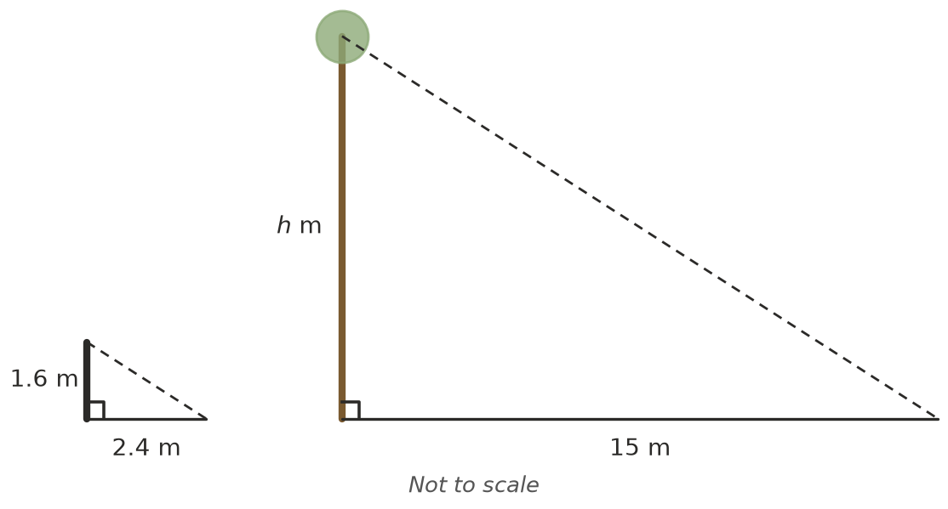
- $h$ =
- A ladder rests on the top of a fence 1.8 m high and reaches a wall behind it. The foot of the ladder is 1.2 m from the fence, and the fence is 2 m from the wall. The fence and the wall are both vertical. How high up the wall does the ladder reach? Draw a sketch.
- A triangle with sides 5 cm, 7 cm and $x$ cm is similar to a triangle with sides 7.5 cm, $y$ cm and 12 cm, with the sides listed in matching order. Find $x$ and $y$.

