Investigation: Determine congruence or similarity
Year 8 Maths · Worksheet
Name: ____________________ Date: ______________
An algorithm is a list of steps and decisions that anyone can follow to get the same answer every time. In this investigation you will follow an algorithm that decides whether two triangles are congruent, similar or neither, then design and test your own algorithms for other information and other shapes. In a flowchart, rounded boxes show the start and the results, plain boxes are steps, and shaded boxes ask a yes or no question.

Part A: Follow an algorithm
This flowchart works when you know all three sides of each triangle.
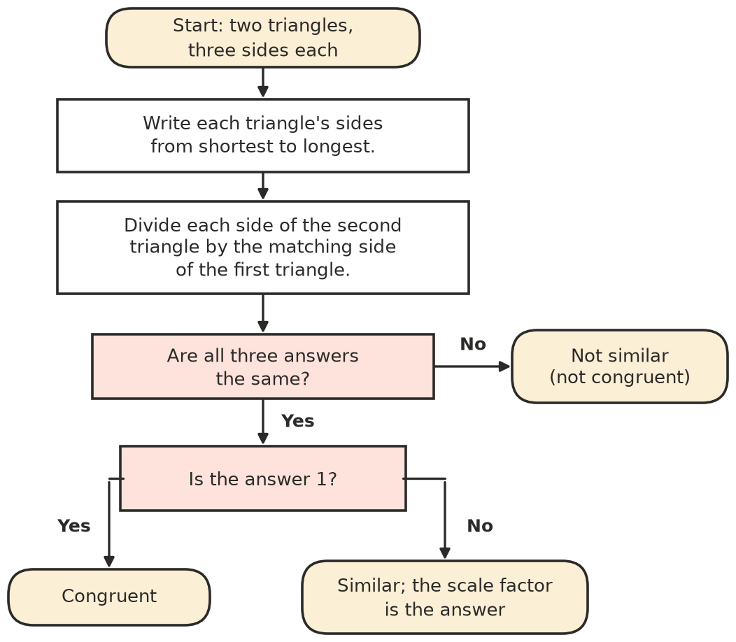
- Use the flowchart on each pair of triangles.
First triangle (cm) | Second triangle (cm) | The three answers | Result
3, 4, 5 | 5, 3, 4
4, 6, 7 | 8, 12, 14
5, 6, 8 | 7.5, 9, 12
2, 3, 4 | 4, 6, 9
6, 8, 9 | 4, 6, 6
10, 6, 8 | 4, 3, 5

- Why does the algorithm sort the sides first? Use the first pair in the table to show what could go wrong without that step.

- Which congruence test and which similarity test is this algorithm using? ______________

Part B: Design an algorithm for angles
- Design a flowchart that decides whether two triangles are similar when you are told two angles of each triangle. Hint: the first step could be to find the third angle of each. Draw it in the box.
- 
- Test your flowchart.
Two angles of the first | Two angles of the second | Result
40°, 60° | 60°, 80°
50°, 50° | 50°, 80°
30°, 70° | 30°, 90°
45°, 45° | 90°, 45°

- Can your angle algorithm ever give the result “congruent”? Explain why or why not.

Part C: Two sides and an angle
- Write an algorithm as numbered steps using IF, THEN and OTHERWISE. It should decide whether two triangles are congruent, similar or neither when you know two sides and the angle between them for each triangle. For example: “Step 1: IF the two angles are different, THEN the result is Neither. OTHERWISE go to Step 2.”

- Test your algorithm.
First triangle | Second triangle | Result
4 cm, 6 cm, 50° between | 6 cm, 9 cm, 50° between
5 cm, 7 cm, 35° between | 7 cm, 5 cm, 35° between
3 cm, 5 cm, 60° between | 6 cm, 9 cm, 60° between
8 cm, 8 cm, 40° between | 4 cm, 4 cm, 40° between

- Your algorithm needs the angle to be between the two sides. What should it do if the angle is not between them? Is there a special case where it can still decide?

Part D: Other shapes
- Lily uses the Part A idea on quadrilaterals: sort the four sides, divide, and check that all four answers are the same.
  - Test her method on a square with sides of 5 cm and a rhombus with sides of 5 cm that is not a square. What result does it give? Is it right? ______________

  - What extra check does an algorithm for quadrilaterals need? ______________
- Write an algorithm (flowchart or numbered steps) that decides whether two rectangles are congruent, similar or neither, from their lengths and widths. Test it on the three pairs below.

First rectangle | Second rectangle | Result
4 cm × 6 cm | 6 cm × 9 cm
3 cm × 5 cm | 5 cm × 3 cm
2 cm × 8 cm | 4 cm × 10 cm

 Part E: Reflect
- In two or three sentences, describe how the Part A algorithm works and why its result can be trusted.

- Extension: if you know a programming language such as Scratch or Python, write a program for the Part A algorithm. Test it on the pairs in Question 1. What did the computer find hard that people find easy (or the other way round)?

