7.04 Transformations and similarity
Year 8 Maths · A5 question sheet · Level 2 · Core
This worksheet practises enlargements from a centre, scale factors, and using similar figures to find unknown sides and angles. Tip: to enlarge from a centre O with scale factor $k$, every image point is on the line from O through the original point, $k$ times as far from O.

 Understanding
- Are the two rectangles similar? Write Yes or No, and the scale factor if they are.
First rectangle | Second rectangle | Similar?
4 cm × 6 cm | 6 cm × 9 cm
2 cm × 5 cm | 4 cm × 8 cm
3 cm × 3 cm | 7 cm × 7 cm
5 cm × 8 cm | 10 cm × 13 cm

 Fluency
- Draw each enlargement.
  - Enlarge ABCD by a scale factor of 3 with centre O.
- 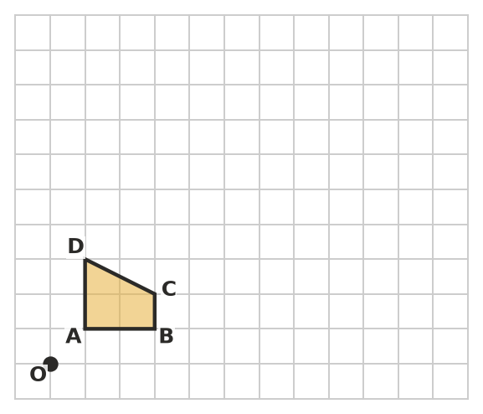
  - Enlarge triangle PQR by a scale factor of $\frac{1}{2}$ with centre O.
- 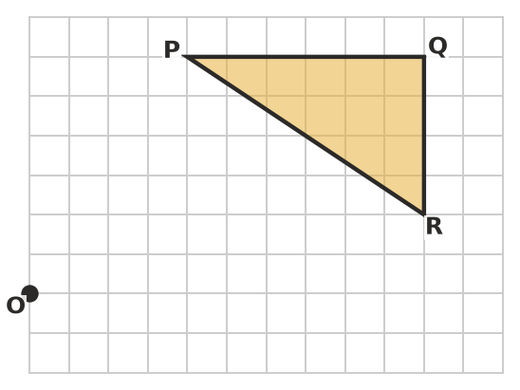
- Triangle ABC has vertices A(1, 1), B(3, 1) and C(1, 4). It is enlarged with the rule $(x,y)$ → $(2x,2y)$.
  - Write the coordinates of A′, B′ and C′.
  - How long are AB and A′B′? ______________ What is the scale factor?
  - Where is the centre of this enlargement?
- Copy and complete the table.
Original length | Image length | Scale factor
8 cm | 20 cm
12 cm |  | 0.75
 | 18 cm | 3
15 cm | 6 cm

- ABCD ||| PQRS.
- 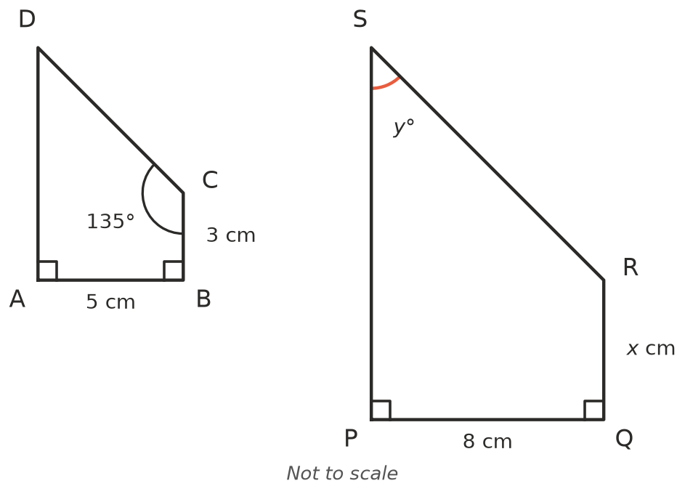
  - Find the scale factor.
  - Find $x$. ______________ c) Find $y$.
- Triangle LMN ||| triangle XYZ, with the vertices in matching order. LM = 6 cm, MN = 9 cm, LN = 12 cm and XY = 10 cm.
  - What is the scale factor from LMN to XYZ?
  - Find YZ and XZ.
  - ∠N = 29°. Which angle in triangle XYZ is also 29°?

 Reasoning
- Shape B is an enlargement of shape A.
- 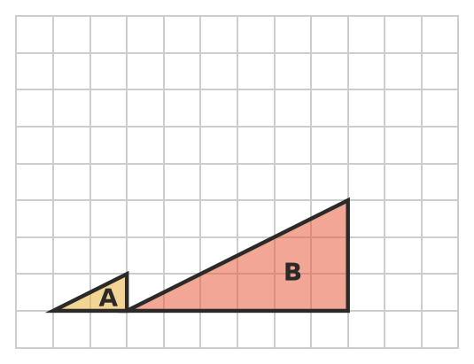
  - Draw lines through matching corners to find the centre of enlargement. Mark it with a dot.
  - What is the scale factor?
- Explain why any two squares are similar, but two rectangles are not always similar.
- Tom wants to enlarge a 2 cm × 4 cm rectangle. He adds 3 cm to each side to get a 5 cm × 7 cm rectangle. Is his rectangle similar to the first one? Explain.

 Problem solving
- On a map with a scale of 1 : 50 000, two towns are 6 cm apart. How far apart are the real towns, in kilometres?
- A photo 12 cm wide and 8 cm high is enlarged to fit a frame 30 cm wide. How high is the enlarged photo?
- A square with side 3 cm is enlarged by a scale factor of 2.
  - Find the area of the original square and of the image.
  - By what number was the area multiplied? Why isn’t it 2?

