7.04 Transformations and similarity
Year 8 Maths · A5 question sheet · Level 1 · Warm-up
This worksheet practises enlargements, scale factors and similar figures. Similar figures have the same shape but can be different sizes: the matching angles are equal, and every length is multiplied by the same scale factor. Tip: scale factor = image length ÷ original length.

 Understanding
- Is the second shape an enlargement of the first? Write Yes or No. If Yes, give the scale factor.
- 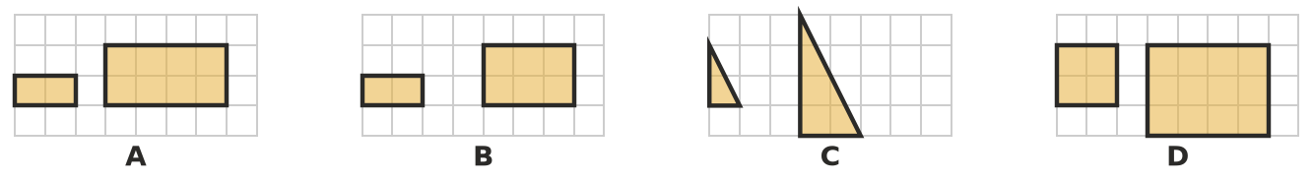
- Complete each sentence.
  - Similar figures have the same ______________ but can be a different
  - In similar figures, matching angles are ______________ and matching sides are multiplied by the same
  - The symbol ||| means
  - A scale factor between 0 and 1 makes the image ______________ than the original.

 Fluency
- Enlarge the shape by a scale factor of 2. Draw your enlargement on the empty part of the grid.
- 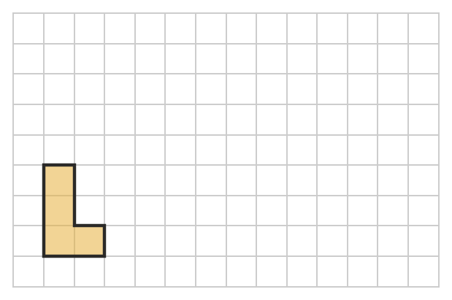
- Find the scale factor from the original length to the image length.
  - 3 cm becomes 12 cm ______________ b) 10 cm becomes 5 cm
  - 6 cm becomes 9 cm ______________ d) 8 cm becomes 8 cm
- A rectangle 3 cm wide and 5 cm long is enlarged by a scale factor of 4. What are the new width and length?
- The two rectangles are similar. Find the scale factor, then find $x$.
- 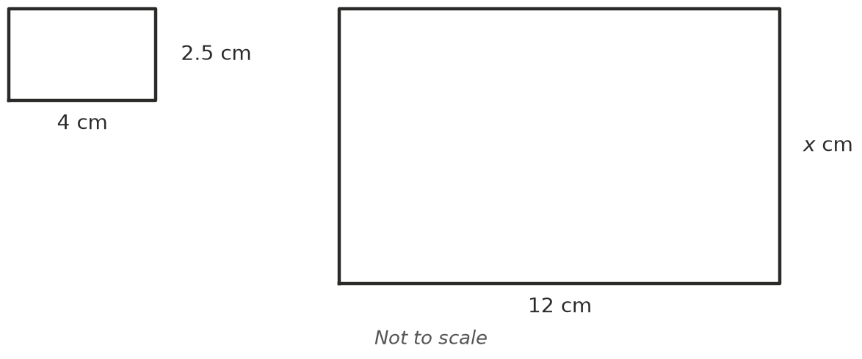
- A photo 15 cm long and 10 cm wide is reduced by a scale factor of $\frac{1}{2}$. What size is the new photo?
- Enlarge triangle ABC by a scale factor of 3 with centre O. Hint: A′ is on the line from O through A, 3 times as far from O as A is.
- 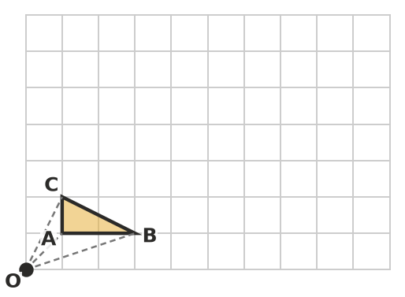
  - Draw triangle A′B′C′.
  - AB is 2 units long. How long is A′B′?

 Reasoning
- Are congruent shapes always similar? Are similar shapes always congruent? Explain.
- Mia says that when you enlarge a triangle by a scale factor of 2, its angles also double. Explain why she is wrong.

 Problem solving
- A model car is built at a scale of 1 : 20. The model is 21 cm long. How long is the real car, in metres?
- A photo 9 cm long and 6 cm wide is enlarged so that its width becomes 15 cm. How long is the enlarged photo?

