7.03 Congruent triangles
Year 8 Maths · Worksheet · Level 3 · Challenge
Name: ____________________ Date: ______________
This worksheet practises choosing congruence tests carefully, writing full congruence proofs, and using congruent triangles to prove geometry facts. Tip: a good proof lists three matching facts, each with a reason, then names the test, then says what follows (“matching sides of congruent triangles are equal”).

 Understanding
- Are the triangles congruent? If yes, name the test. If no, explain why not. Check carefully where each marked side sits.
- 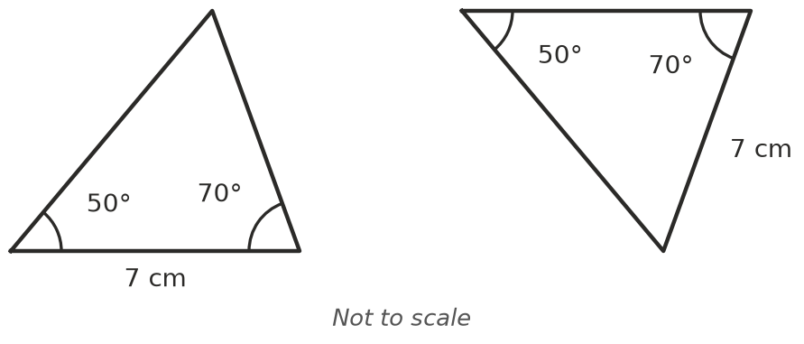
  - ______________
- 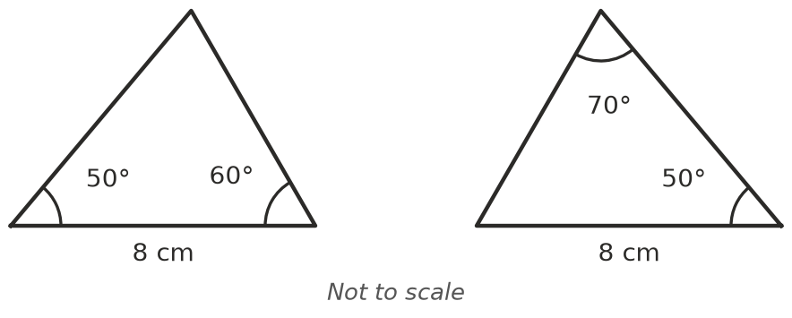
  - ______________
- 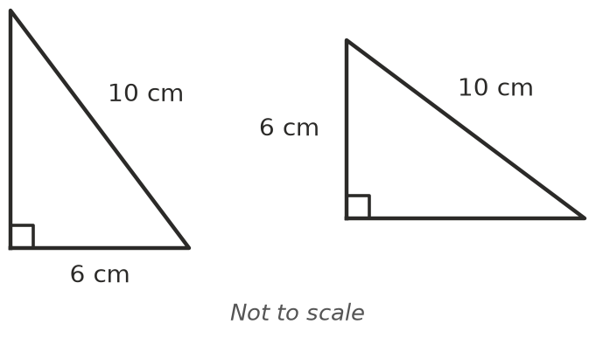
  - ______________
- In the diagram, AD = AE and DB = EC.
- 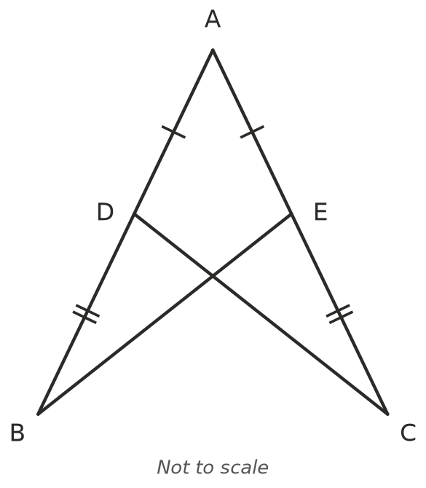
  - Explain why AB = AC. ______________
  - Prove that △ABE ≅ △ACD. ______________

  - What does this tell you about BE and CD? ______________

 Fluency
- △PQR ≅ △STU. PQ = (2$x$ + 1) cm, QR = ($y$ + 4) cm and PR = 10 cm. ST = 9 cm and TU = ($x$ + 7) cm.
  - Find $x$. ______________ b) Find $y$. ______________
  - Find the perimeter of triangle STU. ______________
- △ABC ≅ △XYZ. ∠A = (2$a$ + 10)°, ∠B = 3$b$° and ∠C = 70°. ∠X = 50°. Find $a$ and $b$. ______________

- ABCD is a parallelogram (both pairs of opposite sides are parallel), with diagonal BD.
- 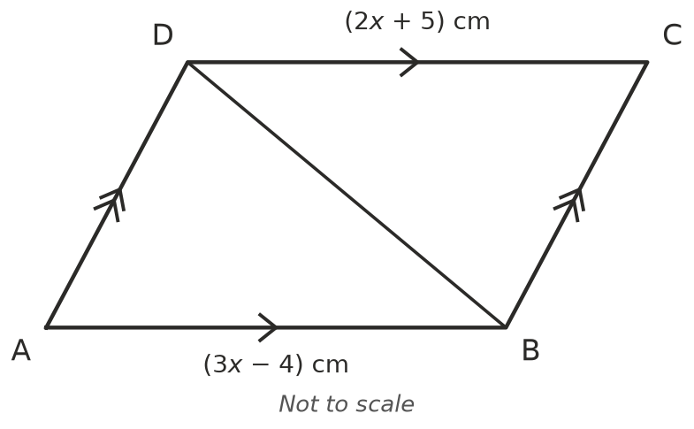
  - Prove that △ABD ≅ △CDB. Hint: look for alternate angles. ______________

  - Find $x$ and the length of AB. ______________

 Reasoning
- Triangle ABC has AB = AC. Prove that ∠B = ∠C. Hint: start by joining A to M, the midpoint of BC.

- Write True or False. If false, describe two triangles that show it is false.
Statement | True or False
Two equilateral triangles with the same side length are congruent.
Two isosceles triangles with the same base are congruent.
Two right-angled triangles with the same two shorter sides are congruent.
Two triangles with the same perimeter are congruent.

- Two triangles have two pairs of matching sides and one pair of matching angles. Explain when this proves they are congruent, and when it doesn’t. A sketch may help.

 Problem solving
- P is a point on the perpendicular bisector of AB. (M is the midpoint of AB, and the dashed line through M is at right angles to AB.)
- 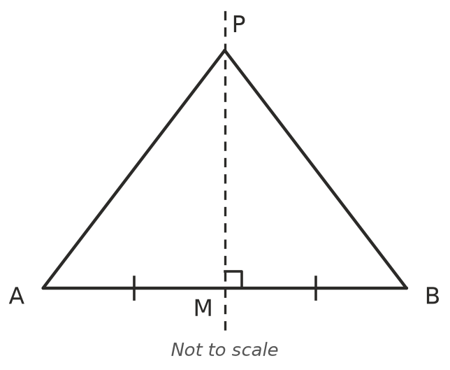
  - Prove that PA = PB. ______________

  - Two towns are at A and B. Describe where a phone tower could go so that it is the same distance from both towns. ______________
- ABCD is a kite with AB = AD and CB = CD. Its diagonals cross at M. Prove that the diagonals cross at right angles. Hint: you need two pairs of congruent triangles.
- 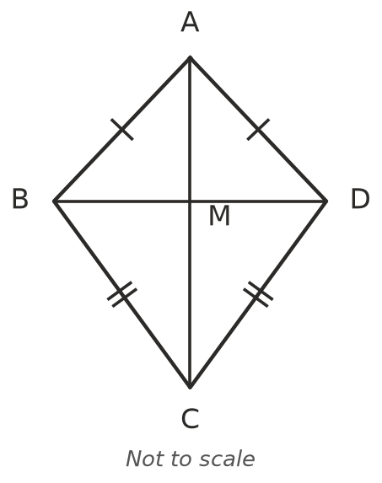

- By SSS, three side lengths make exactly one triangle (any two triangles with the same three sides are congruent).
  - How many different triangles have whole-number sides and a perimeter of 12 cm? List them. ______________
  - How many have a perimeter of 15 cm? ______________

