7.03 Congruent triangles
Year 8 Maths · Worksheet · Level 2 · Core
Name: ____________________ Date: ______________
This worksheet practises choosing a congruence test (SSS, SAS, AAS or RHS), writing congruence statements, and using congruent triangles to prove facts and find unknowns. Tip: look for “free” information in a diagram. A side shared by two triangles is equal to itself, and vertically opposite angles are equal.

 Understanding
- Circle the two that are not congruence tests, and explain why one of them does not work.
- SSS · SAS · AAA · RHS · AAS · SSA

- For each pair, name the test that proves they are congruent, or write “Not enough information”.
- 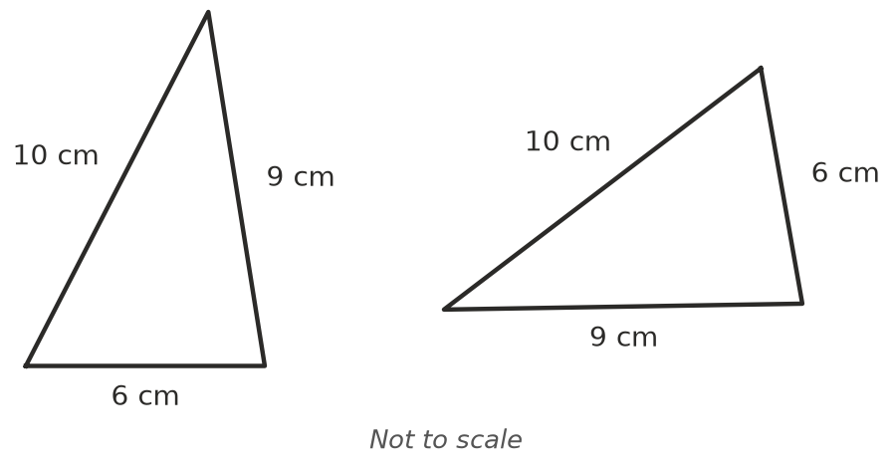
  - ______________
- 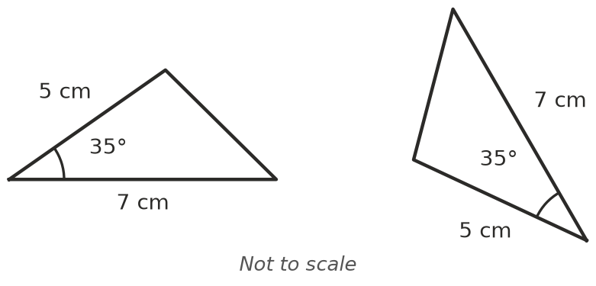
  - ______________
- 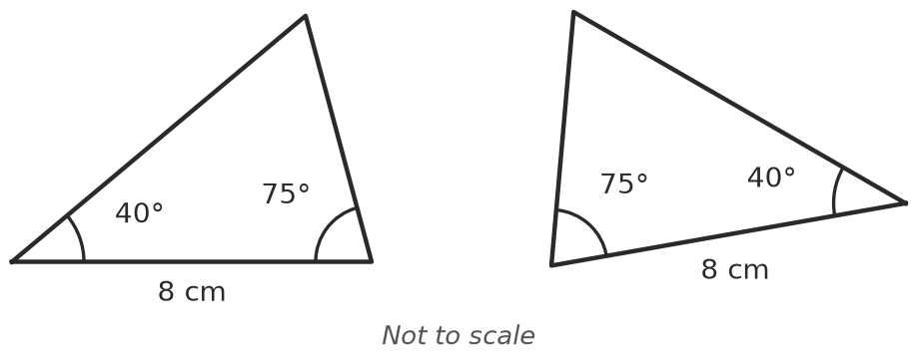
  - ______________
- 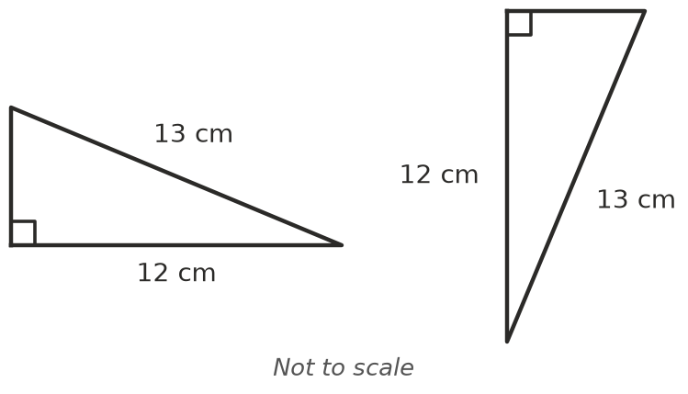
  - ______________
- 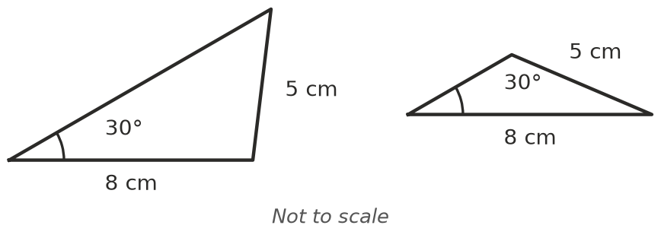
  - ______________
- 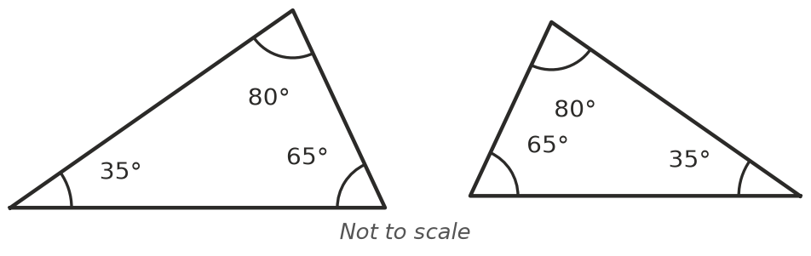
  - ______________

 Fluency
- Each diagram contains two congruent triangles. Write a congruence statement and name the test. Say what extra fact you used (a shared side or vertically opposite angles).
- 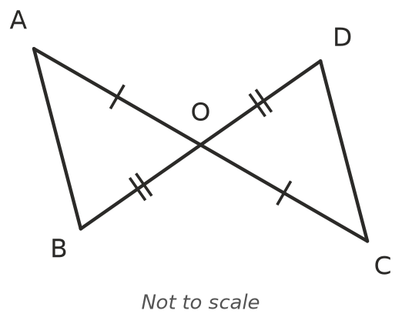
  - ______________
- 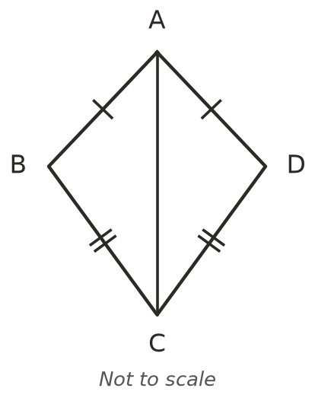
  - ______________
- 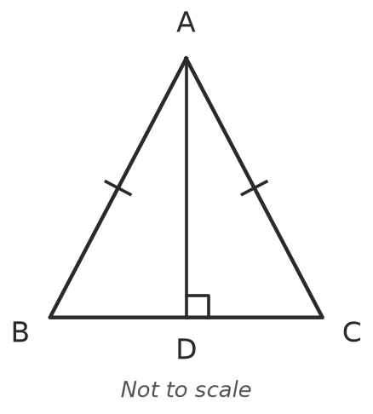
  - ______________
- Name the test that shows △ABC ≅ △DEF. Then find $x$ and $y$.
- 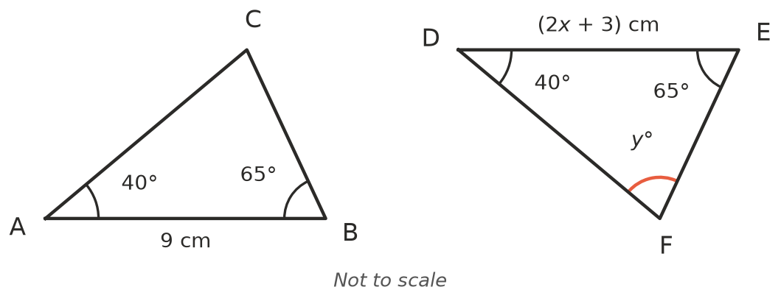
- Test: ______________ $x$ = ______________ $y$ = ______________
- What extra piece of information would prove that the triangles are congruent by the test given?
- 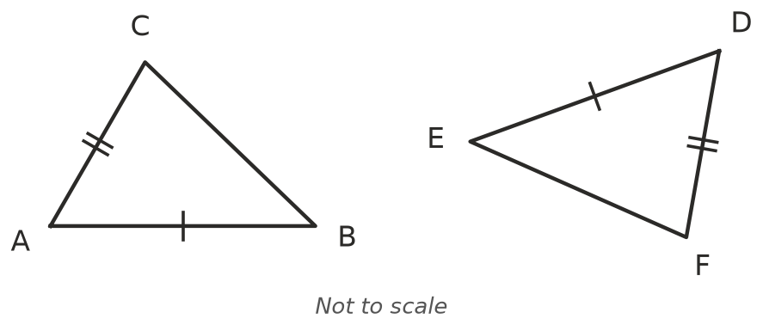
  - SAS: ______________
- 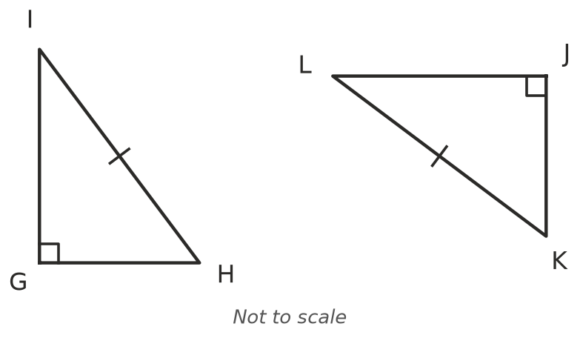
  - RHS: ______________
- 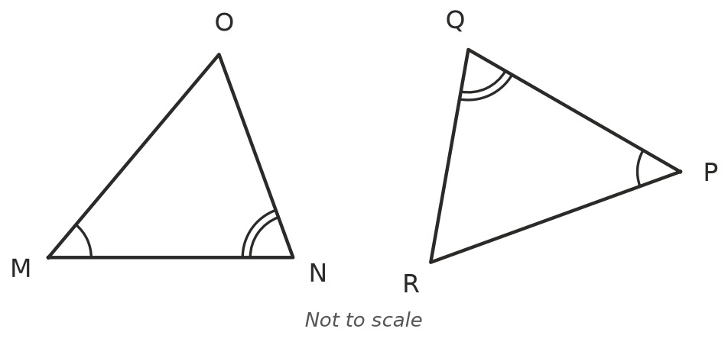
  - AAS: ______________

 Reasoning
- PQRS is a kite with PQ = PS and RQ = RS. Complete the proof that ∠PQR = ∠PSR.
- 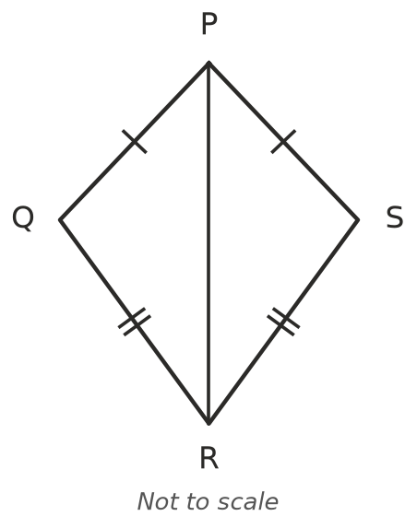
  - PQ = ______________ (given)
  - RQ = ______________ (given)
  - PR = PR (______________)
  - So △PQR ≅ △______________ by the ______________ test.
  - So ∠PQR = ∠PSR because ______________
- The lines AC and BD cross at O. O is the midpoint of both AC and BD. Prove that AB = CD. Give a reason for each step.

- In the diagram, triangles ABC and ABD both have the side AB, the 42° angle at A, and a side from B equal to BC = BD. Use the diagram to explain why SSA is not a congruence test.
- 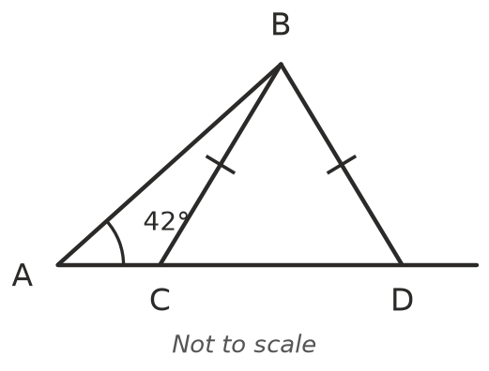

 Problem solving
- Lena wants to know how wide a river is. She stands at A, opposite a tree T. She walks 30 m along the bank to B and puts in a peg, then walks another 30 m to C. From C she walks straight away from the river until she sees the peg and the tree lined up, at D. CD is 42 m.
- 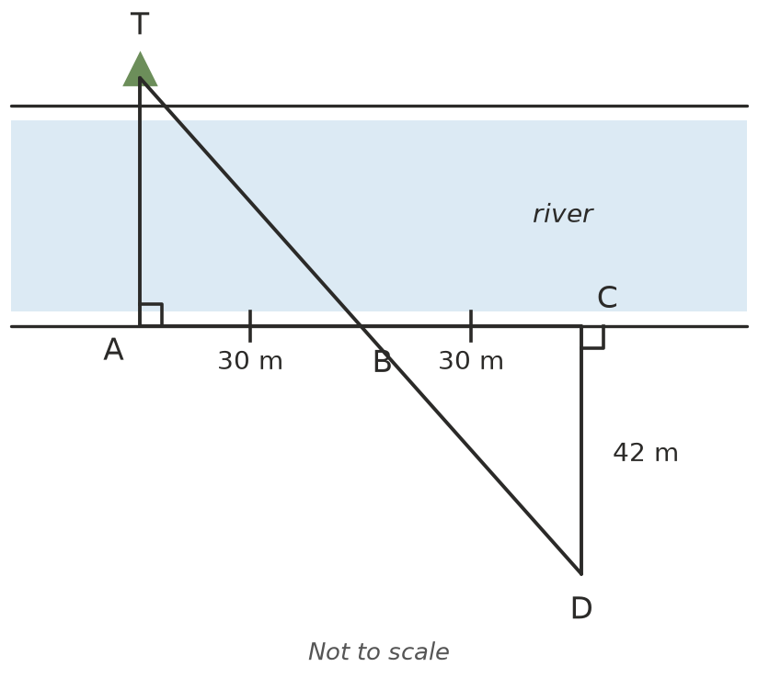
  - Explain why △TAB ≅ △DCB, and name the test. ______________

  - How far is it from A to the tree? ______________
- PQR is isosceles with PQ = PR, and M is the midpoint of QR. Prove that PM is perpendicular to QR.
- 