7.03 Congruent triangles
Year 8 Maths · Worksheet · Level 1 · Warm-up
Name: ____________________ Date: ______________
This worksheet practises the four tests that prove two triangles are congruent: SSS, SAS, AAS and RHS. Tip: you don’t need to check all six sides and angles. If three of the right parts match, the triangles must be congruent.

 Understanding
- Complete the table of congruence tests.
Test | What must match
SSS
SAS | two sides and the angle ______________ them
AAS | two angles and ______________
RHS | a right angle, the ______________ and one other side

- Each pair of triangles is congruent. Name the test that shows it: SSS, SAS, AAS or RHS.
- 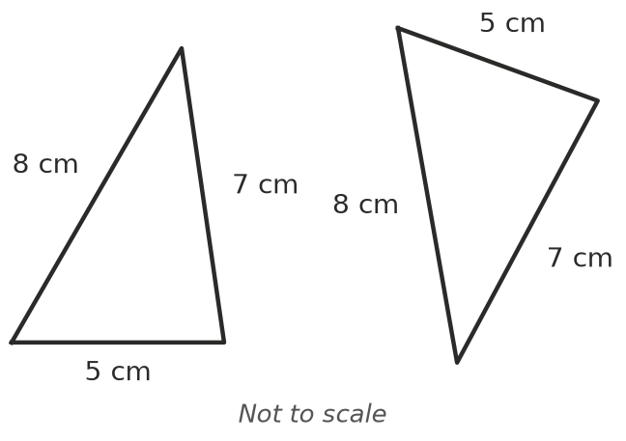
  - ______________
- 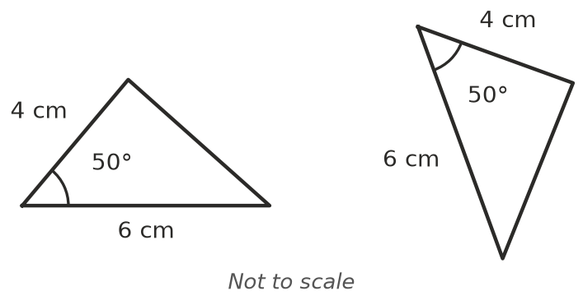
  - ______________
- 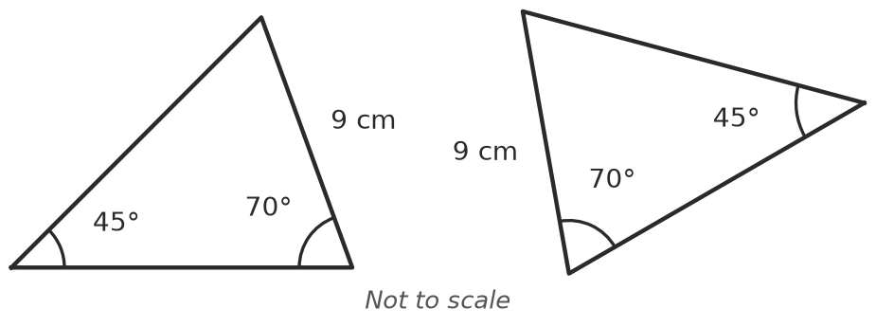
  - ______________
- 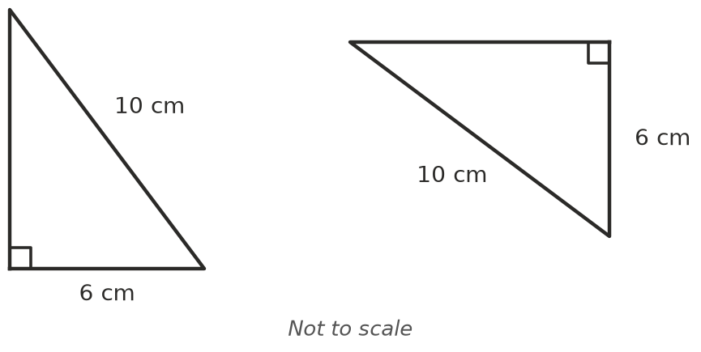
  - ______________
- Answer these about triangle ABC.
  - Which angle is between sides AB and BC? ______________
  - Which side is between ∠A and ∠B? ______________
  - In a right-angled triangle, what is the longest side called? ______________

 Fluency
- Are the two triangles congruent? Write Yes and the test, or write “Not enough information”.
- 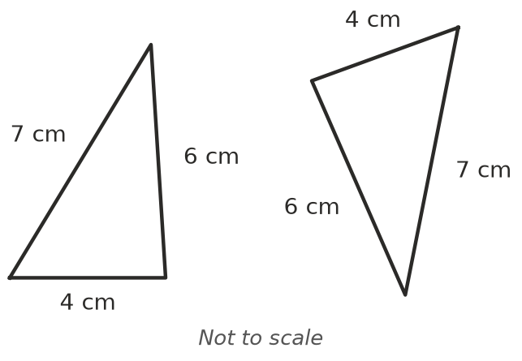
  - ______________
- 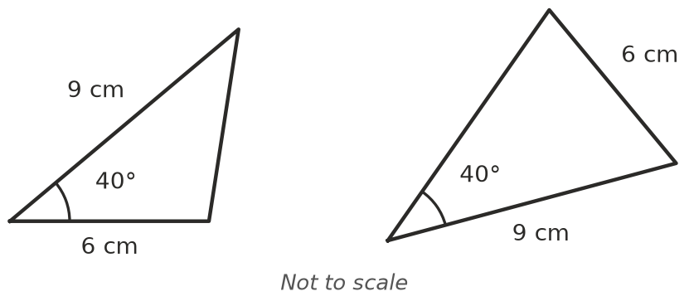
  - ______________
- 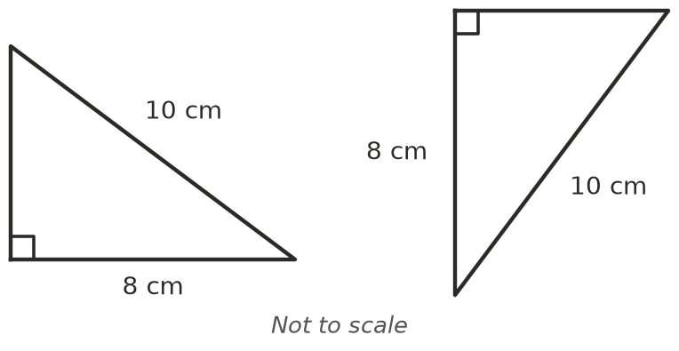
  - ______________
- 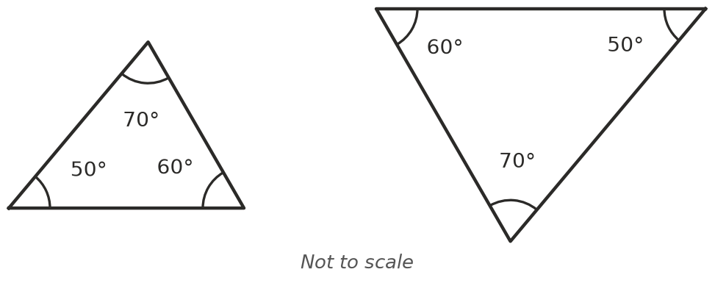
  - ______________
- Each pair is congruent. Use the markings to write a congruence statement with the vertices in matching order, and name the test.
- 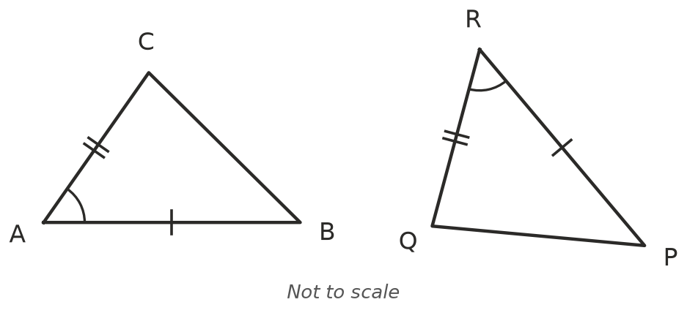
- 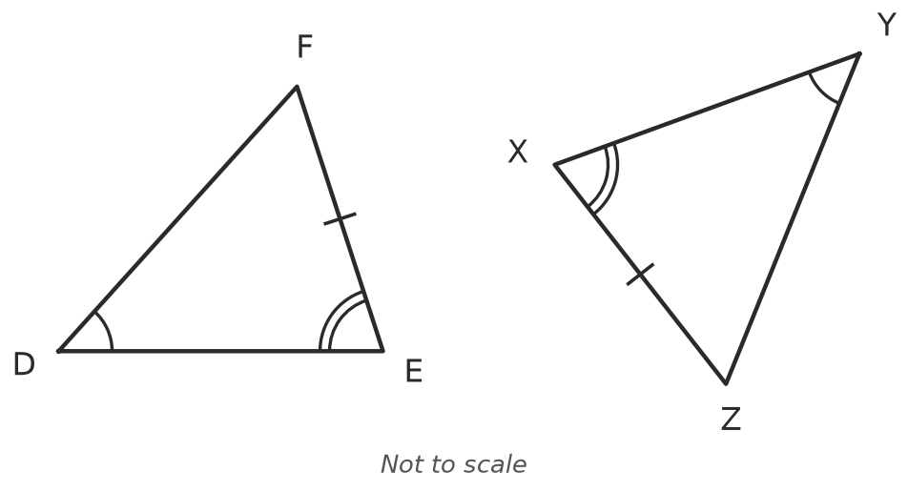
  - △ABC ≅ △______________ Test: ______________
  - △DEF ≅ △______________ Test: ______________
- The two triangles are congruent.
- 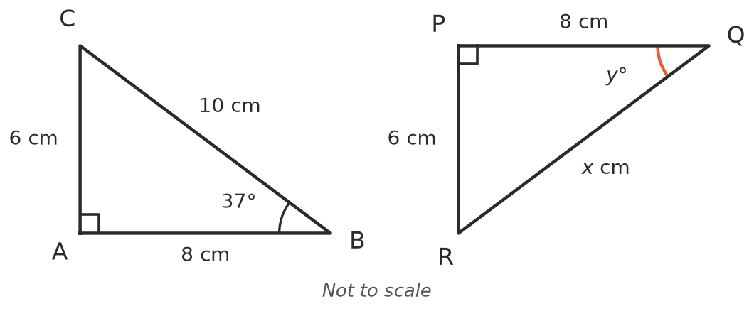
  - Which test shows they are congruent? ______________
  - Find $x$. ______________ c) Find $y$. ______________

 Reasoning
- Two triangles both have angles of 50°, 60° and 70°. Explain why they might not be congruent.

- ABCD is a kite. The diagonal AC splits it into two triangles.
- 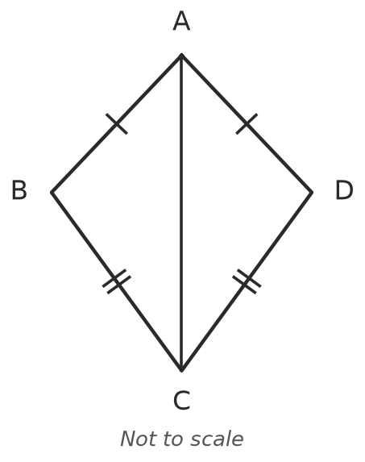
  - Which side do triangles ABC and ADC share? ______________
  - Which test shows that △ABC ≅ △ADC? ______________
  - What does this tell you about ∠ABC and ∠ADC? ______________

 Problem solving
- Triangle ABC is isosceles with AB = AC. M is the midpoint of BC.
- 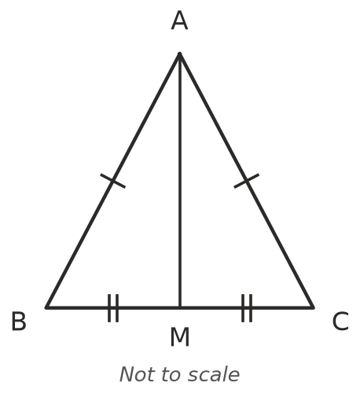
  - Explain why △ABM ≅ △ACM, and name the test. ______________

  - ∠AMB and ∠AMC are equal and make a straight angle. How big is each one? ______________
- Two ladders, each 3.5 m long, lean against opposite sides of a wall. The foot of each ladder is 1.2 m from the wall.
- 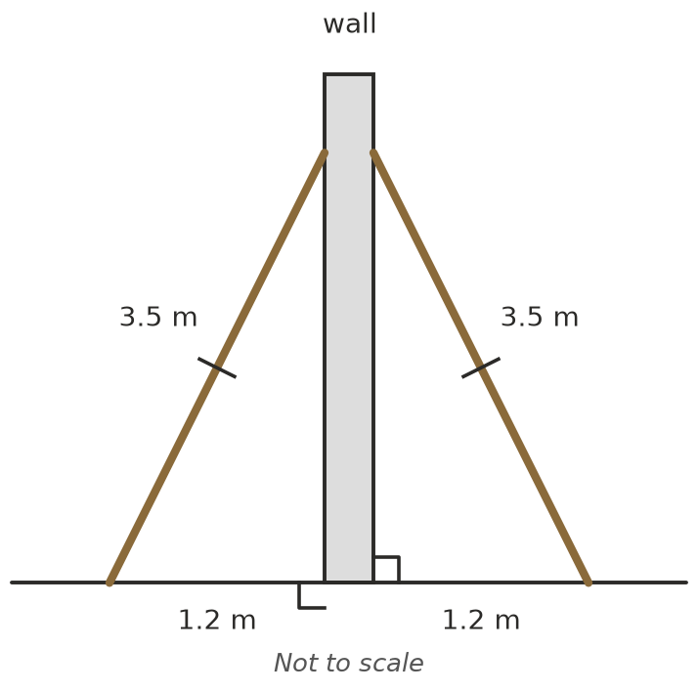
  - Which test shows the two triangles are congruent? ______________
  - Do the ladders reach the same height up the wall? Explain. ______________

