7.03 Congruent triangles
Year 8 Maths · A5 question sheet · Level 3 · Challenge
This worksheet practises choosing congruence tests carefully, writing full congruence proofs, and using congruent triangles to prove geometry facts. Tip: a good proof lists three matching facts, each with a reason, then names the test, then says what follows (“matching sides of congruent triangles are equal”).

 Understanding
- Are the triangles congruent? If yes, name the test. If no, explain why not. Check carefully where each marked side sits.
  - 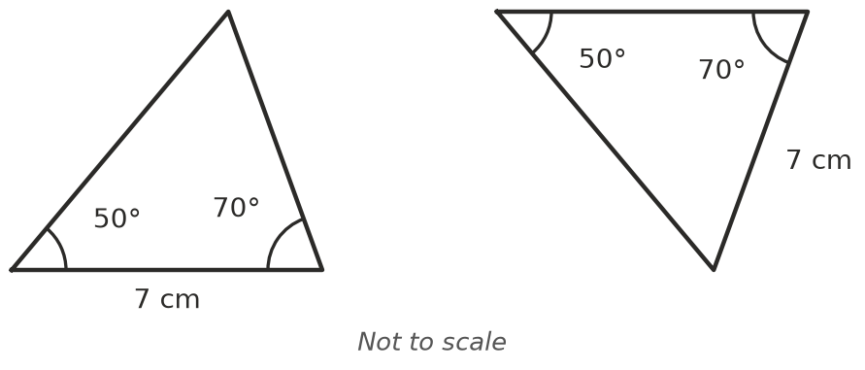
  - 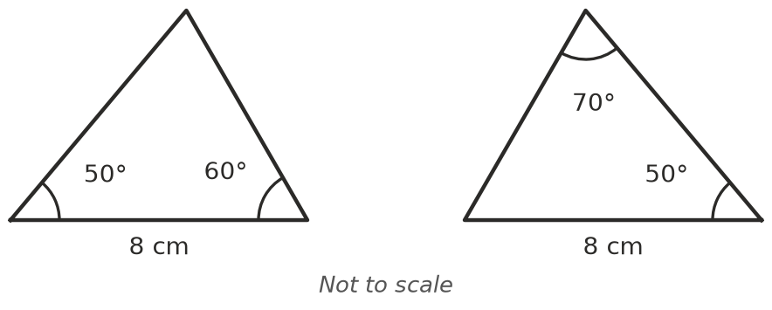
  - 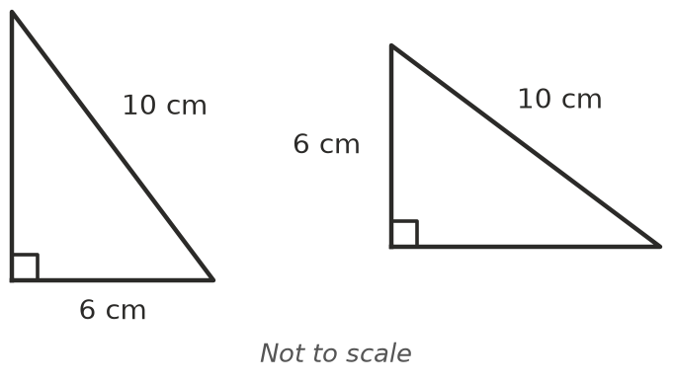
- In the diagram, AD = AE and DB = EC.
- 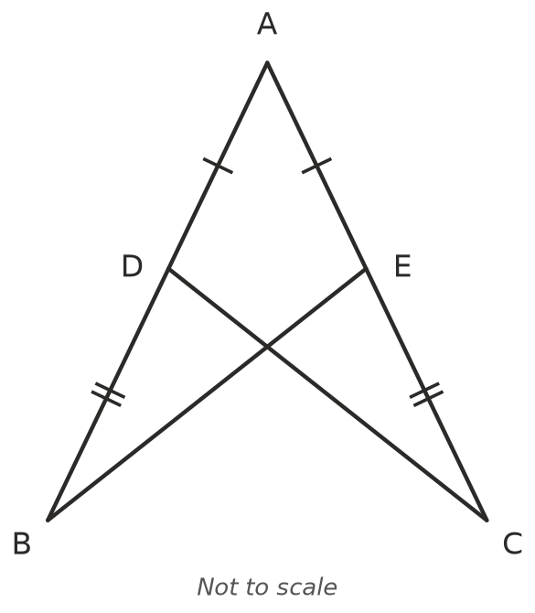
  - Explain why AB = AC.
  - Prove that △ABE ≅ △ACD.
  - What does this tell you about BE and CD?

 Fluency
- △PQR ≅ △STU. PQ = (2$x$ + 1) cm, QR = ($y$ + 4) cm and PR = 10 cm. ST = 9 cm and TU = ($x$ + 7) cm.
  - Find $x$. ______________ b) Find $y$.
  - Find the perimeter of triangle STU.
- △ABC ≅ △XYZ. ∠A = (2$a$ + 10)°, ∠B = 3$b$° and ∠C = 70°. ∠X = 50°. Find $a$ and $b$.
- ABCD is a parallelogram (both pairs of opposite sides are parallel), with diagonal BD.
- 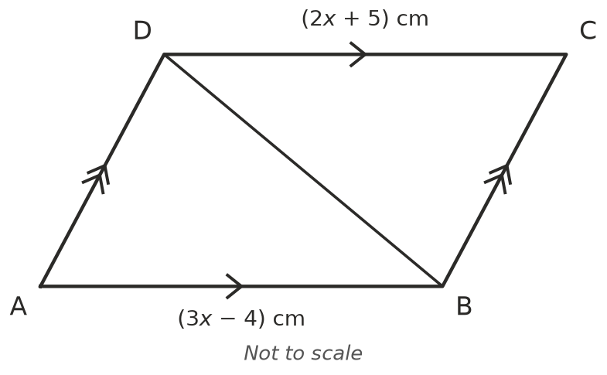
  - Prove that △ABD ≅ △CDB. Hint: look for alternate angles.
  - Find $x$ and the length of AB.

 Reasoning
- Triangle ABC has AB = AC. Prove that ∠B = ∠C. Hint: start by joining A to M, the midpoint of BC.
- Write True or False. If false, describe two triangles that show it is false.
Statement
Two equilateral triangles with the same side length are congruent.
Two isosceles triangles with the same base are congruent.
Two right-angled triangles with the same two shorter sides are congruent.
Two triangles with the same perimeter are congruent.

- Two triangles have two pairs of matching sides and one pair of matching angles. Explain when this proves they are congruent, and when it doesn’t. A sketch may help.

 Problem solving
- P is a point on the perpendicular bisector of AB. (M is the midpoint of AB, and the dashed line through M is at right angles to AB.)
- 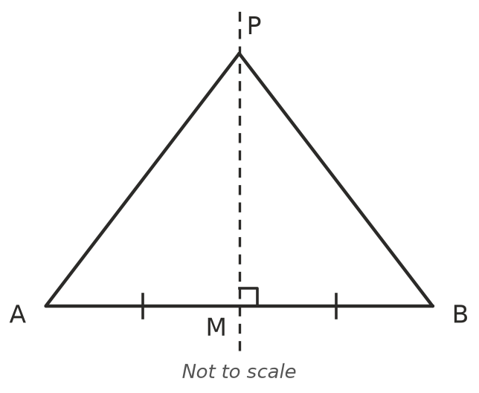
  - Prove that PA = PB.
  - Two towns are at A and B. Describe where a phone tower could go so that it is the same distance from both towns.
- ABCD is a kite with AB = AD and CB = CD. Its diagonals cross at M. Prove that the diagonals cross at right angles. Hint: you need two pairs of congruent triangles.
- 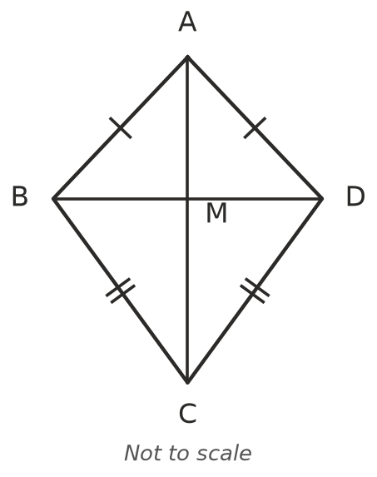
- By SSS, three side lengths make exactly one triangle (any two triangles with the same three sides are congruent).
  - How many different triangles have whole-number sides and a perimeter of 12 cm? List them.
  - How many have a perimeter of 15 cm?

