7.03 Congruent triangles
Year 8 Maths · A5 question sheet · Level 1 · Warm-up
This worksheet practises the four tests that prove two triangles are congruent: SSS, SAS, AAS and RHS. Tip: you don’t need to check all six sides and angles. If three of the right parts match, the triangles must be congruent.

 Understanding
- Copy and complete the table of congruence tests.
Test | What must match
SSS
SAS | two sides and the angle ______________ them
AAS | two angles and ______________
RHS | a right angle, the ______________ and one other side

- Each pair of triangles is congruent. Name the test that shows it: SSS, SAS, AAS or RHS.
  - 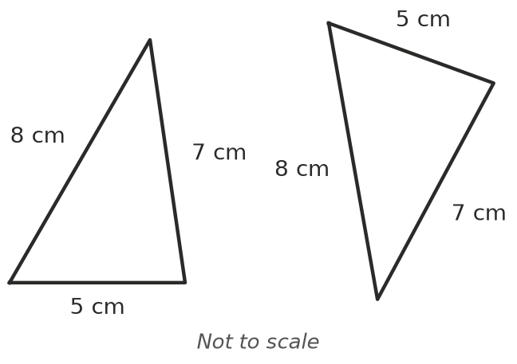
  - 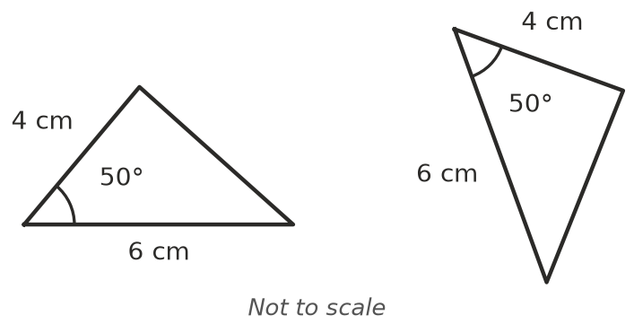
  - 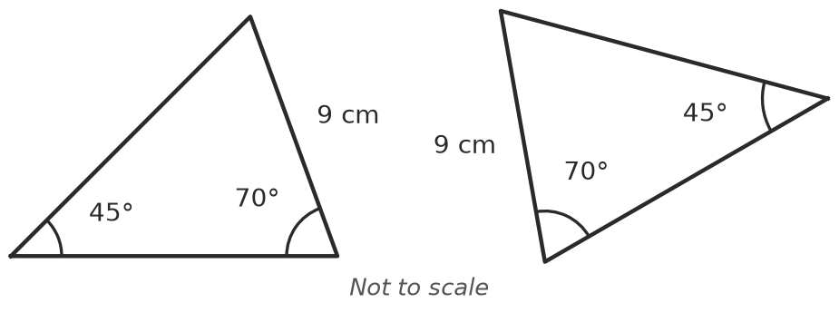
  - 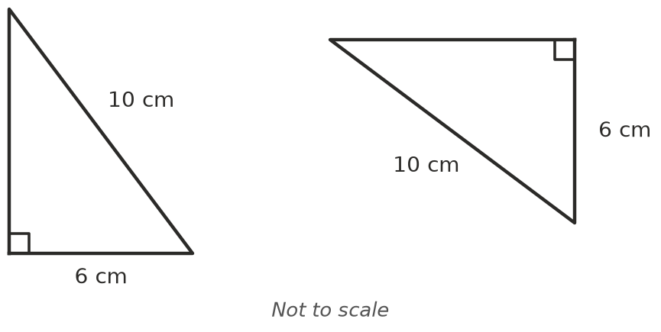
- Answer these about triangle ABC.
  - Which angle is between sides AB and BC?
  - Which side is between ∠A and ∠B?
  - In a right-angled triangle, what is the longest side called?

 Fluency
- Are the two triangles congruent? Write Yes and the test, or write “Not enough information”.
  - 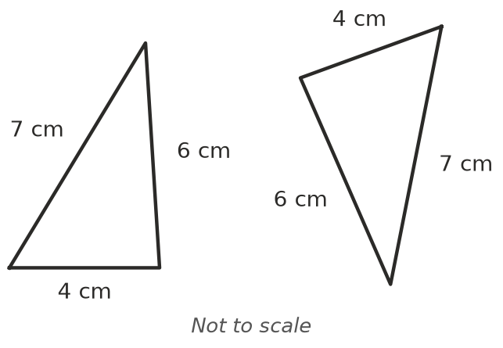
  - 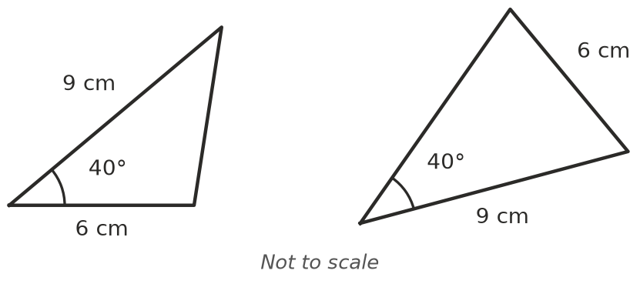
  - 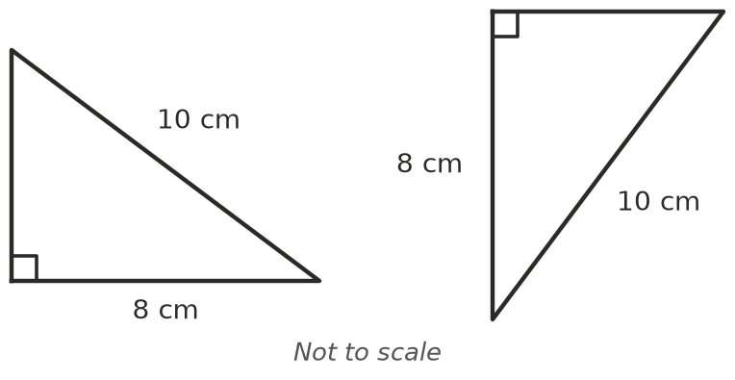
  - 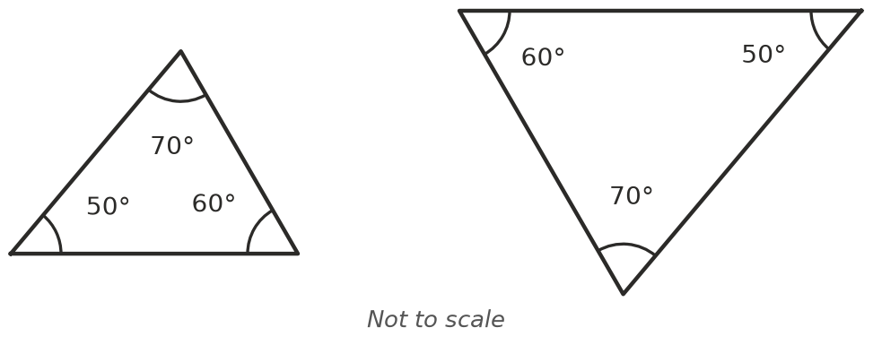
- Each pair is congruent. Use the markings to write a congruence statement with the vertices in matching order, and name the test.
- 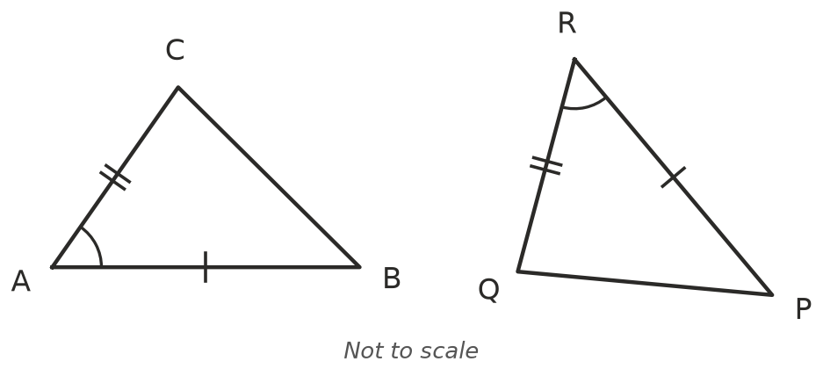
- 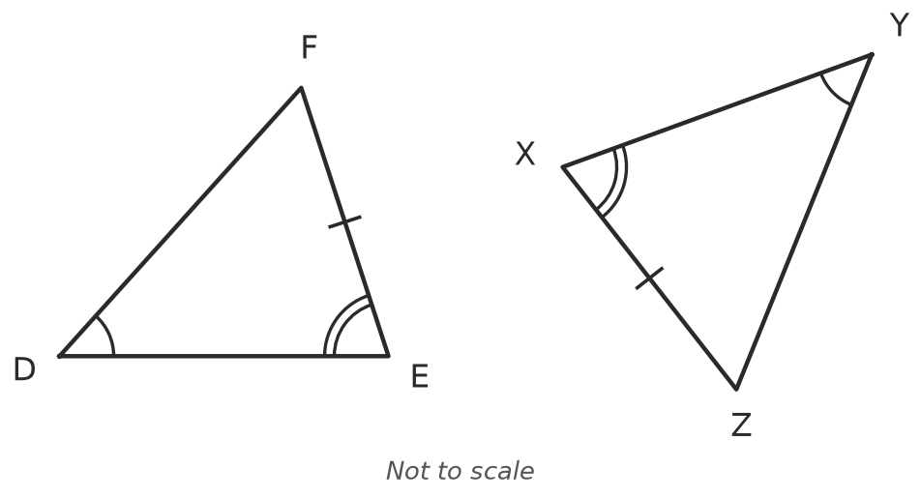
  - △ABC ≅ △______________ Test:
  - △DEF ≅ △______________ Test:
- The two triangles are congruent.
- 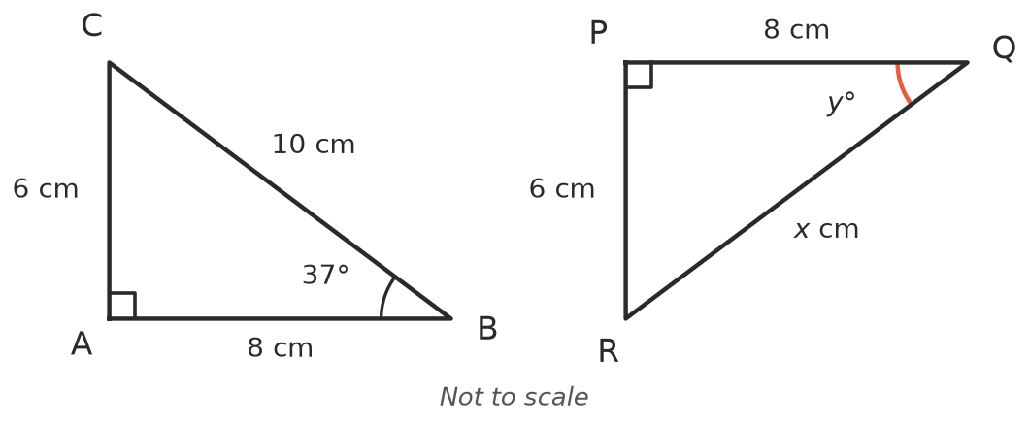
  - Which test shows they are congruent?
  - Find $x$. ______________ c) Find $y$.

 Reasoning
- Two triangles both have angles of 50°, 60° and 70°. Explain why they might not be congruent.
- ABCD is a kite. The diagonal AC splits it into two triangles.
- 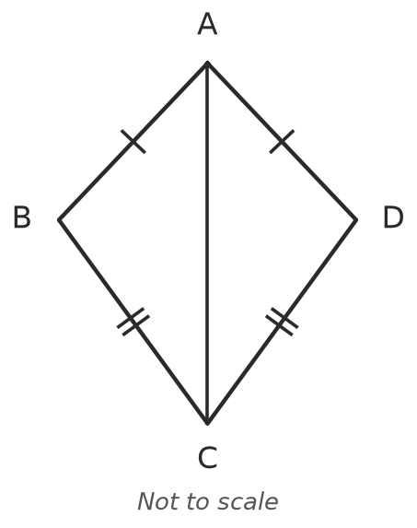
  - Which side do triangles ABC and ADC share?
  - Which test shows that △ABC ≅ △ADC?
  - What does this tell you about ∠ABC and ∠ADC?

 Problem solving
- Triangle ABC is isosceles with AB = AC. M is the midpoint of BC.
- 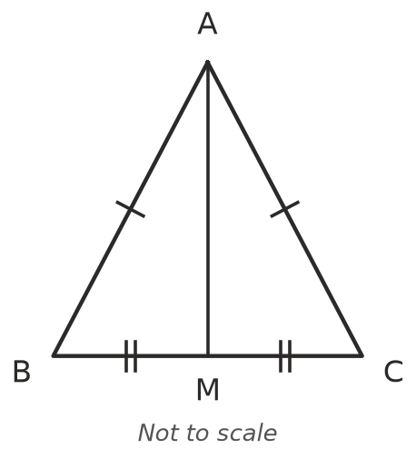
  - Explain why △ABM ≅ △ACM, and name the test.
  - ∠AMB and ∠AMC are equal and make a straight angle. How big is each one?
- Two ladders, each 3.5 m long, lean against opposite sides of a wall. The foot of each ladder is 1.2 m from the wall.
- 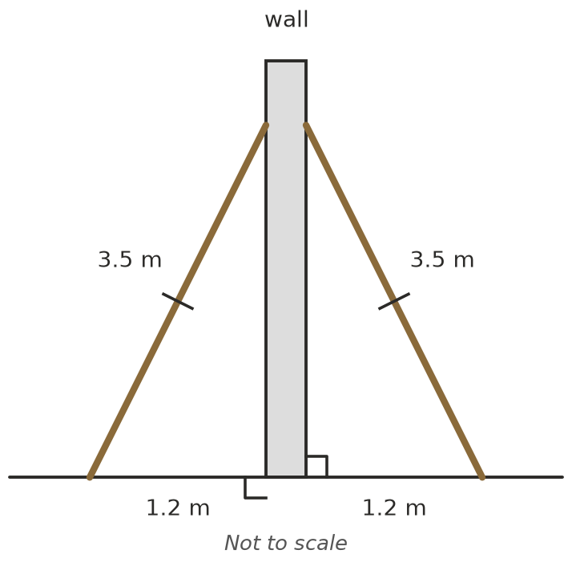
  - Which test shows the two triangles are congruent?
  - Do the ladders reach the same height up the wall? Explain.

