7.02 Transformations and congruence
Year 8 Maths · Worksheet · Level 3 · Challenge
Name: ____________________ Date: ______________
This worksheet practises describing transformations with coordinate rules, combining transformations, and reasoning about when figures are congruent. Tip: to test a coordinate rule, try it on one point, such as (3, 1), and plot where it goes.

 Understanding
- Each pair of figures is congruent. Use the markings to complete each congruence statement.
- 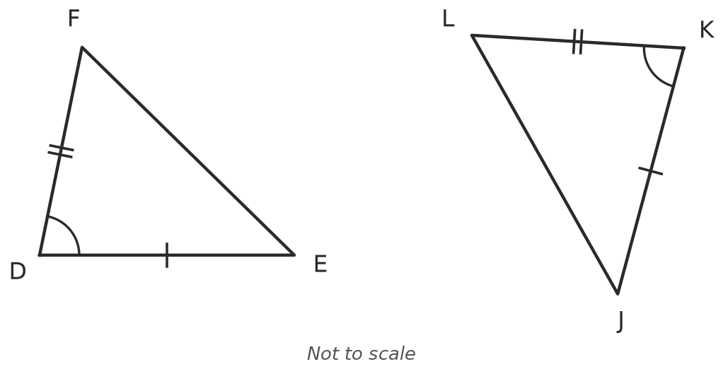
- 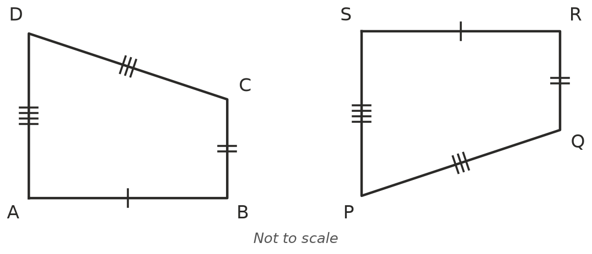
  - △DEF ≅ △______________
  - ABCD ≅ ______________
- Each rule moves every point $(x,y)$ of a shape. Describe the transformation, and say whether the image is congruent to the original.
Rule | Transformation | Congruent?
$(x,y)$ → $(−x,y)$
$(x,y)$ → $(x+3,y−2)$
$(x,y)$ → $(y,−x)$
$(x,y)$ → $(2x,2y)$
$(x,y)$ → $(−x,−y)$

 Fluency
- Triangle ABC has vertices A(1, 1), B(4, 1) and C(4, 3).
  - Reflect ABC in the $x$-axis. Write the coordinates of the image. ______________
  - Now reflect that image in the $y$-axis. Write the coordinates of the final image. ______________
  - Describe the single transformation that maps ABC straight onto the final image. ______________
- Shape A has been rotated onto shape B. Find the angle, the direction and the centre of the rotation.
- 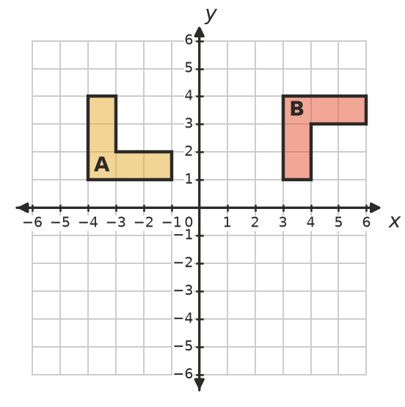

- △ABC ≅ △DEF. AB = (2$x$ + $y$) cm, BC = ($x$ + 3$y$) cm, DE = 11 cm and EF = 13 cm. Find $x$ and $y$.

- Triangle ABC has vertices A(0, 0), B(4, 0) and C(0, 3). Triangle PQR has P(6, 1) and Q(10, 1). Find two different positions of R so that △ABC ≅ △PQR. ______________

 Reasoning
- Reflect shape A in the line $x$ = 1, and label the image B. Then reflect B in the line $x$ = 4, and label the image C.
- 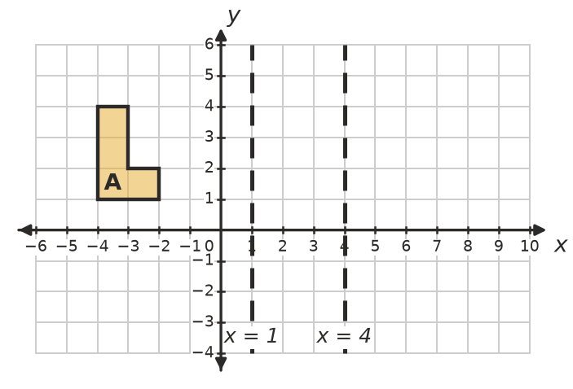
  - Describe the single transformation that maps A onto C. ______________
  - How is the distance A moved related to the distance between the two mirror lines? ______________
- The two quadrilaterals in Question 1b have matching sides. Explain why four matching sides are not enough to be sure that two quadrilaterals are congruent. A sketch may help.

- The point (2, 1) is translated 3 units right and then reflected in the $y$-axis. Is the result the same if you reflect first and then translate? Show your working, and say what this tells you about the order of transformations.

 Problem solving
- Show that triangle A(1, 1), B(5, 1), C(2, 4) is congruent to triangle P(−1, −1), Q(−1, −5), R(−4, −2) by finding a single transformation that maps ABC onto PQR, with A going to P. Plot both triangles first.
- 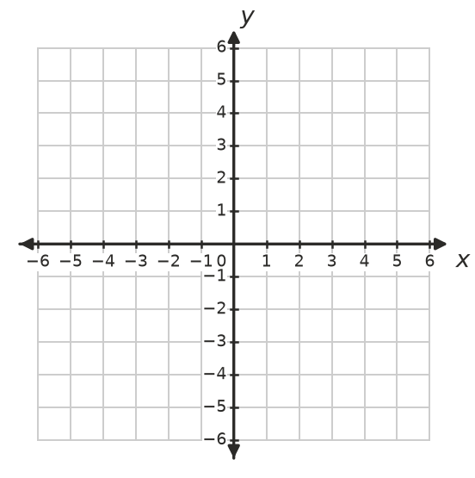

- A shape can be mapped onto itself by some rotations and reflections. For a square, these are the rotations of 90°, 180°, 270° and 360° about its centre and the reflections in its 4 lines of symmetry: 8 ways in all.
  - How many ways can an equilateral triangle be mapped onto itself? ______________
  - How many ways can a regular hexagon be mapped onto itself? ______________
  - Predict the number for a regular polygon with $n$ sides. Explain. ______________

- A rotation of 180° about the point (2, 1) maps P(5, 3) onto P′.
  - Find the coordinates of P′. ______________
  - Which point is not moved at all by this rotation? ______________

