7.02 Transformations and congruence
Year 8 Maths · Worksheet · Level 2 · Core
Name: ____________________ Date: ______________
This worksheet practises describing transformations exactly, writing congruence statements with the vertices in matching order, and using congruent figures to find unknown sides and angles. Tip: matching marks (ticks on sides, arcs on angles) tell you which parts correspond. In △ABC ≅ △DEF, A matches D, B matches E and C matches F.

 Understanding
- Each pair of triangles is congruent. Use the markings to complete each congruence statement, with the vertices in matching order.
- 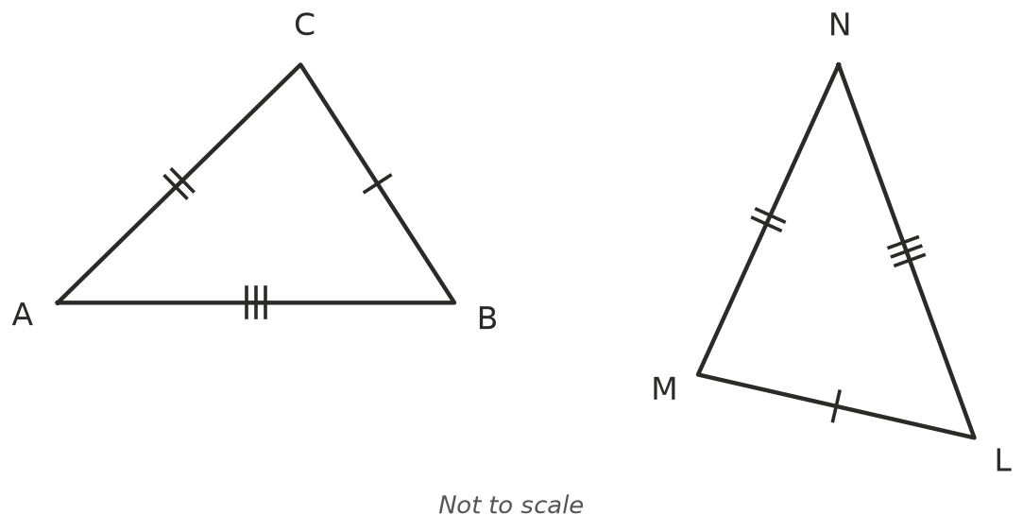
- 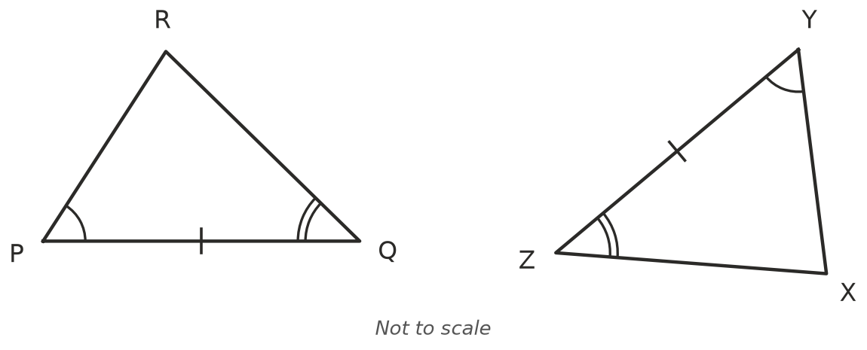
  - △ABC ≅ △______________
  - △PQR ≅ △______________
- Does each transformation always make an image that is congruent to the original? Write Yes or No.
Transformation | Congruent image?
translation
reflection
rotation
enlargement with scale factor 3
enlargement with scale factor 1

 Fluency
- Describe fully the single transformation that maps shape A onto each other shape. For a rotation, give the angle, the direction and the centre.
- 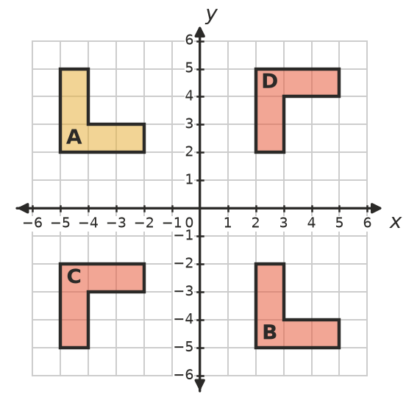
  - A to B: ______________
  - A to C: ______________
  - A to D: ______________
- Triangle PQR has vertices P(1, 2), Q(4, 2) and R(2, 5). Write the coordinates of the image after each transformation.
  - a reflection in the $y$-axis ______________
  - a rotation of 90° anticlockwise about the origin ______________
  - a translation 3 units left and 1 unit up ______________
  - Explain why all three images are congruent to triangle PQR. ______________

- Triangle ABC ≅ triangle PQR. Find $x$ and $y$.
- 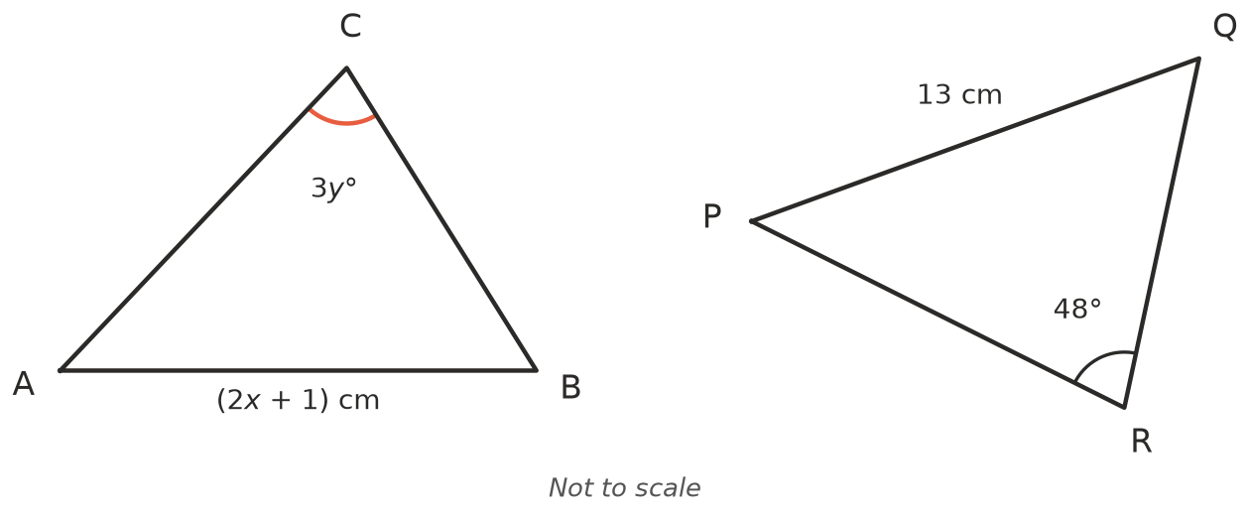
- $x$ = ______________ $y$ = ______________
- △JKL ≅ △STU. In triangle JKL, JK = 9 cm, KL = 12 cm, JL = 15 cm and ∠K = 90°. Without drawing, find:
  - ST ______________ b) TU ______________ c) SU ______________
  - ∠T ______________ e) the perimeter of triangle STU ______________
- Shape A can be moved onto shape B with two transformations. Describe a sequence that works.
- 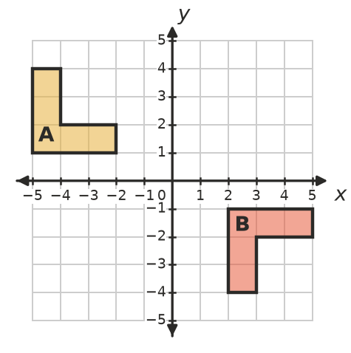

 Reasoning
- For Question 1a, Ella wrote △ABC ≅ △LMN. Explain why her statement is wrong, even though the triangles are congruent.

- Rachel says, “A reflected image is back to front, so it isn’t congruent to the original.” Explain why she is wrong.

- Two shapes have the same area and the same perimeter. Must they be congruent? Draw two shapes on the grid to show your answer.
- 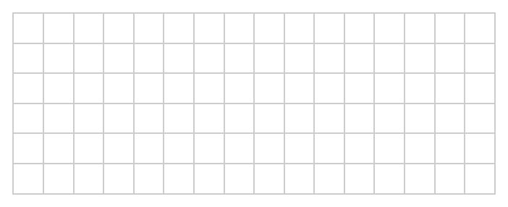

 Problem solving
- This design is made from four triangles that turn about the dot at the centre.
- 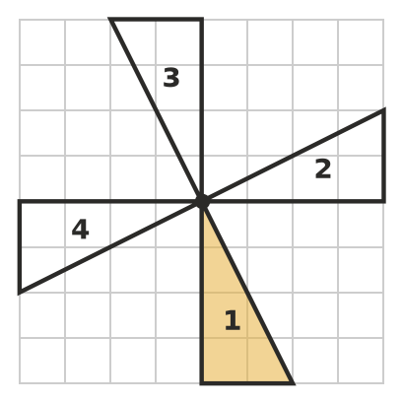
  - Describe the single transformation that maps triangle 1 onto triangle 2. ______________
  - Describe the transformation that maps triangle 1 onto triangle 3, and onto triangle 4. ______________
  - Explain why all four triangles are congruent. ______________
- Triangle ABC has vertices A(−3, 1), B(−1, 1) and C(−1, 4). Its image is A′(1, 3), B′(1, 1) and C′(4, 1). Describe the single transformation. Sketch the triangles if it helps. ______________

- △DEF ≅ △KLM. DE = (3$x$ − 2) cm and KL = ($x$ + 8) cm. ∠F = (5$y$ + 10)° and ∠M = 70°.
  - Find $x$ and the length of DE. ______________
  - Find $y$. ______________

